**CORE Group Cholera Module Flipcharts**

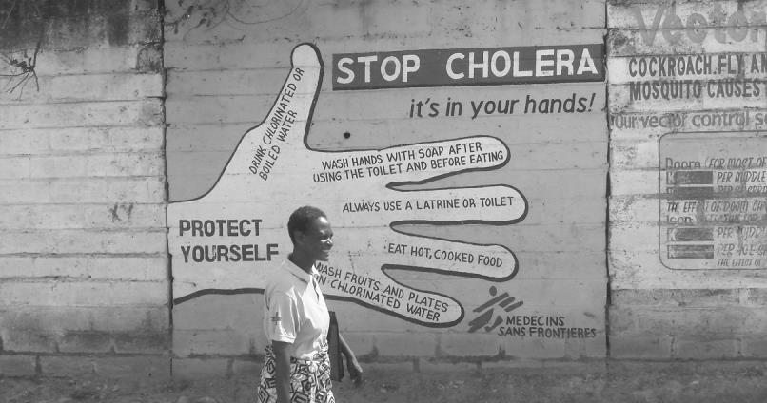



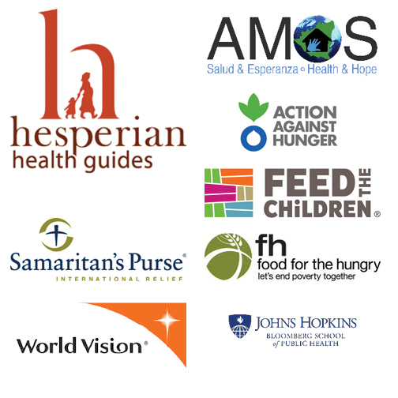

*This flipchart was made possible by a grant from The Technical and Operational Performance Support (TOPS) Program. The TOPS Micro Grants Program is made possible by the generous support and contribution of the American people through the U.S. Agency for International Development (USAID). The contents of the materials produced through the Micro Grants do not necessarily reflect the views of TOPS, USAID, or the U.S. Government.*

**Acknowledgements**

Thanks to those who have contributed to this module including:

Pfitzenmaier, C; Davis, T; Srinivasan, A; and McDaniel, S (2016). Consultants to CORE Group, and Hesperian Health Guides for access to their health images.

Following initial development, CORE Group’s SBC Working Group, and the FSN Network Care Groups Forward Interest Group were invited to review the lessons for technical content. Special thanks to the following individuals and organizations who reviewed and or field tested the lesson plans and/or flip charts and provided feedback:

* Dr Marlène Dorismond Adrien, a seasoned Haitian public health physician who has managed cholera responses in Haiti reviewed the complete module.
* Mary Decoster, Senior Specialist for SBC (FH/TOPS), and SBCTF Chair reviewed the first two lessons.
* Christophe Valingot Delaurenti, who has several years of experience in cholera prevention and control from the field level to the top management of epidemics at national, regional and global level, reviewed the complete module.
* Adugna Kebede, Technical Director for HIV/AIDS at World Vision who has previous experience with cholera epidemics reviewed the complete module.
* Armelle Sacher, Action Against Hunger, reviewed the first lesson.
* David A. Sack, M.D., Professor, Department of International Health, Johns Hopkins University Bloomberg School of Public Health provided input on several technical interventions to reduce cholera transmission.
* Cindy Uttley, CNM, MSN, RN, Community Health Advisor with Samaritan’s Purse (and on the SBCWG) reviewed the complete module.
* CORE Group staff Lisa Hilmi, MPH, RN, CPN, Executive Director, who had technical review and oversight as an expert in disaster, cholera camps, and nursing, Holly Collins, Communications Associate, and Michelle Shapiro, Communications and Knowledge Manager, who completed editing and formatting.

Materials were also shared with the FHI360 WASHPlus Project, and we reached out to the CORE Nutrition Working Group for review.

***Field Testing:***

The following people/organizations field tested the module and flipcharts:

* Adugna Kebede, World Vision International, Zambia (tested lessons #1 and #2 with Mother-to-Mother Support Groups.)
* Seintje Veldhuis, Feed the Children, Kenya (tested all four lessons in an urban Care Group project).
* Lara Chanchien-Parajon, AMOS Health and Hope, Nicaragua (tested lessons 3 & 4.)

***Suggested Citation:***

Pfitzenmaier, C; Davis, T; Srinivasan, A; and McDaniel, S (2016). CORE Group Cholera Module. Washington, DC. Food for the Hungry (FH). This TOPS Small Grants Program Improvement Award was made possible by the generous support and contribution of the American people through the United States Agency for International Development (USAID). The contents of the materials produced through the TOPS Small Grants Program Improvement Award do not necessarily reflect the views of TOPS, USAID or the United States Government.

1

***This page left blank intentionally.***

2

**Lesson One: What is Cholera?**

**Game: Germ in the Circle**

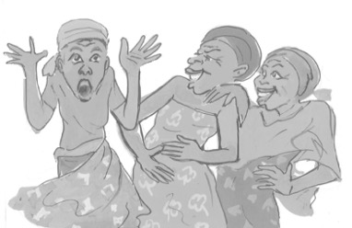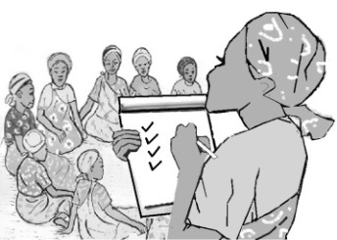

**Attendance and Troubleshooting**

**Story: Fatima’s Daughter Gets Sick (Picture 1.1)**

Fatima and her family live in a rural village in the northern part of Tanzania. She lives with her husband and two children, Asad, who is three years old, and Afya, who just turned one. Afya is not quite walking, but crawling everywhere! Fatima loves her family and works hard to take care of them. Every day, Fatima walks with both children about thirty minutes each way to the river to fetch water for the household. Last week there were extreme rains causing widespread flooding along the river and in the fields of Fatima’s village and the surrounding villages. Yesterday was the first day Fatima was able to make it to the river with her children since the flooding. While she gathered water, Afya played on the shore of the river, putting her hands in the water and then in her mouth. Early the next day, Fatima noticed her youngest child was not feeling well at all. Afya was having very frequent, watery, and abundant diarrhea like rice water. She was also vomiting and very thirsty. By late that afternoon, Afya had stopped peeing and her eyes were sunken. Both Fatima and Asad felt okay. That night Fatima was very worried about Afya. She heard about cholera on the radio from local community health workers last year when there were heavy rains and flooding up north. The health workers said that cholera is a very serious disease and can be deadly especially in small children. She remembered that contaminated water can often be the source. As Fatima continued to care for Afya, she thought that it could just be common diarrhea. No one was talking about cholera in her village, but Fatima was very worried about Afya and unsure what to do.

3

**Fatima’s Daughter Gets Sick (Picture 1.1)**

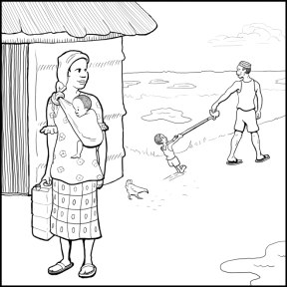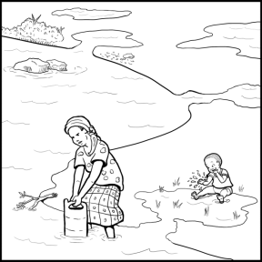

*One day, while Fatima gathered water, Afya played on the shore of the river, putting her hands in the water and then in her mouth.*

*Fatima and her family live in a rural village in the northern part of Tanzania.*

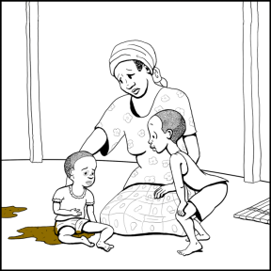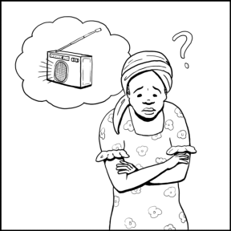

*Early the next day, Fatima noticed that Afya was not feeling well at all. Afya was having diarrhea and vomiting and she had sunken eyes. She was also very thirsty.*

*Fatima was very worried about Afya. She had heard about cholera on the radio from local community health workers last year. The health workers said that cholera is a very serious disease and can be deadly, especially in small children. She remembered that contaminated water can often be the source.*

4

|  |  |
| --- | --- |
|  | * What has Fatima heard about cholera? * What are some of the symptoms of cholera? What symptoms did Afya have? * What have you heard about how cholera is spread? * What things have you heard that we can do to prevent cholera spreading in our households and communities? |

**Encourage discussion. Don’t correct “wrong answers**.” Let everyone give an opinion.

**Where is cholera found and how is it spread? (Picture 1.2)**

|  |  |
| --- | --- |
|  | **What do you see in these pictures?** |

**Explain: Cholera is a diarrheal disease caused by consuming water or food that is contaminated with cholera bacteria.**

1. Cholera often spreads following flooding or the rainy season, particularly during hot, rainy months. In some places, cholera epidemics start at the end of the dry season or the beginning of the rainy season, when water sources are limited and become brackish and/or highly polluted.
2. Cholera bacteria are usually found in food and water sources that have been contaminated by feces[1] from an infected person.
3. Cholera is easily spread in places where people do not bury their feces or use latrines, where people do not wash their hands at proper times with soap or ash and water, and where people do not treat (disinfect) their drinking water.

**?** ***Where do you get your water now? Do your children come with you? What are some things you can do to keep your children safe while you fetch water?***

**?  *What is the latrine situation in your household/community? Do you have a latrine to use? What do you do with your children’s feces?***

5

**Where is cholera found and how is it spread? (Picture 1.2)**

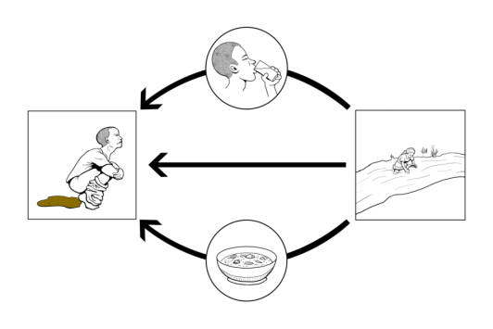

*Cholera is a diarrheal disease caused by consuming water or food that is contaminated with cholera bacteria.*

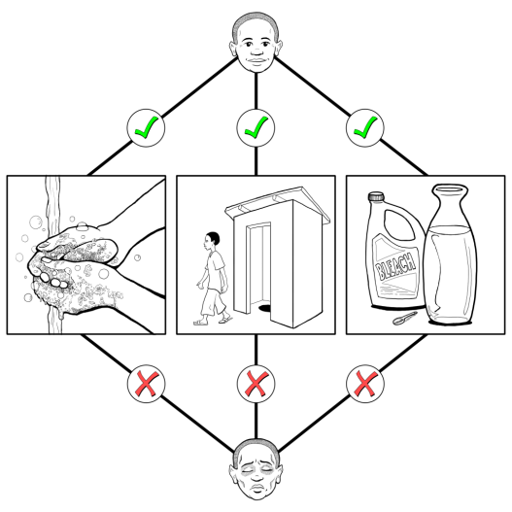

*Cholera is easily spread in places where people do not bury their feces or use latrines, where people do not wash their hands at proper times with soap or ash or water, and where people do not treat (disinfect) their drinking water.*

6

**The 5 F’s of Transmission (Fluids, Fingers, Flies, Food, and Field) (Picture 1.3)**

|  |  |
| --- | --- |
|  | **What do you see in these pictures?** |

**Explain: Cholera is spread the way many diarrheal diseases are spread, through the five “Fs”:**

1. **Fluid/Water**: By drinking water that has been contaminated by feces and has not been treated (disinfected).
2. **Fingers**: By getting hands in one’s mouth, when hands are not washed after using the toilet or after contact with feces on the ground (which is especially common for young children who are crawling).
3. **Flies**: Because flies sit on feces and then land on food.
4. **Food**: By eating food that has been contaminated (made dirty) by fingers, flies, or water that have come in contact with feces.
5. **Fields/Floors**: The soil where food is grown can contain feces when cholera-infected people or animals feces on the ground or near water sources instead of using latrines or burying the feces. Hands that have been working in the soil can pass microbes like cholera on when handwashing is not done afterwards. Floors that get contaminated with animal or human feces can also end up contaminating fingers that end up in mouths.

It can also be spread from other contaminated things including buckets, cups, ladles, shoes, soiled clothing, etc., that has touched feces or touched by something that has touched feces (e.g., fingers).

People can have cholera without knowing it and without having any symptoms.

**? *Why do you think it is so easy for children to get sick from cholera?***

**? *How can you protect yourself from spreading cholera through the five Fs?***

7

**The 5 F’s of Transmission (Picture 1.3)**

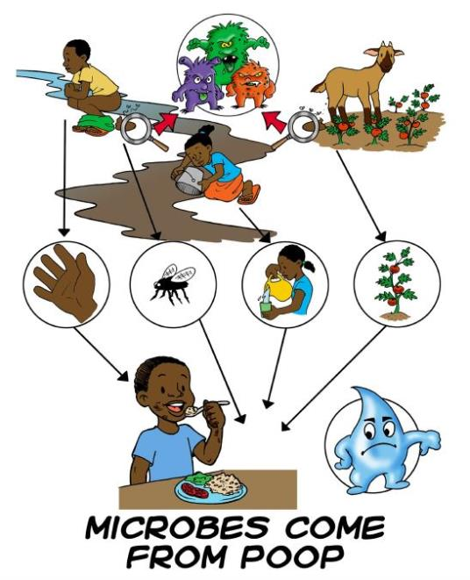

*Cholera is spread the way many diarrheal diseases are spread, through the five “Fs:” fluids, fingers, flies, foods, and fields.*

*Cholera can also be spread from other contaminated things, including buckets, cups, ladles, shoes, soiled clothing, etc., that have touched feces or been touched by feces (e.g., fingers). People can have cholera without knowing it and without having any symptoms.*

8

**Signs and symptoms of cholera, incubation period, and who it affects (Picture 1.4)**

|  |  |
| --- | --- |
|  | **What do you see in these pictures?** |

**Explain:**

**Cholera can cause very frequent, watery, and abundant diarrhea, looking like rice water.**

* Diarrhea is three or more watery feces in one day and night (24-hour period).
* Other symptoms of cholera include vomiting and leg cramps. If diarrhea and vomiting are not treated, severe dehydration and shock can occur, and without treatment, death can occur.
* People who have dehydration often become very thirsty and have less pee, dry mucous membranes, sunken eyes, and skin that is less elastic.

It takes between 12 hours and 5 days for a person to show symptoms of cholera, and most people who get cholera have mild or no symptoms at first.[2] These people are still able to infect other people with it.

* This is because the cholera bacteria can be living in their feces even if they have no symptoms.

9

**Signs and symptoms of cholera, incubation period, and who it affects (Picture 1.4)**

C:\Users\hcollins\Dropbox (StCU)\Cholera Lesson Plans\Flipbook Design - Holly Collins\FLIPCHART 1\Images\1.4.b (2) (vomit).TIFC:\Users\hcollins\Dropbox (StCU)\Cholera Lesson Plans\Flipbook Design - Holly Collins\FLIPCHART 1\Images\1.4.a.tif

*Cholera can cause very frequent, watery, and abundant diarrhea, looking like rice water. Other symptoms of cholera include vomiting and leg cramps. If diarrhea and vomiting are not treated, severe dehydration and shock can occur, and without treatment, death can occur.*

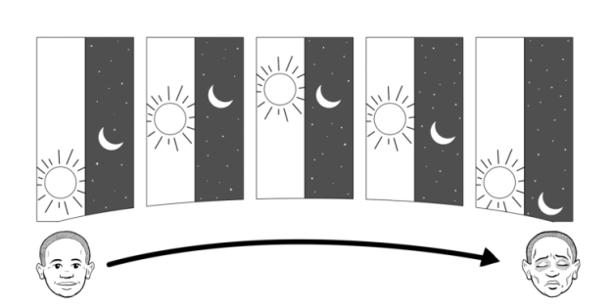

10

*It takes between 12 hours and 5 days for a person to show symptoms of cholera, and most people who get cholera have mild or no symptoms at first. These people are still able to infect other people with it.*

**Signs and symptoms of cholera, incubation period, and who it affects (Picture 1.4 continued)**

|  |  |
| --- | --- |
|  | **What do you see in these pictures?** |

**Explain:**

**Cholera affects both children and adults and can sometimes kill a person through dehydration within hours if it is untreated.**

* Pregnant women and children under 5 years of age are at increased risk of getting and dying from cholera.
* Being malnourished or HIV+, or having TB and other chronic diseases, can increase a person’s risk of getting and dying from cholera.
* The elderly and other persons who are immune-suppressed are also particularly susceptible to cholera.

**? *What are the symptoms of cholera?***

**? *Can people with no symptoms transmit cholera? Why?***

11

**Signs and symptoms of cholera, incubation period, and who it affects (Picture 1.4 continued)**

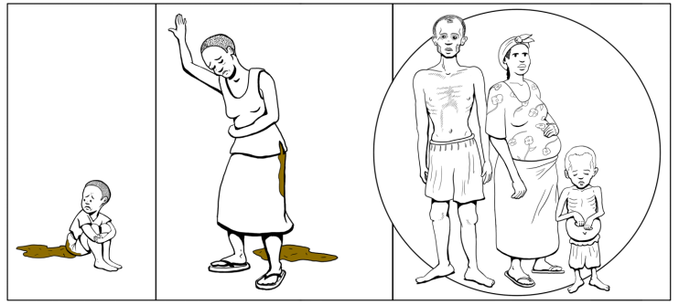

*Cholera affects both children and adults, and can sometimes kill a person through dehydration within hours if it is untreated.*

*Pregnant women and children under 5 years of age are at increased risk of getting and dying from cholera. A person’s risk of getting and dying from cholera is also increased if they are malnourished, HIV +, or have TB or other chronic diseases. The elderly and other persons with suppressed immune systems are also at increased risk.*

12

**What are the main things that you can do to avoid getting cholera and other diarrheal diseases? (Picture 1.5)**

|  |  |
| --- | --- |
|  | **What do you see in these pictures?** |

**Explain:**

**Wash your hands with soap (or ash) and water:**

* After defecating or cleaning a child’s bottom or sick family member’s bottom.
* After disposing of children’s feces.
* Before preparing food.
* Before eating food or feeding young children.
* After handling animals or dung, or working in the field.
* After caring for a sick person.

13

**What are the main things that you can do to avoid getting cholera and other diarrheal diseases? (Picture 1.5)**

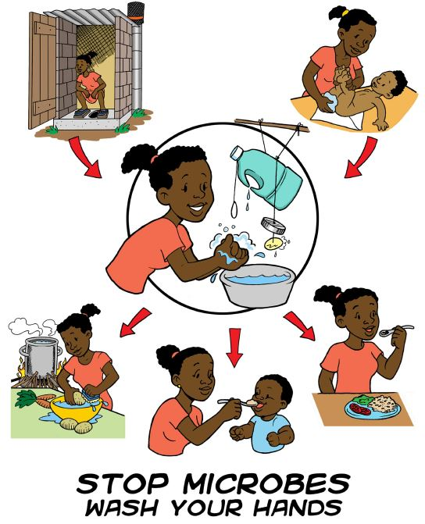

*Wash your hands with soap (or ash) and water…*

* *After defecating or cleaning a child’s bottom or sick family member’s bottom.*
* *After disposing of children’s feces.*
* *Before preparing food.*
* *Before eating food or feeding young children.*
* *After handling animals or dung, or working in the field.*
* *After caring for a sick person.*

14

**What are the main things that you can do to avoid getting cholera and other diarrheal diseases? (Picture 1.5 continued)**

|  |  |
| --- | --- |
|  | **What do you see in these pictures?** |

**Explain:**

**Carefully treat, store, and use water:**

* Drink only filtered (strained) and treated water! There are several ways to filter and treat your water.
  + First, filter the water through fabric, sand or other material that removes any particles in the water.
  + Then you can add two drops of household bleach or ½ of an iodine tablet per liter of water, or boil the water until large bubbles appear. Be sure to let the water sit for at least 20 minutes after adding bleach as it helps to kill off bacteria and also to reduce the chlorine smell. *(More details will be provided in lesson 2.)*
  + Avoid getting untreated water in children’s (and adults’) mouths during bathing, or bathe with treated water.
* Only use narrow-neck containers for storing water since they help keep hands out of the water, and keep the storage container clean and covered!
  + Do not put dirty ladles, cups, or anything else in the water container.
  + When possible, pour water into clean cups or pots for use rather than dipping anything into the container.

15

**What are the main things that you can do to avoid getting cholera and other diarrheal diseases? (Picture 1.5 continued)**

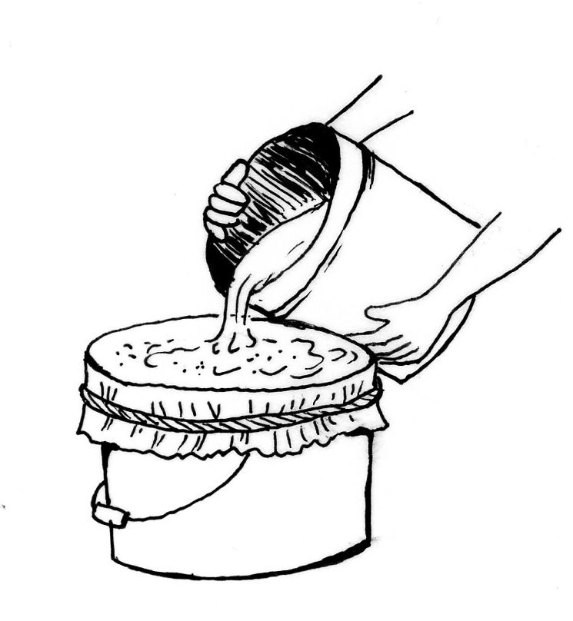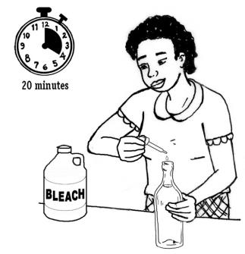

*Only use narrow-neck containers for storing water since they help keep hands out of the water, and keep the storage container clean and covered.*

*Carefully treat, store, and use water! Drink only filtered (strained) and treated water. There are several ways to filter and treat your water.*

*Avoid getting untreated water in children’s (and adults’) mouths during bathing, or bathe with treated water.*

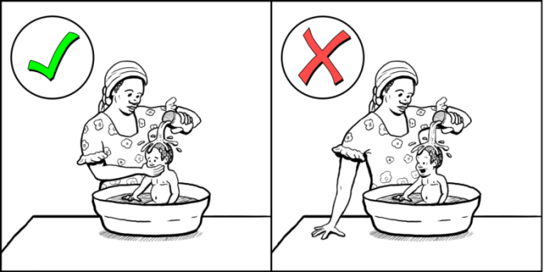

16

**What are the main things that you can do to avoid getting cholera and other diarrheal diseases? (Picture 1.5 continued)**

|  |  |
| --- | --- |
|  | **What do you see in these pictures?** |

**Explain:**

**Handle food in a clean and safe manner:**

* + Cook food thoroughly and eat it while it is hot! Improperly-cooked fish and shellfish are a major source of cholera, so only eat them if they are very well cooked.
  + Do not let cooked foods touch raw foods or surfaces that have touched raw foods or have not been cleaned with soap and water.
  + Cover and properly store food after cooking it.
  + Do not allow sick people to prepare or handle food eaten by others.
  + Wash all vegetables and fruit in treated water before cooking or eating them. Peel them if there is no water to wash them.

**Properly dispose of feces.**

* Use latrines and keep them clean, or bury all feces!
* For children too young to use a latrine, use a potty or diapers. Bury their feces or throw it in a latrine.
* Regularly clean latrines and then clean your hands.

**? *When are the five critical times you should wash your hands with soap and water?***

**? *How do you store your water? Do you think it is safe? What can you do to ensure the water in your household is safe?***

17

**What are the main things that you can do to avoid getting cholera and other diarrheal diseases? (Picture 1.5 continued)**

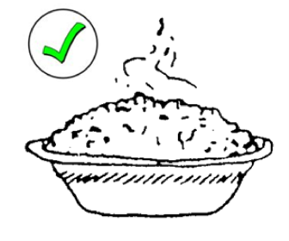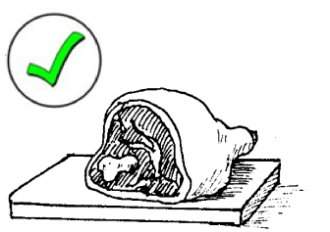

*Handle food in a clean and safe manner! Cook food thoroughly and do not let cooked food touch raw food.*

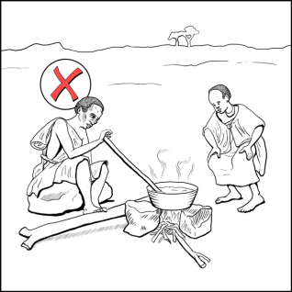

*Do not allow sick people to prepare or handle food eaten by others.*

18

**ACTIVITY: Making a Tippy Tap**



Make a hole in the soap and tin. Hang them on the string with a knot underneath each one.

Tie the container to a stick. Add two more strings: One around the lid and one for the soap.

Make a hole with the hot nail above the sealed handle, and two holes on the back. Thread string through the holes at the back.

Pinch the warm handle with pliers until it seals tight.

Use a clean, plastic five-liter container. Warm up the end of the handle under a flame.

Hang the Tippy Tap near your latrine. Add gravel and rocks below the Tippy Tap.

19

***This page left blank intentionally.***

20

**Lesson Two: What to Do during a Declared Epidemic to Protect Yourself and your Family from Getting Cholera**

**Game: Germ in the Circle**



**Attendance and Troubleshooting**

**Story: Fatima Protects Her Family from Cholera (Picture 2.1)**

When we last visited Fatima, we learned her daughter Afya was very sick and Fatima was worried she might have cholera. In the past few days it became clear from radio messages and community health workers that a cholera outbreak is occurring in Fatima’s village and the surrounding communities. Thankfully, Fatima was able to care for Afya and she is fully healthy now. However, two of her neighbor’s children have severe diarrhea and vomiting. The Care Group Volunteer (CGV) that counsels Fatima came over and complimented her on some of the things that she is already doing to protect her family from cholera like using a latrine and burying her child’s feces, and using safe/clean cooking practices. However, the CGV notices that there are things that Fatima needs to do that she is not yet doing around her house to prevent the spread of cholera to her household, especially treating and storing her drinking water in a narrow-neck container. She offers to share some of her chlorine bleach solution to treat Fatima’s drinking water until Fatima can buy some herself. Fatima gladly accepts her offer and after her CGV left, she first filtered the water using a folded-up clean cloth, pouring the water from one jerry can into another one, and adding ½ teaspoon of chlorine bleach into the second jerry can where the family stores their water. Asad, her son, came over to see what she was doing. After 20 minutes, she poured him water from the jerry can, filling a small cup of water for him.

21

**Fatima Protects Her Family from Cholera (Picture 2.1)**

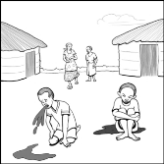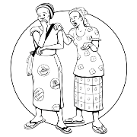

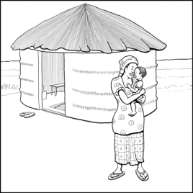

*When we last saw Fatima, we learned her daughter Afya was very sick and that Fatima was worried she might have cholera. In the past few days community health workers made it clear a cholera outbreak is occurring in Fatima’s village and the surrounding communities. Fatima was able to care for Afya and she is fully healthy now.*

*However, two of Fatima’s neighbor’s children have severe diarrhea and vomiting. A Care Group Volunteer visited Fatima and complimented her on how she is protecting her family from cholera by using a latrine, burying her child’s feces, and using safe and clean cooking practices. However, the volunteer also notes there are things Fatima needs to do that she is not yet doing, especially treating and storing her drinking water in a narrow-neck container.*

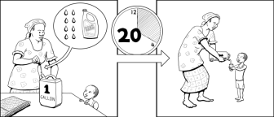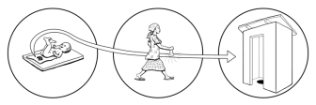

*Fatima is careful to always take her child’s feces to the latrine to dispose of it.*

*Fatima filters her water using a folded-up clean cloth, pouring the water from one jerry can into another one, and adding ½ teaspoons of chlorine bleach into the second jerry can where the family stores their water. After 20 minutes, she pours water from the jerry can for her son, Asad, filling a small cup of water for him.*

22

|  |  |
| --- | --- |
|  | * When was the last time there was someone with cholera in your community? * What are all the things that people can do to protect themselves and their households from cholera and other diarrhea diseases? * What did Fatima’s neighbor offer to do? How is this helpful during a cholera epidemic? |

**Encourage discussion. Don’t correct “wrong answers**.” Let everyone give an opinion.

**How to protect your community during a cholera outbreak (Picture 2.2)**

|  |  |
| --- | --- |
|  | **What do you see in these pictures?** |

**Health officials and others working in the community (e.g., NGOs, CBOs) will identify, isolate, and refer the severe cases of cholera.**

**Community Health Workers (CHWs) and others like Leader Mothers will provide correct, up-to-date information on the cholera outbreak and how to prevent cholera’s spread.**

* Leader Mothers will promote water treatment at home using chlorine products, and teach people other methods if they do not want to use chlorine products or they are not available.

**Avoid non-essential public gatherings during an outbreak, since it is easy for people to come into contact with feces and vomit from sick people when a lot of people are sick with cholera. Feces and vomit easily spread cholera. If you must hold a large public gathering, people should stand further apart and avoid touching.**

**?  *Are there cholera isolation tents in your community? Do you know of anyone in your community who has been treated at one? What are some things you can do to support your neighbor if you know someone from their household is being treated for severe cholera?***

23

**How to protect your community during a cholera outbreak (Picture 2.2)**

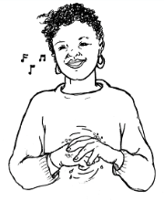

*Community Health Workers (CHWs) and others like Leader Mothers will provide correct, up-to-date information on the cholera outbreak and how to prevent cholera’s spread.*

*Health officials and others working in the community (e.g., NGOs, CBOs) will identify, isolate, and refer the severe case of cholera.*

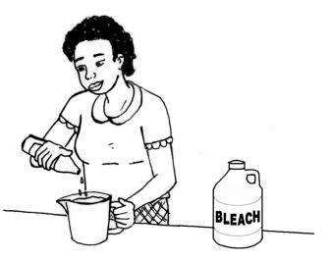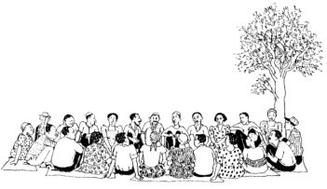

*Avoid non-essential public gatherings during an outbreak, since it is easy for people to come into contact with feces and vomit from sick people when a lot of people are sick with cholera.*

*Leader Mothers will promote treatment at home using chlorine products and teach people other methods if they do not want to use or can’t access chlorine products.*

24

**Making water safe for drinking and cooking (Picture 2.3)**

|  |  |
| --- | --- |
|  | **What do you see in these pictures?** |

**Explain:**

**Settle and use simple filtering of the water first before treating it!**

1. Let water sit in a container until the solids have settled out and the water is clearer.

2. Pour the water through several folds of a clean piece of cloth, or a sand and charcoal filter.

3. After filtering the water, you must treat it using one of the recommended methods below or adding ½ of an iodine tablet per liter of water.

**Treat water by boiling:**

1. Bring water to a rapid boil for at least one minute.

2. Pour water into a clear container to cool before drinking it.

**Disinfect water using 5% chlorine bleach:**

1. For small amounts (one liter), add two drops of household bleach (5% chlorine) to a clean container to kill all germs.

2. For larger amounts (five gallons or 20 liters), add ½ teaspoon of household bleach to a clean container.

3. If a very large container (e.g., a covered barrel) is used to store water, treat the water in a smaller container first, and let it sit for 20 minutes before pouring the treated water into the larger water storage container.

4. Mix the chlorine well with the water and allow it to stand for at least 20 minutes, or preferably overnight before use. Store it in a clean container.

**Using sunlight (Solar Disinfection or SODIS):**

1. Fill a clean plastic bottle half full with water, then shake it for 20 seconds.

2. Then fill the bottle to the top and replace the cap.

3. Place the bottle where it is very sunny (often a roof works well) and where people and animals will leave it alone.

4. Leave the bottle there for at least six hours in full sun or for two days (12 hours) if the weather is cloudy. After that, you can drink it.

**? *Have you purified your water using any of these methods in the past? Which ones? Which method can you do today to keep your family safe from cholera?***

25

**Making water safe for drinking and cooking (Picture 2.3)**



*When drinking water comes from surface water, such as ponds, lakes, and rivers, unsealed wells, or other water that may be contaminated with germs, there are different ways we should treat it to remove germs.*

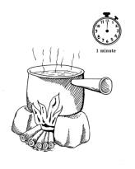

*Settle and use simple filtering of the water first before treating it. Treat water by boiling it.*

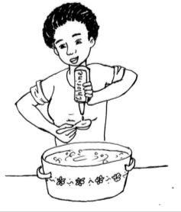

*Disinfect water using 5% chlorine bleach. If a commercial chlorine product is available (e.g. WaterGuard, DioLavi, Pureza, etc.) use one of those products.* ***(see image to the left)***

*Use sunlight to filter your water.* ***(see images below)***

*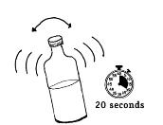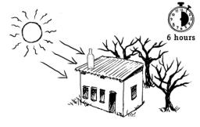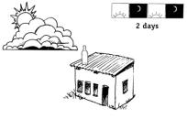*

26

**Proper additional hygiene and sanitation behaviors (Picture 2.4)**

|  |  |
| --- | --- |
|  | **What do you see in these pictures?** |

**Explain:**

* 1. The household member in charge should clean latrines and surfaces contaminated with feces using a solution of 1-part household bleach to 9 parts water at least once every two days.
  + Clean all surfaces touched by flood water with this bleach solution after waters subside.

1. Each household member should always defecate at least 30 paces away from streams, rivers, ponds, or other bodies of water that may be used by others for drinking water, using a latrine or burying your feces.
2. Do not wash people, cooking pots, utensils, diapers or clothes directly in any body of water, especially during a cholera epidemic.
   * Bathe at least 30 paces away from any body of water.
3. Family members who do cooking should always clean food preparation areas with soap and safe water and allow to dry completely after each meal.
4. Every day, family members in charge of water should treat water according to the previous instructions, and use treated water for drinking, washing clothes and hands, and to disinfect buckets/utensils.
5. Cloths used for household cleaning should be washed daily with soap and air dried before reuse.
6. Once dishes have been washed, they should be dried on a dish rack.

**? *Where do you bathe now? Where do you get your water to bathe?***

**? *Who in your household is responsible for cleaning the latrine? What about cooking? Who is in charge of water? Can you share these responsibilities during the cholera epidemic so one person is not responsible for it all?***

27

**Proper additional hygiene and sanitation behaviors (Picture 2.4)**

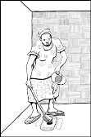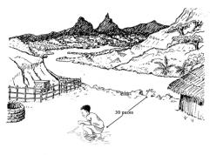



*Each household member should always defecate at least 30 paces away from streams, rivers, ponds, or other bodies of water, using a latrine or burying feces.*

*Clean latrines and surfaces contaminated with feces using a solution of one-part household bleach to nine parts water at least once every two days or more if needed.*

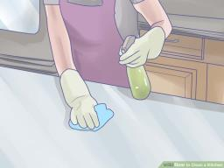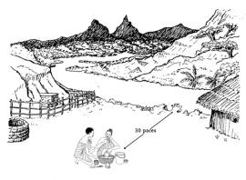

*Family members who do cooking should always clean food preparation areas with soap and safe water and allow to dry completely after each meal.*

*Do not wash people, cooking pots, utensils, diapers, or clothes directly in any body of water. Bathe at least 30 paces away from any body of water.*

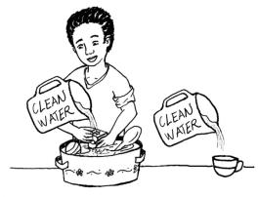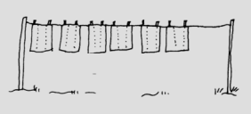

*Cloths used for household cleaning should be washed daily with soap and air dried before reuse.*

*Every day, family members in charge of the water should treat water according to previous instructions, and use treated water for drinking, washing clothes and hands, and to disinfect buckets/utensils.*

28

**Preparing a trench to be used as an emergency pit latrine (Picture 2.5)**

|  |  |
| --- | --- |
|  | **What do you see in these pictures?** |

**Explain:**

**If you do not have a latrine, a simple trench can be dug as a temporary solution for the disposal of human feces.**

* It should measure 0.3 meter across – so users can squat with a leg on each side – have a depth of 0.75 meters, and can be as long as necessary.
* One meter of trench can serve four users.

**Dig the trench at least 30 paces (meters) from a well or other source of drinking water, and at least six meters from the nearest house.**

* It should not be located uphill from the water source or dug in marshy soil.
* The bottom of the trench should never reach the groundwater.

**After each use, a covering of soil should be put over the waste to bury it in the trench.**

* In an area affected by cholera, a layer of lime should also be put in the trench every day.

29

**Preparing a trench to be used as an emergency pit latrine (Picture 2.5)**

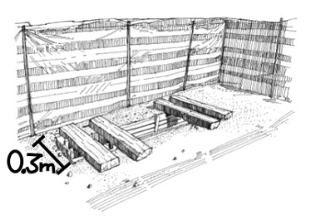

*If you do not have a latrine, a simple trench can be dug as a temporary solution for the disposal of human feces. Dig the trench at least 30 paces from a well or other source of drinking water, and at least six from the nearest house. One meter of trench can serve four users.*

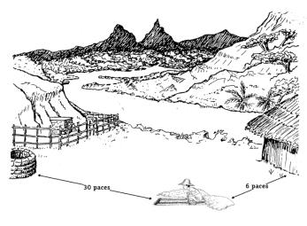

*Dig the trench at least 30 paces from wells or other sources of drinking water, and at least 6 paces from the nearest house. Position the trench downhill from water sources.*



*After each use, a covering of soil or lime should be put over the waste to bury it in the trench.*

30

**Other cholera prevention methods (Picture 2.6)**

|  |  |
| --- | --- |
|  | **What do you see in these pictures?** |

**Explain:**

**If cholera vaccines are offered in your area, be sure to get everyone who is eligible vaccinated with it.**

* The cholera vaccine is safe and requires two doses given two weeks apart, for adults and children over one years old.
* The cholera vaccine is 43-65% effective so it does not completely protect you – you still need to do the other things we are recommending.

**There are some nutrition behaviors that *may* also help prevent cholera such as making foods more acidic by adding lemon, tomatoes, yoghurt, and fermented milk.**

* These may help reduce the growth of cholera bacteria in the food.

**Discourage people from eating out of a shared bowl, plate, leaf, or food container so they avoid sharing germs during a cholera epidemic.**

|  |  |
| --- | --- |
|  | **Activity: Demonstrate water purification using chlorine** |

31

**Other cholera prevention methods (Picture 2.6)**

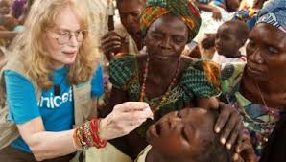

*If cholera vaccines are offered in your area, be sure to get everyone who is eligible vaccinated with it, with the recommended dosing schedule.*

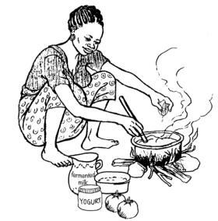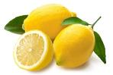

*There are some nutrition behaviors that may also help prevent cholera, such as making foods more acidic by adding lemon, tomatoes, yoghurt, and fermented milk.*

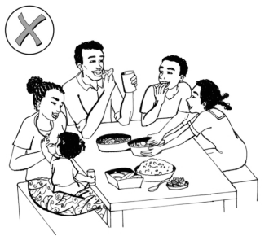 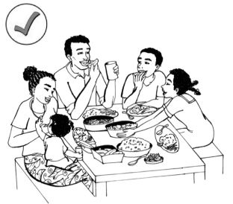

*During a cholera epidemic, discourage people from eating out of a shared bowl, plate, leaf, or food container so they avoid sharing germs.*

32

***This page left blank intentionally.***

33

**Lesson 3: Proper Care Seeking and Management of Cholera**

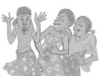



**Attendance and Troubleshooting**

**Game: Memory Game, Danger signs during illness and dehydration**

**Story: Fatima’s son Asad Gets Cholera (Picture 3.1)**

Fatima’s community continues to be affected by the cholera outbreak. Despite learning to purify her water with chlorine and committing to protective practices such as burying her children’s feces, always using and drinking only purified water, and having installed a hand-washing station, her son Asad became sick with cholera. Fatima’s Leader Mother stops by for a visit. In addition to the practices already mentioned, the Leader Mother counsels Fatima to wash her and Asad’s clothes every day in treated water and to leave them to dry in the sun. She also counsels her to clean the latrine daily. Next, she also explains to Fatima how to make and administer ORS. Using 1 liter of treated water, she adds ½ teaspoon of salt and 8 teaspoons of sugar and mixes well. Every time Asad has diarrhea, Fatima gives him at least 1/3 cup of ORS to assure he has the same amount of liquid “going in” as “going out”. On the second day, Fatima and the Leader Mother decide that it is time to take Asad to the health facility. He has stopped urinating but is always thirsty, his skin remains up when pinched, and the diarrhea has continued. Fatima and her husband together take Asad to the nearest health facility. The nurses at the health facility promptly admit Asad and starts giving him IV fluids immediately. He also receives antibiotics to help reduce the duration and severity of the diarrhea. Slowly the signs of dehydration start to lessen and in three days he becomes well enough to be discharged. Fatima and her family are very grateful that they took Asad to the health facility.

34

**Fatima’s son Asad Gets Cholera (Picture 3.1)**

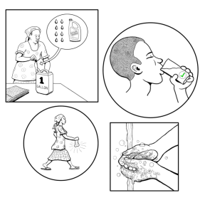 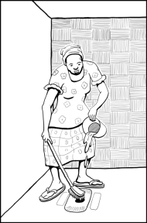

*Fatima’s Leader Mother counsels her to wash her and Asad’s clothes every day (drying them in the sun), to clean the latrine every 1-2 days, and how to use and administer ORS. Every time Asad has diarrhea, Fatima gives him at least 1/3 cups of ORS to assure he has the same amount of liquid going in as going out.*

*Fatima’s community continues to be affected by the cholera outbreak. Despite learning to purify her water with chlorine and committing to protective practices such as burying her children’s feces, always using and drinking purified water only, and having installed a hand-washing station, her son Asad became sick with cholera.*

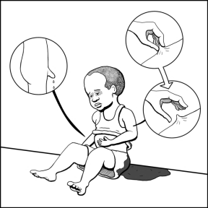

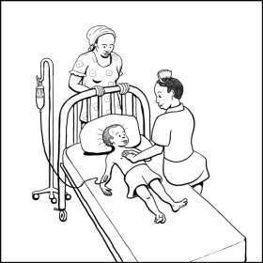

*On the second day, Fatima and the Leader Mother decide that it is time to take Asad to the health facility. He has stopped urinating but is always thirsty, his skin remains up when pinched, and the diarrhea has continued.*

*Fatima and her husband take Asad to the nearest health facility. The nurses at the health facility admit Asad and start giving him IV fluids immediately. He also receives antibiotics to help reduce the duration and severity of the diarrhea. Slowly, the signs of dehydration lessen and in three days he becomes well enough to be discharged.*

35

|  |  |
| --- | --- |
|  | * What protective actions was the Leader Mother doing to help Fatima? * What danger signs did Asad have that made her decide to take him to a health facility? * What do you do when someone in your household is sick with diarrhea? |

**Encourage discussion. Don’t correct “wrong answers**.” Let everyone give an opinion.

**How do you make ORS? (Picture 3.2)**

|  |  |
| --- | --- |
|  | **What do you see in these pictures?** |

**The most important part of treatment of cholera is to give the person enough oral rehydration serum (ORS) that they do not become dehydrated (dried out)!**

* Cholera can usually be simply and successfully treated by immediate replacement of the fluids and minerals lost through diarrhea.

**You should start giving ORS as soon as the person has diarrhea, even if you plan to take the person to a health facility.**

* If ORS sachets are available, put one sachet of ORS in one liter of clean, safe (e.g., treated) water. Stir it well, and taste it before giving to the person. It should be no saltier than tears – if it is, you have not used enough water – add a bit more water and taste it again.
* If you do not have ORS sachets or cannot get them quickly, add to one liter of clean, safe water:
  + ½ teaspoon (3.5 grams) of salt
  + 8 teaspoons (40 grams) of sugar
  + *Mix well with a long teaspoon or another utensil.*
  + *Taste to assure it is no saltier than tears. If it is, add more water and taste again.*
  + *The Leader Mother can show you which teaspoon is a teaspoon.*

36

**How do you make ORS? (Picture 3.2)**

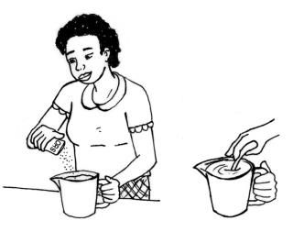 

*The most important part of treatment of cholera is to give the person enough oral rehydration serum (ORS) that they do not become dehydrated! You should start giving oral rehydration solution as soon as the person has diarrhea, even if you plan to take the person to a health facility. There are 2 ways to make it. Always taste it after you have made it – it should not be saltier than tears.*

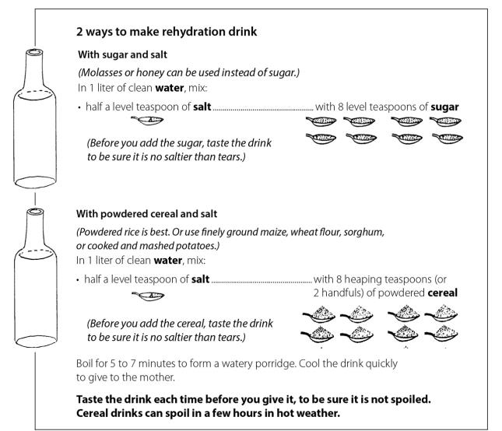

37

**How do you make ORS? (Picture 3.2 continued)**

|  |  |
| --- | --- |
|  | **What do you see in these pictures?** |

**Explain:**

**How do you administer ORS?**

* Give a child with diarrhea sips of the drink every five minutes, day and night, until he/she begins to urinate normally.
* A child who is six months and older should get at least 1/3 to ½ cup every time they have a liquid feces. An older child should get ½ to 1 large cup every time they have a liquid feces. A small child usually needs at least 1 liter of ORS drink a day. Remember: You are replacing the liquids the child is losing through diarrhea.
* Adults need two glasses of ORS after each liquid feces, and usually three or more liters a day. Keep giving the ORS drink to them often and encourage them to drink.
* If a person receiving ORS vomits, wait ten minutes and give the ORS to the person more slowly in small sips or teaspoonfuls.

**Go to a health facility if the person has any danger sign during the illness or signs of dehydration, and give ORS along the way.**

**?  *How familiar are you with ORS? Have you made it before? Can you share an example of when and why?***

38

**How do you make ORS? (Picture 3.2 continued)**

**

*Give a child with diarrhea sips of the drink every five minutes, day and night, until he or she begins to urinate normally.*



**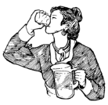

*Adults need two glasses of ORS after each liquid feces, and usually three or more liters a day. Children need ½ cup after every feces.*

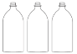 **X**



*If a person drinking ORS vomits, wait ten minutes and then give the ORS more slowly.*

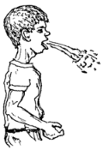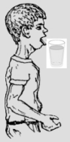

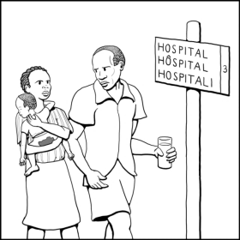

39

*Go to a health facility if the person has any danger sign during illness or signs of dehydration, and give ORS along the way.*

**Fatima shows her neighbor how to continue feeding her child during cholera (Picture 3.3)**

|  |  |
| --- | --- |
|  | **What do you see in these pictures?** |

**Explain:**

**Children can lose weight rapidly and become malnourished during diarrhea. Providing nutritious food helps in early recovery. For children who are six months and older and for adults:**

* Provide frequent small meals with familiar and favorite soft foods and increased breastfeeding during the first two days rather than infrequent large meals.
* Good foods to give include bananas, white rice, local porridge, toast, meat, and fish.
* Avoid giving very high-fiber foods such as beans, lentils, mangos, guava, brown rice, cornmeal, and fruit or vegetable peels during diarrhea.
* Avoid giving food or drinks with a lot of sugar, such as fruit juices or cola, which can increase diarrhea.

**Give lots of liquids to the person to drink such as ORS, thin cereal-based ORS, or water.**

* ORS is much better than water during diarrhea.
* Give other solid and semi-solid food along with these drinks.
* For children 6m and older, give breastmilk before giving any other drinks, and *breastfeed more than usual.*
* For children less than 6 months, only give breastmilk, and breastfeed more often than normal.

**Do not serve food or drinks to visitors when someone in the household has cholera, and do not let the infected person help with cooking or handle others’ food.**

**Remember, if signs of dehydration are seen, take the child to a health facility immediately.**

**?  *Why is it important to breastfeed more than usual when a child has diarrhea? Is this hard for you to do? Why or why not?***

40

**Fatima shows her neighbor how to continue feeding her child during cholera (Picture 3.3)**

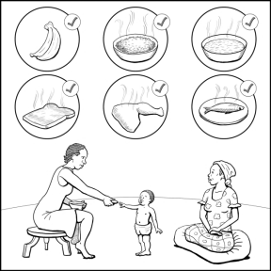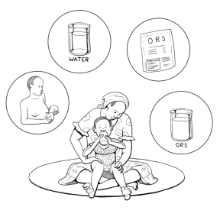

*Give lots of liquids to the person to drink such as ORS, thin cereal-based ORS, or water.*

*Children can lose weight rapidly and become malnourished during diarrhea, including the diarrhea from cholera, so providing nutritious foods helps in early recovery. Give frequent small meals.*

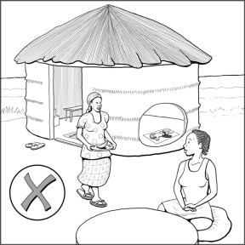 

*Remember, if signs of dehydration are seen, take the child to a health facility immediately.*

*Do not serve food or drinks to visitors when someone in the household has cholera, and do not let the infected person help with cooking or handle others’ foods.*

v

41

**Danger signs (Picture 3.4)**

|  |  |
| --- | --- |
|  | **What do you see in these pictures?** |

**Explain:**

**Review the danger signs during child illness and signs of dehydration taught in the opening game. At the health facility, they may receive IV fluids or other treatment.**

* **fontanel** (soft spot) **is sunken**;
* **having convulsions**;
* **having a high fever**;
* **having eyes that are sunken;**
* **not eating or drinking**, or **baby stops breastfeeding or has decreased breastfeeding**;
* **being very thirsty**;
* **vomiting everything** given;
* **having fast/difficult breathing**
* if the person’s **skin is not elastic**
* if a child **looks unwell or not playing normally**;
* if a person **stops urinating or urinates much less than usual;**
* if **diarrhea lasts more than seven days or more severe diarrhea lasting 3 or more days**; or
* if there is **blood in the diarrhea**.

**Remember, every family should develop a plan for transporting the person to a health facility if they get sick with cholera or another serious illness.**

**?  *Why is it important to take your child to the health facility if you see any of these danger signs?***

**?  *How will you get your family member to the health facility if they are sick? What if you are the sick one, how will you get there?***

42

**Danger signs (Picture 3.4)**



*Sunken fontanel* ***(left)***

*Convulsions* ***(right)***



*High fever* ***(left)***

*Not eating, drinking, or breastfeeding or vomiting everything*

***(right)***



*Skin is not elastic* ***(left)***

*Looks unwell or not playing normally* ***(right)***



*Blood in diarrhea* ***(left)***

*Diarrhea more than seven days or severe diarrhea more than two days* ***(right)***









43

**Caring for a family member who is sick with cholera (Picture 3.5)**

|  |  |
| --- | --- |
|  | **What do you see in these pictures?** |

**Explain:**

1. **If a household member develops frequent, watery diarrhea, give the person oral rehydration solution (ORS) right away.**
2. **Handwashing with soap (or ash) and treated water should be done before and after each time you touch the sick person or have contact with their clothes or bedding.**

* If no water and soap are available, use an alcohol-based hand cleaner, or ash.

1. **Continue to breastfeed a baby if he or she has frequent, watery diarrhea even while traveling for treatment**.

* Breastfeeding should be continued while a child has cholera, as it is protective.

1. **Remove and wash any bedding or clothing that may have had contact with the person’s diarrhea or vomit in warm or hot water.**

* Use the usual detergents that you have.
* Throw out the wash water in a pit that can be covered with dirt or ash.
* Disinfect mattresses that are soiled with diarrhea or vomit by drying well in the sun.

1. **Use a solution of one-part chlorine bleach and nine parts water to clean any surfaces or objects that may have contact with the person’s diarrhea or vomit, including the floor, the person’s bathroom, and bedpan.**

* Do this as soon as possible after being soiled.
* When possible, use rubber gloves when cleaning any room, floor, or surface that may have had contact with the patient’s fecal matter.

44

**Caring for a family member who is sick with cholera (Picture 3.5)**

 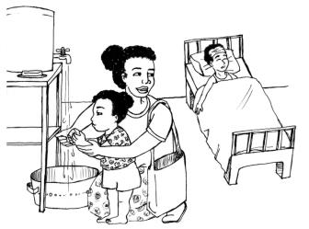

*If a household member develops frequent, watery diarrhea, give the person ORS (oral rehydration solution) right away.*

*Handwashing with soap (or ash) and treated water should be done before and after each time you touch the sick person or have contact with their clothes or bedding.*

 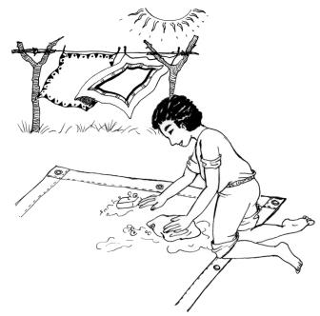

*Remove and wash any bedding or clothing that may have come in contact with the person’s diarrhea or vomit in warm or hot water.*

*Continue to breastfeed a baby if he or she has frequent, watery diarrhea even while traveling for treatment, as it is protective.*

45

**What NOT to do (Picture 3.6)**

|  |  |
| --- | --- |
|  | **What do you see in these pictures?** |

**Explain:**

* A child or adult sick with cholera should not be given any antibiotics or other medication at home unless they are provided by a trained health worker.
* Do not share water from the same drinking cup with a sick person, and do not leave undrunk water in the cup.
* Try to avoid getting the sick person’s feces or vomit on your clothes. If you do, change your clothes promptly.
* Do not ask a child to clean and care for another sick child with diarrhea without observing their hygiene practices to assure they do not get the disease or spread it to someone else. Try to have another adult care for the sick child.

|  |  |
| --- | --- |
|  | **Activity: Dehydration Demonstration** |

46

**What NOT to do (Picture 3.6)**



*A child or adult sick with cholera should not be given any antibiotics or other medication at home unless they are provided by a trained health worker.*

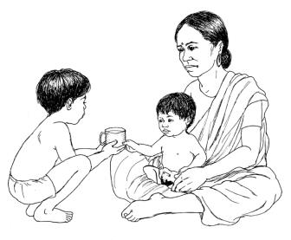

*Do not share water from the same drinking cup with a sick person, and do not leave undrunk water in a cup.*

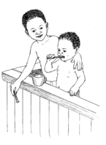

47

*Do not ask a child to clean and care for another sick child with diarrhea without observing their hygiene practices to assure they do not get the disease or spread it to someone else. Try to have another adult care for the sick child.*

***This page left blank intentionally.***

48

**Lesson Four: Dealing with the Aftermath of a Cholera Outbreak**

**Game: Rainstorm**



**Attendance and Troubleshooting**

**Story: Fatima Helps Plan Her Uncle’s Funeral (Picture 4.1)**

Today Fatima and her family members are all healthy. Fatima and her husband continue to follow all the cholera prevention measures as the outbreak is ongoing and it helps them to stay healthier, in general. Yesterday however, Fatima received the news that her uncle who lives in a nearby village, passed away due to cholera. Her family asked her to help plan his funeral. Fatima remembers what her Leader Mother shared with her last week in terms of funerals and large gatherings. She shares with her aunt that it is important for family members to not handle the body if at all possible to prevent the spread of cholera. She convinces her aunt to call the local health authorities to prepare the body for burial and to bury the body. Together they decide that the family will hold a very small memorial service at the grave site, after the authorities bury the body. Fatima’s aunt also shares that her daughter’s friends are not playing with her any more for fear of getting cholera and dying like the uncle just did. Fatima offers to visit her aunt’s village and talk to the parents of her daughter’s friends to share with them that there is no reason to avoid her aunt’s family. Fatima reinforces the importance of prevention measures, like washing your hands with soap and water and only drinking purified water.

49

**Fatima Helps Plan Her Uncle’s Funeral (Picture 4.1)**

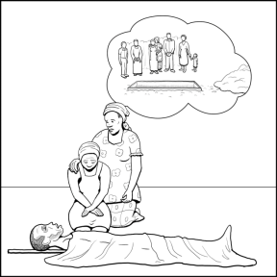 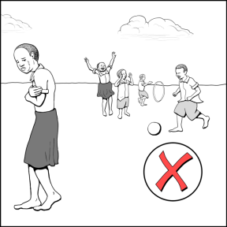

*Fatima’s aunt shares that her daughter’s friends are not playing with for fear of getting cholera and dying. Fatima visits her aunt’s village and talks to the parents of the children to share with them that there is no reason to avoid her aunt’s family. Fatima reinforces the importance of prevention measures, such as washing your hands with soap and water and only drinking purified water.*

*Today Fatima and her family members are all healthy, as they continue to follow all the cholera prevention measures as the outbreak is ongoing. Yesterday, however, Fatima heard that her uncle who lives in a nearby village passed away due to cholera. Her family asked her to help plan his funeral. Fatima remembers what her Leader Mother shared in terms of funerals and large gatherings. She shares with her aunt that it is important for family members to not handle the body if at all possible to prevent the spread of cholera. She convinces her aunt to call the local health authorities to prepare the body for burial and to bury the body. They decide to hold a very small memorial service at the grave site, after the body is buried.*

50

|  |  |
| --- | --- |
|  | * What happened to Fatima’s uncle and Fatima’s niece in the story? * What key information did Fatima share with her aunt about the death and burial of her uncle? * Why were the village children afraid to play with the child of the man who died? How should we treat children who have lost a parent to cholera? |

**Encourage discussion. Don’t correct “wrong answers**.” Let everyone give an opinion.

**Preventing the spread of cholera during patient transport and burials (Picture 4.2)**

|  |  |
| --- | --- |
|  | **What do you see in these pictures?** |

**Explain:**

* When death occurs, and cholera is suspected, health care workers or local officials should be contacted immediately.
* Special care should be taken to prepare the body for burial so others do not get ill with cholera. If possible, family members should not handle the body.
* Bodies should be buried at least 30 paces away from water sources.

**?  *How common is it for you to prepare the body for burial if a family member dies? How do you feel about having a trained official prepare and bury the body? Would you be able to follow this guidance? Why or why not?***

51

**Preventing the spread of cholera during patient transport and burials (Picture 4.2)**

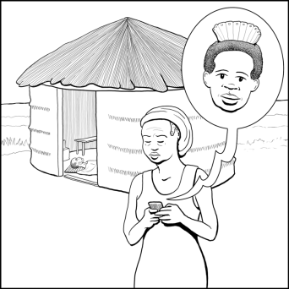

*When death occurs, and cholera is suspected, local officials or health care workers should be contacted immediately.*

*****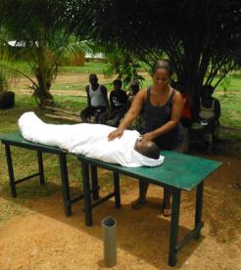*

*Special care should be taken to prepare the body for burial so others do not get ill with cholera. If possible, family members should not handle the body.*

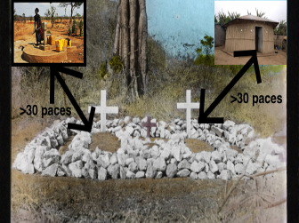

52

*Bodies should be buried at least 30 paces away from houses and water sources.*

**Cholera and stigma (Picture 4.3)**

|  |  |
| --- | --- |
|  | **What do you see in these pictures?** |

**Explain:**

**Avoid stigmatizing people who have recovered from cholera.**

* They can share their experience of having cholera with others (e.g. the importance of drinking ORS and going to the clinic if they cannot stay hydrated). They can explain how ANYONE can get cholera and how it is spread to help prevent further spread in their community.
* It is important for a person to continue to follow good cholera prevention measures even when he or she is declared well. Good cholera prevention measures include washing hands with soap at the five critical times, drinking only clean, safe water, avoiding funerals, etc.

**?  *When and where do you see stigma around cholera in your community?***

**?  *How can you help care for children whose parents have died from cholera and stay safe at the same time?***

53

**Cholera and stigma (Picture 4.3)**

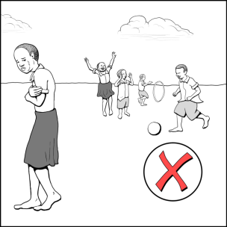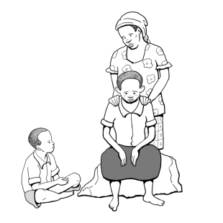

*Avoid stigmatizing people who have recovered from cholera. They can be heroes in their community by helping others who have cholera!*

***Please note: It is always important for a person to continue to follow cholera prevention measures even after declared well.***

54

**Recovering from cholera (Picture 4.4)**

|  |  |
| --- | --- |
|  | **What do you see in these pictures?** |

**Explain:**

**People who have had cholera but no longer have signs and symptoms (e.g., diarrhea) should not bathe in bodies of water (e.g., ponds, rivers, lakes, streams) for at least two weeks after symptoms are gone.**

* Instead they should take bucket baths at home using water that has been purified.

**People recovering from cholera should not swim for two weeks after the disease to avoid transmitting the bacteria in the water.**

**When recovering from cholera, a person needs to eat well to regain any weight loss and to replenish vitamin, calorie, and nutrient loss from having diarrhea. This includes foods that are:**

* A good protein source to help build strong bones and muscles such as fish, meat, eggs, beans, and dairy foods such as cheese, yogurt, and milk if available.
* A good source of vitamins to protect the body such as leafy green vegetables and fruits, such as bananas, papaya, and mango.
* A good source of energy foods like rice and maize and fats such as nuts, avocados, and cooking oil.

**Be sure to continue the safe food practices discussed earlier such as washing all fruits and vegetables with purified water and cooking food thoroughly.**

**?  *What are some foods your family eats each day? Would you be able to incorporate foods from all these groups into your family’s diet?***

55

**Recovering from cholera (Picture 4.4)**



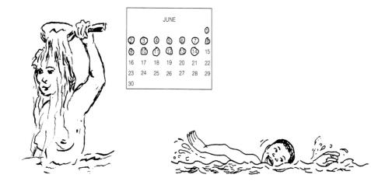

*People who have had cholera but no longer have signs and symptoms should not bathe in bodies of water such as ponds, rivers, or lakes for at least two weeks after symptoms are gone. They should instead take bucket baths at home with purified water. People recovering from cholera should also not swim for two weeks after having the disease to avoid transmitting bacteria into the water.*

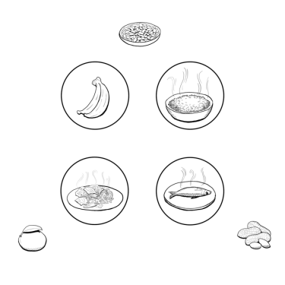

*When recovering from cholera, a person needs to eat well to regain any weight loss and to replenish vitamin, calorie, and nutrient loss from having diarrhea. Be sure to continue the safe food practices discussed earlier such as washing all fruits and vegetables with purified water and cooking food thoroughly.*

56

**Helping children cope when someone they love dies (Picture 4.5)**

|  |  |
| --- | --- |
|  | **What do you see in these pictures?** |

**Explain:**

**Children grieve when someone they love has died.** Here are some ways you can help a young child who is grieving:

* Answer honestly: tell the child the truth about how the parent or relative died. It is not helpful to tell a confusing story.
* Help children to express their feelings and thoughts.
* Allow children to express their sadness.
* Encourage the child to find meaning in their family members’ lives by telling stories about (or drawing pictures about) the good things that their deceased family member did while they were alive.

**Children who have recently lost a parent or both parents need emotional support to help them move through the grieving process.**

* Teachers and religious leaders can be good mentors and be mobilized for psychological support.
* You can help raise community awareness about cholera orphans and encourage your community to love and accept these children.

**Children have physical needs that need to be cared for. Orphaned children are at risk of poor health if no one is there to care for them.**

* Children need good nutrition and medical care to remain healthy (e.g., vaccinations, good nutrition, medical care, sleeping under an insecticide-treated bed net, etc.).
* *What have we learned in previous Care Group lessons about the nutritional needs of children?*
* *What have we learned already about the medical care children need to remain healthy?*

**Children also have social needs. Orphans need to interact with other adults and children.**

57

**Helping children cope when someone they love dies (Picture 4.5)**

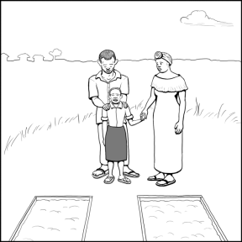

*Children grieve when someone they love has died. Here are some ways to help a young child who is grieving:*

* *Explain things and answer their questions honestly*
* *Help them express their feelings and thoughts*
* *Allow them to express sadness*
* *Encourage them to find meaning in their loved one’s life through telling stories and sharing memories.*

*Children who have recently lost one or both parents need emotional support to help them move through the grieving process. Teachers and religious leaders are good mentors, and the community can be encouraged to love and accept these children.*

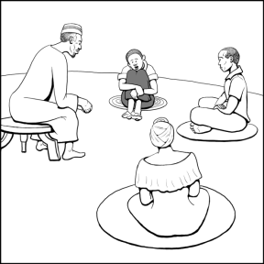

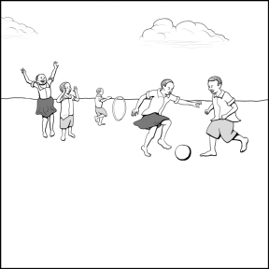

*Children have physical and social needs that must be met. Someone must care for the nutritional and medical needs of orphans, and make sure they interact with other adults and children.*

58

**ACTIVITY: Behavior Review**

*Look at the picture of the community below. What things are missing from each circle? Can you draw lines with your fingers to show how cholera is spread throughout the community?*

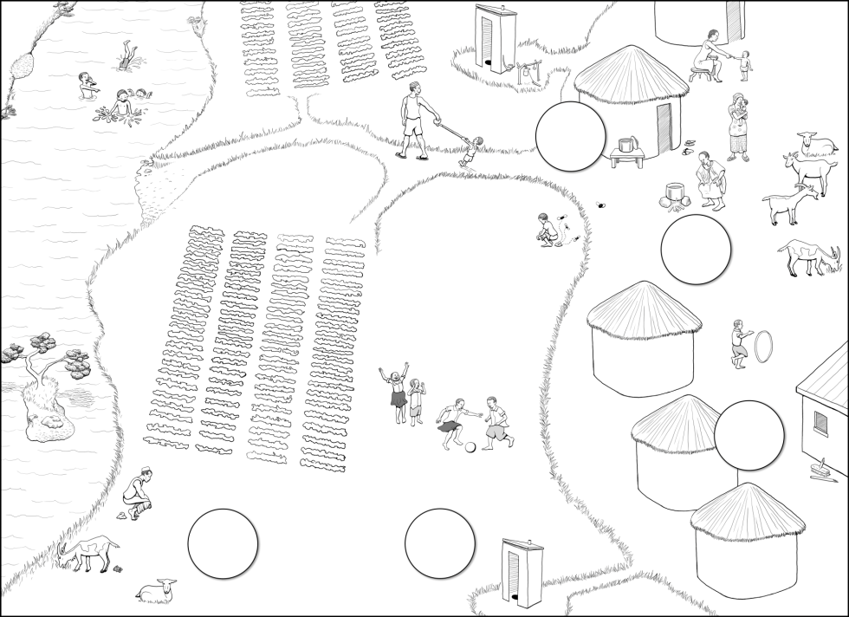

59

1. It may be more appropriate to refer to feces as poo or whatever word is most commonly known and understood by adults in your area.
2. Around 75% have no symptoms, around 29% have mild or moderate (diarrhea which can produce dehydration) and around 5% have severe diarrhea, vomiting and severe dehydration.