CGPP Team Attends the American Public Health Association Annual Meeting

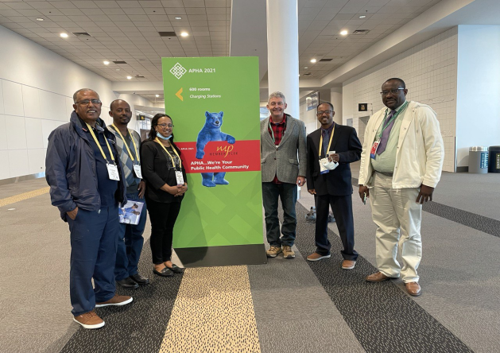
The CGPP team consisting of the global office, and the Ethiopia and Nigeria secretariats have attended the APHA 2021 Annual Conference and Expo held in Denver Colorado from October 24 to 27, 2021.
Group Pictures of the CGPP Team

From the CGPP Global Office, Mr. Lee Losey, Deputy Director has attended the workshop. The Ethiopian Secretariat team who are attended the workshop were: Dr. Filimona Bisrat (presented an oral paper entitled “the assessment of health workers and caregivers interaction during child vaccination sessions at health facilities in Ethiopia”, Mr. Legesse Kidanne (presented one paper on “curbing circulating vaccine-derived poliovirus type2 (cVDPV2) outbreak in Ethiopia”, Dr. Muluken Asress (presented a paper “knowledge, perception and factors affecting health care service provider s for reporting adverse events following immunization in pastoral zone of Ethiopia” and Mrs. Bethelehem Asegedew presented documentary film entitled “Towards polio-free country: reaching the unreached communities in Ethiopia”. From Nigeria, Dr. Samuel Usman has attended and the workshop and presented two oral papers entitled “improving access to oral polio vaccine amongst internally displaced persons in conflict affect areas of northeast Nigeria” and “enhancing the role of civil society organizations in addressing emerging infectious diseases through community-based structures”.
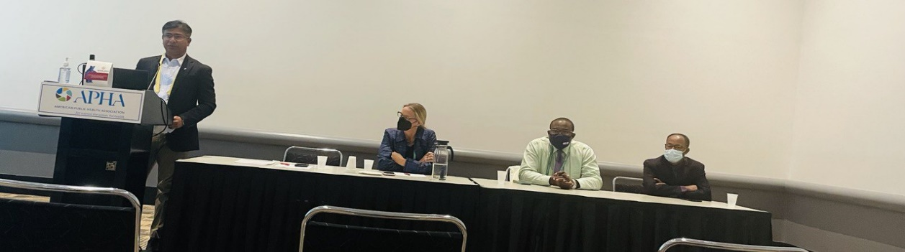
From right to left: Mr. Legesse and Dr. Usaman presenting their papers

The Annual APHA Meeting is the largest gathering of public health professionals in the world bringing together thousands of people. More than 900 sessions featuring over 4,000 scientific papers and thousands of oral presentations are presented during the meeting. APHA champions the health of all people and all communities. This gathering is intended to strengthen the profession of public health, share the latest research and information, promote best practices and advocate for public health issues and policies grounded in research.

