**Core Group Polio Project Report on**

**CROSS BORDER COLLABORATION MEETING ON POLIO ERADICATION**

**INITIATIVE, EBOLA PREPAREDNESS, MITIGATION AND RESPONSE**

**BETWEEN UGANDA–SOUTH SUDAN & DEMOCRATIC REPUBLIC OF CONGO**

**HELD IN DESERT BREEZE HOTEL ARUA UGANDA**

**FROM 25-26 SEPTEMBER 2018**

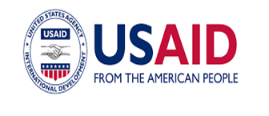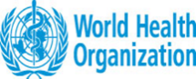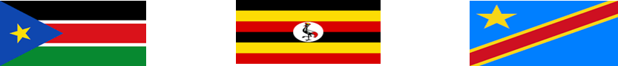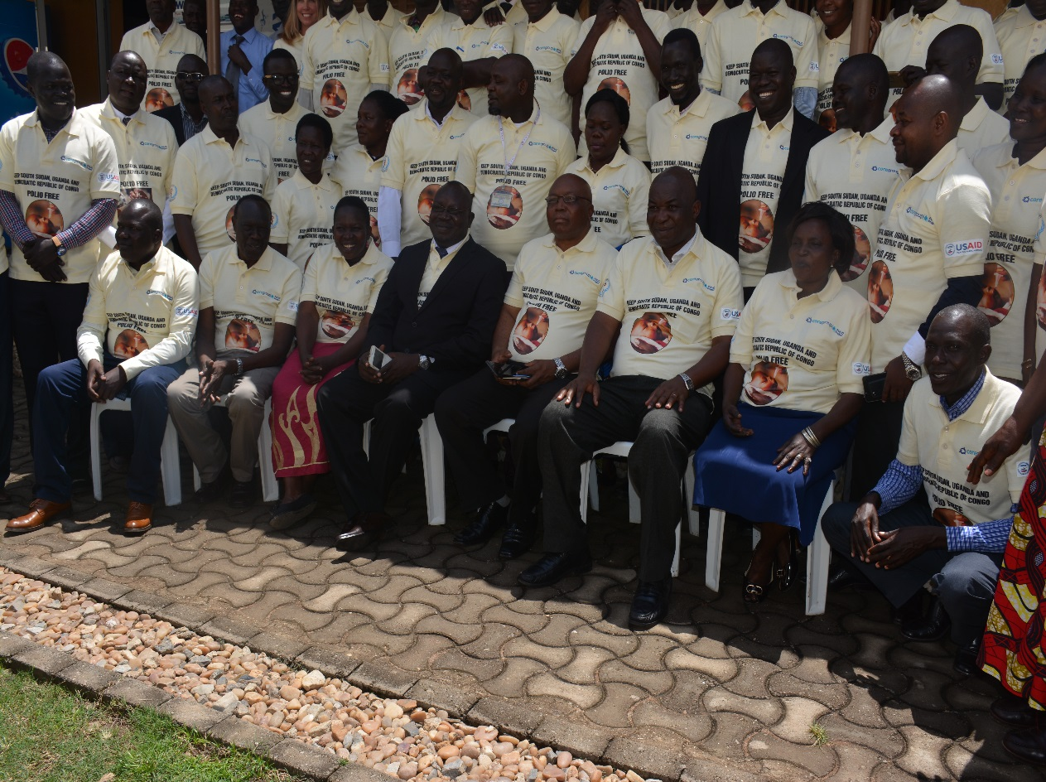

**Group Photo of meeting participants.**

**Enhancing cooperation between Uganda, South Sudan & the Democratic Republic of Congo to strengthen cross border disease surveillance, outbreak preparedness, mitigation, and response.**

Table of Contents

[1.0: INTRODUCTION 3](#_Toc528855998)

[1.1: Background to the cross border meeting 3](#_Toc528855999)

[1.2: Why the cross border meeting in Arua Uganda 3](#_Toc528856000)

[1.3: Objectives: 4](#_Toc528856001)

[1.3: Methodology: 4](#_Toc528856002)

[1.4: Meeting participants: 4](#_Toc528856003)

[1.5: Key Note Speakers: 5](#_Toc528856004)

[2.0: POLIO ERADICATION INITIATIVE 7](#_Toc528856005)

[2.1: Update on Previous Cross border Meetings: 7](#_Toc528856006)

[2.2: Global and regional update on polio eradication: 8](#_Toc528856007)

[Risk and challenges in the region 9](#_Toc528856008)

[2.3: Update on polio eradication in DRC 9](#_Toc528856009)

[Risks and challenges 10](#_Toc528856010)

[Immunization response plan for DR Congo 10](#_Toc528856011)

[2.4: Update on polio eradication in Uganda 10](#_Toc528856012)

[Risks and challenges to Polio Eradication in Uganda 12](#_Toc528856013)

[Immunization Response plan for Uganda 12](#_Toc528856014)

[2.5: Update on polio eradication in South Sudan 12](#_Toc528856015)

[Surveillance Performance, current risks and responses 13](#_Toc528856016)

[Risk and challenges to polio Eradication in South Sudan 14](#_Toc528856017)

[3.0: DRC EBOLA VIRUS DISEASE OUTBREAK AND RESPONSE 16](#_Toc528856018)

[3.1: Update on Ebola Virus Disease (EVD) Outbreak in DR Congo. 16](#_Toc528856019)

[3.2: Update on South Sudan EVD preparedness and response 18](#_Toc528856020)

[3.3: Update on Uganda EVD preparedness and response 20](#_Toc528856021)

[**3.3.1: Updates on EVD preparedness and response at the border District on Koboko** 23](#_Toc528856022)

[4.0: AGREED ACTION PLANS FOR POLIO ERADICATION, EVD PREPARENSS AND RESPONSE: 24](#_Toc528856023)

[5.0: RESOLUTIONS 24](#_Toc528856024)

[6.0: ANNEXES 29](#_Toc528856025)

[Annex 1: ACTION POINTS FROM PLENARY GROUP DISCUSSIONS 29](#_Toc528856026)

[Annex 11: Cross Border Participants list 32](#_Toc528856027)

[Annex 111: Cross Border Collaboration Meeting Agenda 34](#_Toc528856028)

1.0: INTRODUCTION

This report documents activities of the Cross-Border collaboration meeting involving the three countries of South Sudan, Uganda and DR Congo that was held in Arua Uganda from 25th -26th September 2018 at Desert Breeze Hotel. It highlights key discussions and action points from previous cross border meetings, updates on polio eradication initiative in the three countries, updates on the ongoing cVDPV and EVD in DR Congo, preparedness and response plans put in place. The last part of the reports documents key resolutions made and action points agreed during the meeting.

# 1.1: **Background to the cross-border meeting**

Core Group Polio Project South Sudan has organized 15 Regional Cross Border Collaboration Meetings on Polio Eradication Initiative since August 2012 with Ethiopia, Kenya, Uganda, and DR Congo. The aim of these meetings was contributed towards information sharing, joint cross border disease surveillance, epidemic preparedness and response and follow up of plans and strategies to effectively mitigate risks of polio outbreaks. In addition to discussions on polio eradication initiative and the recent cVDP outbreak in Ituri province (DRC), this main meeting incorporated Ebola Outbreak Preparedness, mitigation and Response.

## 1.2: Why the cross-border meeting in Arua Uganda

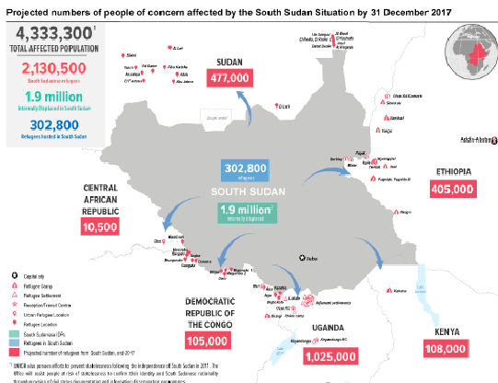Whereas South Sudan reported the last case of wild poliovirus in 2009, the country remains at risk of a polio outbreak. The five years of protracted conflict in South Sudan and the ongoing conflict in DR Congo created inaccessible zones, sub-optimal disease surveillance systems, and low immunization coverage. There is widespread displacement of communities and health personnel, destruction of health infrastructures including cold chain installations. The conflict and porous international borders resulted in large population movements hence increasing the risk of polio and importation of other diseases to the country. According to the UN refugee agency (UNHCR), 2.4 million of the estimated 12.0 million South Sudanese now live as refugees in the neighboring Countries and another 2.18 million people are internally displaced by the five years conflict. Renewed violence, compounded by the threat of famine continue to increase the exodus mostly to Uganda, Sudan, Ethiopia, Kenya, DR Congo, and the Central African Republic. This movement poses a threat to cross border transmission of Polio and other diseases including EVD because diseases know no border.

It is against this background that the **Core Group Polio Project South Sudan** organized a two days cross border collaboration meeting in response to the ongoing cVDPV and EVD outbreaks in the DRC to enhance preparedness, mitigation and response mechanisms among the sister countries of South Sudan, Uganda and the Democratic Republic of Congo.

## 1.3: Objectives:

The goal of the cross-border collaboration meeting is to improve cooperation between Uganda, South Sudan & Democratic Republic of Congo to strengthen cross border disease surveillance, disease outbreak preparedness, mitigation, and response.

Specifically, this meeting aims to;

1. *Improve information sharing on the ongoing outbreaks of cVDPV and EVD in the Ituri Province of DR Congo;*
2. *To strengthen collaboration & coordination in response to the current VDPV2 and EVD outbreaks.*
3. *To reinforce cross border surveillance in border districts and counties of South Sudan, Uganda and DR. Congo*
4. *To develop joint response plans for South Sudan, Uganda and DR Congo on Polio eradication initiative, Ebola outbreak preparedness and response.*

## 1.3: Methodology:

The meeting took two days (25th- 26th September 2018). The meeting dedicated a day for deliberations on updates on Polio Eradication initiative and the next day discussions were focused on the ongoing EVD in DRC, preparedness and response plans. ***See details in the annex (iii***).

Presentations were drawn from MoH representatives at various levels (National, State and county/ district) and WHO country offices, and HoA Coordination Office in Nairobi. The meeting was designed to be interactive. Time was allocated for plenary discussions after each presentation and informal interaction. The discussions focused on relevant benchmarks, indicators, and examples of best practice drawn from the various presentations and overseen by a moderator. At the end of the two days, participants were grouped into three, based on the countries they represent to develop agreed action points. The group work focused six thematic areas; (i) Cross-border coordination & collaboration (ii) Polio SIAs (iii) Social Mobilization (iv) Routine Immunization (v) Monitoring &Evaluation and (vi). Cross-cutting issues on Polio eradication and EVD Action Plans. The country-specific action plans were presented by respective Rapporteurs and amalgamated to a joint action plan. See annex 1.

## 1.4: Meeting participants:

The Arua Cross border collaboration meeting brought participants from the three countries of Uganda, DR Congo and South Sudan. The participants include Ministries of Health representatives, WHO, UNICEF representatives from all the three countries, District and County Health Directors, Surveillance focal persons from the districts/ counties, Immigration officers, district/county administrators. The meeting also brought Non-Governmental Organizations (NGOs) implementing partners in the border districts/ counties and refugee hosting districts of Uganda, DRC, and South Sudan. They include the American Refugee Committee (ARC), Action Africa Help International (AAH-I), Medical Teams International (MTI), Infectious Disease Institute (IDI), UNHCR and Malteser International. In participation were also Dr. Chris Kamugisha and Tracci Garner who represented WHO Horn of African Region (-WHO-HoA) and Geneva (WHO-HQ) respectively.

**Table1: Participants by countries and agencies**

|  |  |  |  |  |
| --- | --- | --- | --- | --- |
| **Country/ Regional office.** | **Type of Agency** | **# of Participants** | **# of Districts/ NGO/ Counties** | **Names of Agency/ NGO** |
| South Sudan | Gov't | 17 | 5 | MoH, SMoH, CHD |
| NGO Rep. | 11 | 5 | WHO, UNICEF. Core Group, ARC, AAHI-SS |
| Democratic Republic of Congo (DRC) | Gov't | 11 | 3 | Regional Gov’t and District Government |
| NGO Rep. | 8 | 4 | WHO, Malteser international, Pro-Aruterr, PNHP-DRC |
| Uganda | Gov't | 29 | 11 | District Local Government (DLG) |
| NGO Rep. | 5 | 5 | IDI, UNHCR, MTI, WHO |
| Regional offices | WHO | 2 | 1 | WHO-HQ/ WHO-HoA region |
| **Total Number of Participants** | | **83** |  |  |

South Sudan participants were drawn from the five (5) border counties Yei, Lainya, Morobo, Kajo-Keji and Magwi bordering Uganda and DR Congo. The delegation was led by Hon. Kogo Manasseh Levi, the State Minister of Health and Environment for Yei River State in South Sudan.

The Arua District Resident Commissioner (RDC), represented by the Arua District Internal Security Officer (DISO); Mr. Dravu Stephen led the Ugandan participants. A total of eight districts which border South Sudan and DRC and are the main host of the South Sudanese refugees in Uganda participated in the meeting. These include Arua, Koboko, Yumbe, Maracha, Moyo, Adjumani, Amuru and Lamwo districts.

The principle Administrator of the Ituri Region of DRC, Mr. Henry Venant led the delegates which consisted of representatives from the three (3) border and refugees hosting districts and NGO in the districts of Aru, Mahagi, and Adi.

## 1.5: Key Note Speakers:

The keynote speakers during the cross-border meeting were the RDC-Arua district, The Provincial Administrator for the Ituri Region in DRC and the Hon State Minister of Health and Environment of Yei River State, Republic of South Sudan. There were also remarks from the representative of Ministry of Health -Uganda, WHO-Uganda, WHO-South Sudan, WHO-DRC and WHO-HQ and HoA Coordination office.

**The RDC Arua**, represented by the Arua District DISO Mr. Dravu Stephen officially opened the meeting. He welcomed all the delegates and described the meeting as a critical tool in the effort to fight Polio and Ebola Virus Disease (EVD) in the three countries. He noted that previous cross border meetings in Arua centered on political and socio-economic spheres which affect the peoples of the 3 sister countries, who share close links and relationships. According to him, the war in South Sudan and Ebola in DRC affect Uganda as well and recalled that during the turbulent times in Uganda, many Ugandans took refuge in the DRC and South Sudan. He urged delegates to explore self-sustaining strategies in order to avoid over-dependence on others, “the rich also cry”; he said; The RDC described Ebola as a big animal which should be fought with a firearm. The firearm he said is technical persons who should present well on how to prevent, treat and manage Ebola and other diseases including Malaria and Polio. He challenged the health experts to make preventable diseases such as Ebola, among others; history.

**The State Minister of Health and Environment-Yei River State,** Hon Kogo Manasseh Levi appreciated the warm reception in Arua. He thanked the Governments of Uganda and DRC for the hospitality in hosting the South Sudanese refugees which he described as a reciprocal role being played by the South Sudan Government in hosting a vast number of refugees from the DRC. The Minister noted that common characteristics of the peoples along the borders of the three countries require a common and integrated approach to diseases prevention. He wondered how long the region will continue bearing the brand of preventable diseases such as Polio and EVD among others.

The Minister pointed out that adoption of preventive approaches is the best option of reducing the burdens of the disease in the region now and in the future. He challenged the respective governments to invest more resources in preventive health than treatments for instances in the case of Polio and Ebola Virus Diseases. He noted that investing in health intelligence by governments stimulates early warning and outbreak detection; “Own this noble activity of cross border collaboration and commit resources” he told the 3 governments of South Sudan, DRC, and Uganda. According to him Cross Border collaboration has for long been solely sponsored by **Core Group Polio Project South Sudan,** which shouldn’t be the case. He concluded that “for a healthy and productive population, time for action is now, not tomorrow, next week, next month or year”.

**The Provincial Administrator of Itur region Mr. Henry Venant headed the DRC delegation.** He appreciated the Organizers of the meeting; which he described as timely and purposeful, assuring that politicians are committed to Polio eradication initiatives and Ebola outbreak preparedness and response. He reported that the Ituri Region already formed a multi-sectoral committee in response to the Ebola outbreaks comprising of the experts from WHO, Government, Non-Governmental Organizations and partners among others and encouraged the villages, communities and districts along the border to form Ebola outbreak and response committees so as to act swiftly, in a coordinated manner in reporting any suspected and or confirmed cases of Ebola in their areas of operations. He, however, cautioned delegates not to ignore simple preventive measures like consistent and right use of Hand rub gel and hand washing in the prevention of Ebola Virus disease.

Whereas the Ituri Region administrator supported screening at the border points; he warned against labeling every Congolese crossing the borders as Ebola vectors. This he described as unfriendly.

He challenged the delegates to develop clear resolutions during the meeting and urged the meeting organizers to share the resolutions with the countries for better action and follow-ups.

**Dr. Kamugisha WHO –Horn of Africa** spoke on behalf of all WHO offices present during the meeting. He appreciated the organizers and delegates to the meeting and commended the effort of the 3 sister countries in meeting the milestone of the polio eradication initiative, Ebola outbreak preparedness and response.

The senior WHO official recognized the resource constraints in the countries but urged the leaders to be creative to ensure efficient and effective use of the limited resources at hand. He stressed the need for collaboration especially in tackling the health needs of the nomadic and mobile population moving in and out of South Sudan, DRC and Uganda. He requested delegates to come up with implementable resolutions in this meeting and identify learning points from the previous meetings.

# 2.0: POLIO ERADICATION INITIATIVE PRESENTATIONS: the first day of the cross border meeting in Arua, Uganda concentrated on the highlights and updates on polio eradication initiative and among the issues discussed include the following;

## 2.1: Update on Previous Cross border Meetings:

Previous cross border meetings organized by Core Group on Polio Eradication recommended the following agreed on actions points;

**Summary of Action points from Previous Cross Border meetings**

1. Appointment of cross border focal points and formation of cross border health committees
2. Setting up of vaccination border posts to interrupt cross border transmission and deploy extra vaccination teams along with busy entry & exit routes during polio SIAs.
3. Conduct social mapping along the borders and establish outreach posts in hard to reach areas.
4. Synchronization of Polio SIAs whenever it is possible and feasible.
5. Holding of follow up cross border meetings too ensure action points are implemented and acted upon.
6. Lobbying for funds to support cross border initiatives.

**Achievements from previous cross border meetings:**

1. Appointments of cross border focal persons and committees along with the bordering districts/counties of South Sudan, Uganda and DR Congo.
2. Mapped cross border points, health facilities, communities, cold chain capacity, and human resource.
3. Over 14 follow up cross border collaboration meetings conducted with neighboring countries.
4. Cross border special vaccination post set up during the 2013-2014 Horn of Africa polio outbreak along the borders of DRC, Uganda, Ethiopia, and Kenya.
5. A total of 119,053 children 0-15 years vaccinated with oral polio vaccines as part of the cross-border initiative during the 2013-2014 polio outbreak in South Sudan.
6. Donors, the regional stakeholders, and the local governments sensitized on the importance of localized cross border initiative and its relevance to cross border disease surveillance.

**Table 2: Summary of Cross Border Meetings held since 2012**

|  |  |  |  |  |
| --- | --- | --- | --- | --- |
| **S/N** | **Venue** | **Countries involved** | **Date of meeting** | **# of participants** |
| 1 | Gambela-Ethiopia | South Sudan & Ethiopia | 30/8/2012 | 86 |
| 2 | Kajo-Keji-S.Sudan | South Sudan & Uganda | 2/7/2013 | 77 |
| 3 | Kaya-S.Sudan | DRC, Uganda & S.Sudan | 11/7/2013 | 78 |
| 4 | Kapoeta-S.Sudan | South Sudan & Kenya | 7/8/2013 | 51 |
| 5 | Nimule\_S.Sudan | Uganda & S.Sudan | 17/7/2013 | 61 |
| 6 | Kisumu-Kenya | S.Sudan, Kenya & Uganda | 9/10/2013 | 160 |
| 7 | Kajo-Keji-S.Sudan | S.Sudan & Uganda | 7/7/2014 | 54 |
| 8 | Loki-Kenya | Kenya & S.Sudan | 5/8/2014 | 51 |
| 9 | Nimule-S.Sudan | Uganda & S.Sudan | 15/7/2014 | 39 |
| 10 | Kaya-S.Sudan | DRC, Uganda & S.Sudan | 24/6/2014 | 75 |
| 11 | Loki-Kenya | Uganda, Kenya & S.Sudan | 22/10/2014 | 62 |
| 12 | Arua-Uganda | Uganda, DRC & S.Sudan | 30/7/2015 | 43 |
| 13 | Kaya-S.Sudan | Uganda, DRC & S.Sudan | 27/5/2016 | 21 |
| 14 | Arua-Uganda | Uganda, DRC & S.Sudan | 16/12/2016 | 53 |

**Major challenges to cross border initiatives**

1. Protracted conflict in South Sudan increased insecurity along with the border districts/counties.
2. Inadequate funding for cross border activities
3. Inadequate understanding of the concept of cross border initiative and its relevance in disease surveillance and outbreak response.

## 2.2: **Global and regional update on polio eradication:**

Dr. Kamugisha made a presentation on the global and regional update on polio eradication. In His presentation, the Afro region was at the brink of Polio eradication until 35 cases of circulating vaccine-derived poliovirus type 2 – cVDPV2 were reported by, Nigeria, Somalia and DR Congo in July 27th, July 30th, August 5th, 2018 respectively and 5 cases of cVDPV3  were reported in May 23rd, 2018 in Somalia. Pakistan and Afghanistan on the other hand, reported 7 and 21 cases of wild poliovirus type1 (WPV1) on August 1 and 11, 2018; respectively.

**Table 3: Global Polio cases update: 19 Sep. 2017 – 18 Sep. 2018****Excludes viruses detected from environmental surveillance**  **Source: WHO**

A total of 57 confirmed human (28 cases) and environmental (29 isolates) of cVDPVs were reported in the Afro region between Week 1 to 36 of 2018. Cases of cVPDV were reported in DRC (15 cases), Nigeria (11 cases) and Niger (1 case). A total of 28 environmental isolates of cVDPV were reported in Nigeria alone with the additional case reported in Kenya. Seven (7) new cVDPV2 cases were reported in July and August 2018, in DRC (2 cases) and Nigeria (5 cases). All the cases reported in DRC were from Yamaluka and Bumba districts of Mongala Province DRC.

**Table 4: cVDPV update in the Afro Region 2017-2018**

|  |  |  |  |  |  |  |  |  |
| --- | --- | --- | --- | --- | --- | --- | --- | --- |
| **cVDPV cases and isolates 2017-2018** | | | | | | | | |
| **2017 cVDPVs by Country: Week 1-36** | | | |  | **2018 cVDPVs by Country: Week 1-36** | | | |
| **Country** | **Human** | **Environment** | **Total** |  | **County** | **Human** | **Environment** | **Total** |
| **DRC** | 9 | 0 | 9 |  | **DRC** | 15 | 0 | 15 |
| **Kenya** | 0 | 0 | 0 |  | **Kenya** | 0 | 1 | 1 |
| **Nigeria** | 0 | 0 | 0 |  | **Nigeria** | 11 | 28 | 39 |
| **Niger** | 0 | 0 | 0 |  | **Niger** | 2 | 0 | 2 |
| **Total AFR** | **9** | **0** | **9** |  | **Total AFR** | **28** | **29** | **57** |

**Fig: 1: SL2 Isolates from Human & Environment AFR 2016-2018**

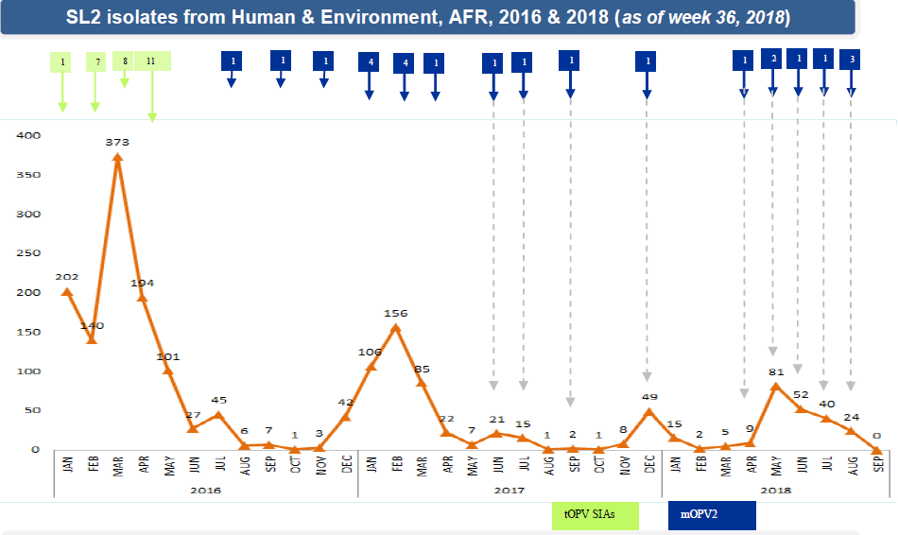

## Risk and challenges in the region

The WHO representative pointed out the following risks and challenges facing the polio eradication initiative in the region;

1. Insecurity in the region leading to; Significantly large inaccessible areas in priority countries, Populations on the move under a humanitarian emergency and conflict.
2. Surveillance gaps because of limited movement to conduct an active search
3. Quality of implemented immunization services in partially accessible areas – lack of supervision
4. Suboptimal routine immunization in most countries in the Horn of Africa
5. High turnover of staff in high-risk areas – Kenya, Ethiopia, Somalia, and South Sudan
6. Suboptimal cross border activities (Enhanced surveillance and increase population immunity)

## 2.3: Update on polio eradication in DRC

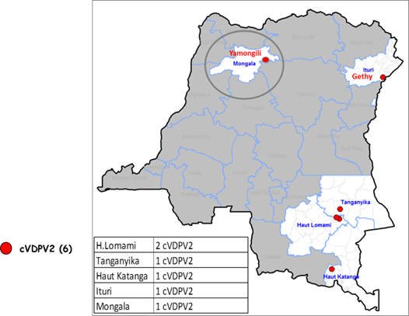DRC is a vast country. just with the Ituri region, South Sudan shares approximately 1,393 km and 628 km with Uganda. The Ituri Region alone has 36 districts. In Adi District, for example, 36,409 of the 177,306-district population are South Sudanese Refugees. The 10 entry and exit points at the border with South Sudan and Uganda make it easy for the refugees to move in and out of the district. Some areas, the refugees outnumbered the local people. This has impacted on the resources. In addition, the active movement of people across the borders increase the risk of cross border transmission of polio and other vaccine-preventable diseases.

In 2002 DRC was declared Polio free. However, on May 8, 2017, a case of circulating Vaccine-Derived Poliovirus type 2 (cVDPV2) was detected in the DRC Ituri Region, approximately 765 km from the Ugandan border.

As of September 16, 2018, DRC has reported 27 cases of confirmed cVDPV2. There is, therefore, need for strong cross border surveillance system within the region.

The cVDPV2 outbreak in DRC is not localized to the borderline. It is widespread in the DRC.

## Risks and challenges

* Insecurity in the larger part of Ituri region making a large population eligible for immunization inaccessible.
* Multiple uncontrolled border crossing points in the vast international borders of DR Congo with South Sudan and Uganda
* High dropout rate especially among the refugee population due to the constant movement of the refugees across the border.

## Immunization response plan for DR Congo

1. Highlighted inventory of all the entries and exits points at the border lines to enable screening at each border post.
2. Intensify community-based surveillance system and electronic surveillance system-ODK.
3. Strengthen the cold chain at the border areas to above the 78% national coverage with the help of partners such as WHO, UNICEF, Malteser. Through this, immunization coverage at the border has greatly improved including in areas occupied by a refugee.
4. Establishment of surveillance focal points at the village level, printing and distribution of IEC Materials intensifying outreaches vaccinations especially in the priority areas;
5. Proposed the need for regular cross border meetings and reactivation google group - e-mail platforms for information sharing.

## 2.4: Update on polio eradication in Uganda

Uganda has a well-coordinated immunization and surveillance system. The country has a regional supervisor and district surveillance focal persons for each of its 122 districts and 14 regions through which the Ministry of Health and UNEPI are linked to the health facilities.

**Fig: 2: Organization of surveillance in Uganda**

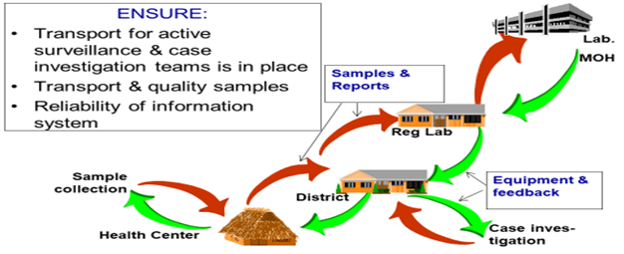

In 2017, EPI performance for all vaccine antigens was above 70%. Polio Supplementary Immunization Activities (SIAs) was implemented in September 2017 targeting 73 High-Risk Districts. These include the 11 refugee hosting districts, Kampala, districts bordering South Sudan and DRC and district with suboptimal surveillance and RI performance. The campaigned achieved 117% (6,376,386) of the 5,508,801 target children 0-59 months old. Independent Monitoring data indicated 90% by Finger marking, 93% by history; 47% of Districts achieved >95% coverage. Awareness stood at 83%.

**Fig 3: Trend of Immunization performance in Uganda 2000-2017**

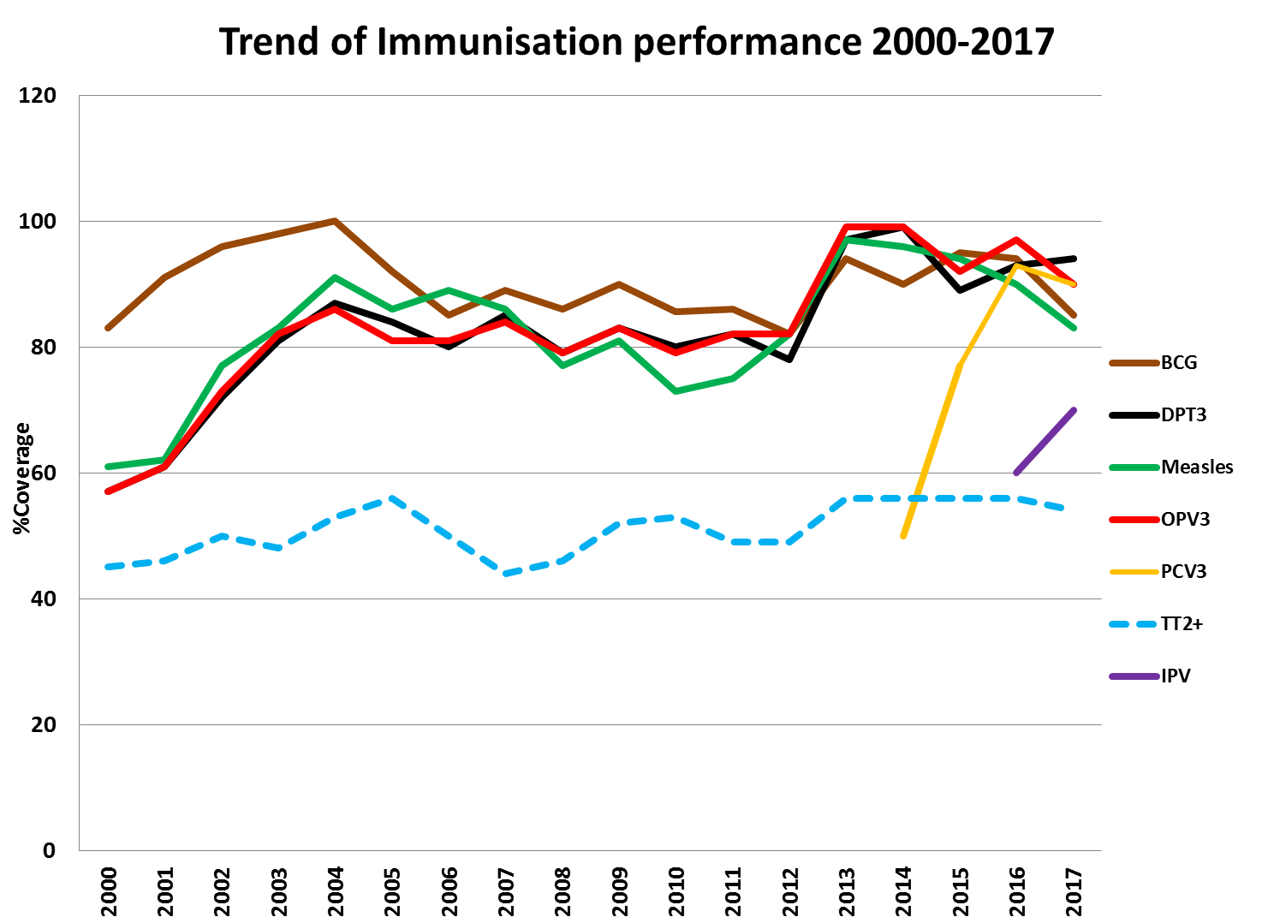

The sensitivity of AFP surveillance is not good enough to detect polio cases. Environmental surveillance is only done in Entebbe and Kampala to supplement surveillance. Plans are however underway to extend to other districts, especially those hosting refugees. There also exist gaps in both non-polio AFP rate and stool adequacy rate at the subnational level. In the last three years, polio compatibles cases were reported in Jinja (1 case) and Kyegegwa (1 case) in 2016 and in Arua (1 case) in 2018 with no clustering.

**NP AFP rate Sept- 2018 Stool Adequacy Sept-2018 Environmental surveillance sites**

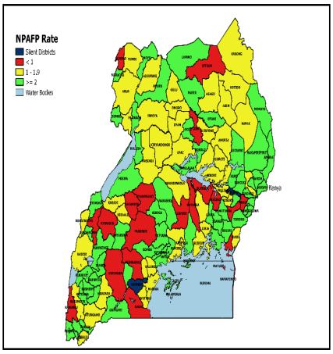 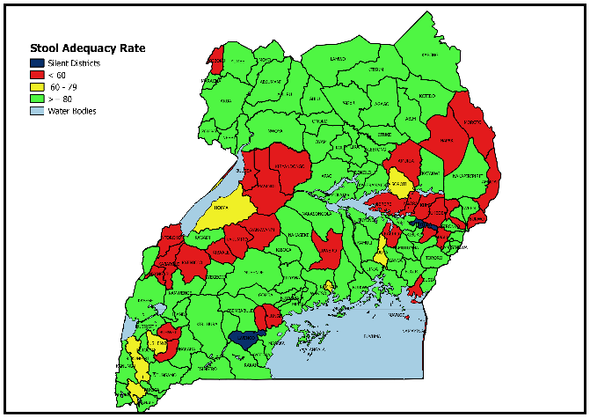 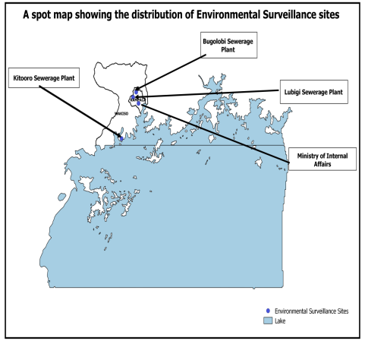

|  |  |  |  |  |
| --- | --- | --- | --- | --- |
| **Table 5: Moyo District Population demographics indication refugee population** | | | | |
| **Target group** | **%** | **Host** | **Refugees** | **Cumulative** |
| **Total population** | **100** | **147,600** | **119,369** | **266,969** |
| WCBA | 20 | 29,815 | 24,113 | 53,928 |
| Est. Pregnancies | 5 | 7,380 | 5,968 | 13,348 |
| Non pregnant | 18 | 26,568 | 21,486 | 48,054 |
| Expected deliveries | 4.9 | 7,159 | 5.789 | 12,948 |
| 0 – 11 months | 4.3 | 6,347 | 5.133 | 11,480 |
| 0 – 59 months | 20 | 29,815 | 24,113 | 53,928 |

**Table 6: Moyo District Routine immunization performance in FY 2017 /2018**

|  |  |  |  |  |  |  |  |  |  |
| --- | --- | --- | --- | --- | --- | --- | --- | --- | --- |
| **Antigens** | Target | **1st Quarter**  **(July– Sept)** | | **2nd Quarter**  **(Oct– Dec)** | | **3rd Quarter**  **(Jan- March)** | | **4th Quarter**  **(April-June)** | |
|  | Achieved | Coverage % | Achieved | Coverage (%) | Achieved | Coverage % | Achieved | Coverage (%) |
| **BCG** | 1790 | 1266 | 70.7% | 2148 | 120.0% | 2127 | 118.8% | 2033 | 113.6% |
| **OPVO** | 1790 | 1897 | 106.0% | 1787 | 99.8% | 1786 | 99.8% | 1866 | 104.2% |
| **OPV1** | 1587 | 2129 | 134.2% | 1990 | 125.4% | 1761 | 111.0% | 1797 | 113.2% |
| **OPV2** | 1587 | 1888 | 119.0% | 1910 | 120.4% | 1894 | 119.3% | 1714 | 108.0% |
| **OPV3** | 1587 | 1876 | 118.2% | 1783 | 112.4% | 1934 | 121.9% | 1778 | 112.0% |
| **Drop out** | - | 253 | - | 207 | - | -173 | - | 19 | - |
| **Dropout rate** | 0-<10 | 11.9 | - | 10.4 | - | -9.8 | - | 1.1 | - |

**What has been done?**

1. Conducted an equity assessment and Identified 36 districts out of 122 *(at that time)* with immunization inequities These 36 districts contribute to 53% of the under-immunized
2. Mapping of high risk / underserved communities done. These include; urban poor settlements, Migrants, ethnic minorities, some religious sects, Upcoming town settlements, fishing communities, Refugee communities, remote rural, Island and Mountainous communities.

## Risks and challenges to Polio Eradication in Uganda

1. Logistical challenges to facilitate surveillance activities and support supervision
2. Funding gaps- amidst increasing anti-vaccination messages in the social media
3. Policy shift to CHWs in the recent past. Demand generation for immunization services has been left to VHTs, political, religious and other stakeholders who play a voluntary role.
4. Non-Compliance – due to religious beliefs; the lack of confidence in the safety of the vaccine, the children had received many polio vaccine doses (fatigue).

## Immunization Response plan for Uganda

1. Implementation of the immunization law which provides for compulsory vaccination of children and target groups
2. Deploy 5 STOP52 to high-risk sub-region to conduct a retrospective search.
3. Funding for active surveillance activities through regional hubs done in all regions except 3 regions (Naguru, Soroti, and Masaka).
4. Use of Multi-antigen catch up a campaign in refugee-hosting districts as an opportunity to strengthen surveillance
5. National roll out of ODK to improve support supervision
6. Provision of IPV along with the transit border points for refugees

**District level cross border risks and challenges**

1. The influx of refugees and porosity of our common borders
2. The multiplicity of cross border committees that are not well coordinated.
3. Donor-driven projects with limited domestic financing for IDRS/EPI programs and activities

# 2.5: Update on polio eradication in South Sudan

In South Sudan, the traditional Routine Immunisation strategies (fixed and outreach) have proven inadequate leading to a high number of unvaccinated children. The country has intensified Polio Supplementary Immunization Activities (SIAs).Due to security challenges, some counties notably; Kajokeji, Morobo, Nasir, Longechuk, Maiwut, Panykank, Leer and Mayendit were not covered in the two rounds of Polio Supplementary Immunization Activities of 2018.

**Fig 4: South Sudan: Routine immunization, 2010-2018\***

A number of activities have been conducted towards strengthening immunization in South Sudan. These include;

* Formation of a National Immunization Task Force and AEFI committee
* Integration of Mobile technology (ODK) in campaign monitoring ( LQA, IM,) and supervision by Field supervisors, EPI Officers, and international Stoppers
* Periodic Intensification of Routine Immunization (PIRI) and Rapid Response Mission (RRM) strategies.

All IDPs camps / PoCs in the country are prioritized for immunization services. Hard to reach areas and their population are identified/accessed using social maps and dedicated social mobilizers with adequate supplies are deployed to intensify social mobilization. The country has developed an accessibility matrix to analyze security and season related accessibility challenges. The matrix divided all the payams of the country into six broad categories, and currently being used for planning, monitoring, and implementation.

|  |  |  |  |  |  |  |  |  |
| --- | --- | --- | --- | --- | --- | --- | --- | --- |
| **Table 7: Yei County % quarterly EPI coverage, 2017-2018** | | | | | | | | |
| **Antigen** | **Q1 (Jan-March)** | | **Q2 (April-Jun)** | | **Q3 (Jul-Sept)** | | **Q4 (Oct-Dec)** | |
| 2017 | 2018 | 2017 | 2018 | 2017 | 2018 | 2017 | 2018 |
| **BCG** | 22.0% | 25.0% | 15.0% | 29.0% | 21.0% | 18.0% | 18.0% |  |
| **OPVO** | 22.0% | 25.0% | 13.0% | 32.0% | 19.0% | 19.0% | 20.0% |  |
| **OPV1** | 32.0% | 36.0% | 27.0% | 43.0% | 31.0% | 26.0% | 36.0% |  |
| **OPV2** | 22.0% | 27.0% | 22.0% | 34.0% | 21.0% | 24.0% | 27.0% |  |
| **OPV3** | 25.0% | 34.0% | 21.0% | 39.0% | 16.0% | 22.0% | 24.0% |  |
| **Dropout rate** | 22.2% | 7.1% | 25.1% | 11.0% | 49.4% | 16.1% | 32.9% |  |

## Surveillance Performance, current risks, and responses

According to World Health Organization (WHO) “Acute Flaccid Paralysis (AFP) detection rate of two per 100 000 children under 15 years and stool adequacy rate of at least **80%**” The system has progressively improved from 2004 to date. Environmental surveillance sites were established in May 2017 with support of WHO/AFRO, four of which are in Juba. All the 110 samples collected from the Environmental sites from 2017/18, did not reveal Poliovirus isolates except Sabin and NPENT.

With the current outbreak of cVDPV2 in DRC, 13 counties of South Sudan at South Sudan- DRC border is at risk. These include; Kajokeji, Lainya, Morobo, Yei, Magwi, Torit, Ikotos, Budi, Ezo, Yambio, Maridi, Iba and Nzara.

**Fig 5: Environmental surveillance site in Juba**

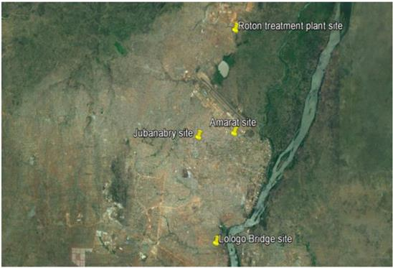 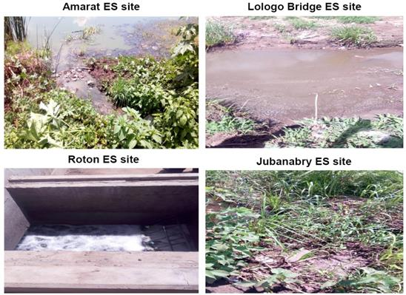

## Risk and challenges to Polio Eradication in South Sudan

|  |  |
| --- | --- |
| **Country-level Risk and challenges** | **Sept 2018: State of Kajo-Keji County Hospital after the 2016 conflict** |
| * An ongoing outbreak in Ituri province of DRC which borders South Sudan * Low immunization coverage across the country. * High population movements, IDPs and inaccessible population due to insecurity * No EPI and Surveillance activities in areas controlled by various opposition groups * Destruction of cold chain installation due to the conflict | C:\Users\Tukunde\Documents\Kajo_Keji\HPF\Field Photos\Hospital\IMG_20180911_145244.jpg |

**Identified County level risk and challenges**

* High number of Internally Displaced Person’s Camps (IDPs). Yei County alone has 4 (IDPs) sites totaling 3,687 households, 15,148 people and 2,829 are below the age of 18 Years.
* Increased population movements. Approximately 1,020 people from the DRC and Uganda to Yei County in September alone.
* Poor Routine Immunization Performance in 2017 with an average dropout rate of 32.4%.
* Limited access to populations, including Mobile Populations

**Fig 7: The ongoing risk to South Sudan and Uganda**

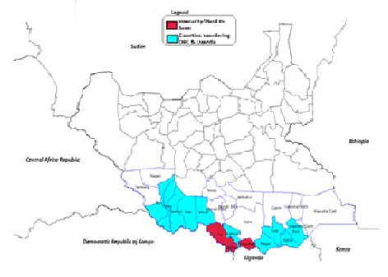

Counties and District bordering DRC Ituri Region

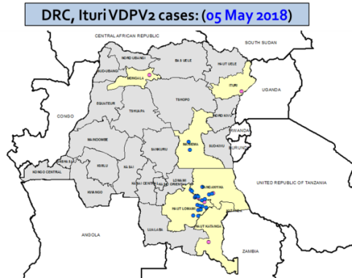 

|  |  |
| --- | --- |
| **County level Immunization response plan** | **Hit & Rum Vaccination mission in an IDP** |
| * Intensify Advocacy, Communication and Social Mobilization Strategies using Home Health Promoters & VHC, Radio programs, and Road drives. * Improve coordination with Cross border partners such as UN agencies (UNHCR) supporting refugee and IDP operation along the South Sudan-DR Congo and Uganda borders and Ministry of Health. * Take advantage of Humanitarian Missions Mobile clinics operations to provide Hit & Run immunization services. * Establish Toll-free lines for reporting to improve surveillance indicators. * County political actors to negotiate and advocate safe access to health personnel during missions. |  |

**Immunization response plan for South Sudan**

1. To increase immunity to type1 and type3 Polioviruses by implementing 3 rounds bOPV with 1 round in 2018, 2 rounds in 2019
2. Set up cross border vaccination point along with the active crossing points from DRC/Uganda, particularly the 3 transit points at Bazi (Morobo), Nabiapai (Yambio), and Nimule (Magwi).
3. Monitor the security situation and employ “hit and run” immunization strategy in Central Equatoria (Yei, Morobo, Lainya); while continuing with supplementary RI through PIRI and RRM activities.

# 3.0: DRC EBOLA VIRUS DISEASE OUTBREAK AND RESPONSE: the discussions surrounding Ebola Virus Disease was held on the second day of the cross-border meeting among the things discussed include the following:

## 3.1: Updates on Ebola Virus Disease (EVD) Outbreak in DR Congo.

Dr, Juvenal Mukuta updated delegates on the ongoing Ebola Virus Disease (EVD) outbreak in DRC, current risks, what has been done and Response Plans. He warned members that EVD is deadly with a case fatality rate of over 80%. He mentioned various group of viruses within the genus *Ebolavirus*: Ebola virus (species *Zaire ebolavirus*), Sudan virus (species *Sudan ebolavirus*), Taï Forest virus (species *Taï Forest ebolavirus*, formerly *Côte d’Ivoire ebolavirus*), Bundibugyo virus (species *Bundibugyo ebolavirus*), Reston virus (species *Reston ebolavirus*) and Bombali virus (species *Bombali ebolavirus);*

The index case in the current outbreak in the DRC was noticed onMay 8, and later declared on August 1, 2018, as Ebola outbreak. It involves the Zaire strain of the virus discovered in 1976, the year Ebola was first identified in what was then Zaire (now the Democratic Republic of the Congo). The 2018 Ebola outbreak is the 10th in the DRC since Ebola was discovered in the then Zaire;

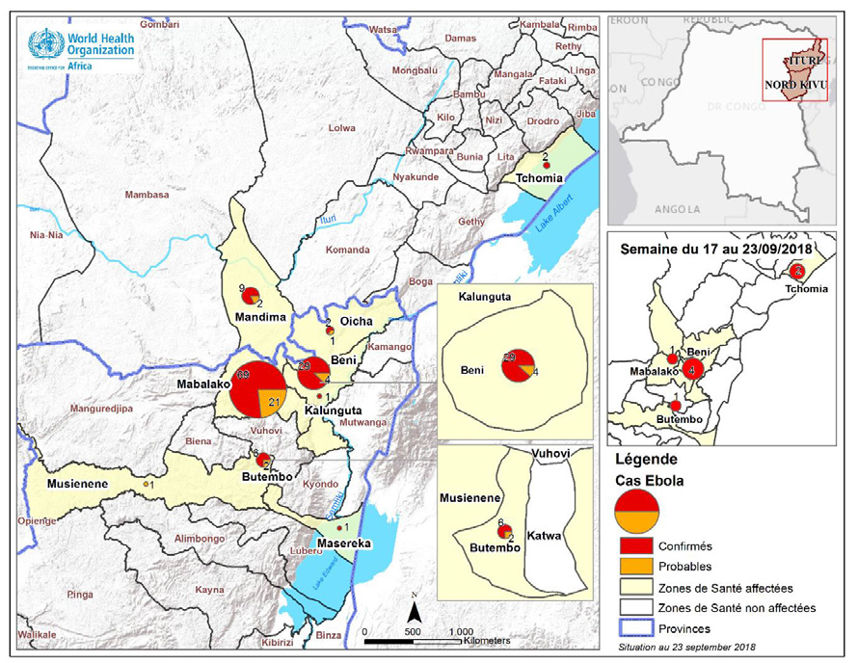**Map of North Kivu and Ituri regions of DRC showing badly Hit district by the EVD**

The first case of EVD was reported in North Kivu Province and later in the Ituri Region.

By the time of the cross-border meeting, a total of 149 cases have been reported and 118 confirmed EVD and 31 were under observation.

The badly hit districts include; Mabalako, Beni, Oicha, Musienene, Masereka, Butembo, Goma and Kalunguta in the North Kivu Province and Komanda, Mandima and Tchomia in the Ituri Région.

**Fig 8: Summary of EVD cases reported, confirmed and deaths as of Sept 26th, 2018**

**EVD response in DRC**

1. EVD conference done and training of health workers conducted
2. Vaccination of health workers ongoing. 96.4% of target achieved
3. Sensitization of traditional healers
4. Active case search and isolation of suspected cases and their contacts ongoing.
5. Psychosocial support being provided to those infected and affected by the Ebola pandemic.
6. MoH in partnership with the UN agencies is doing all it takes to curtail the Ebola virus from spreading to the other parts of the country or to Uganda and South Sudan.

**Challenges**

1. Opposition to vaccination
2. Rejection of those affected and infected by Ebola by the communities, traditional healers, etc
3. Insecurity in most parts of Ituri prevents medical intervention.
4. Gaps in the surveillance system;

**Fig 9: Epidemic Curve of EVD in DRC**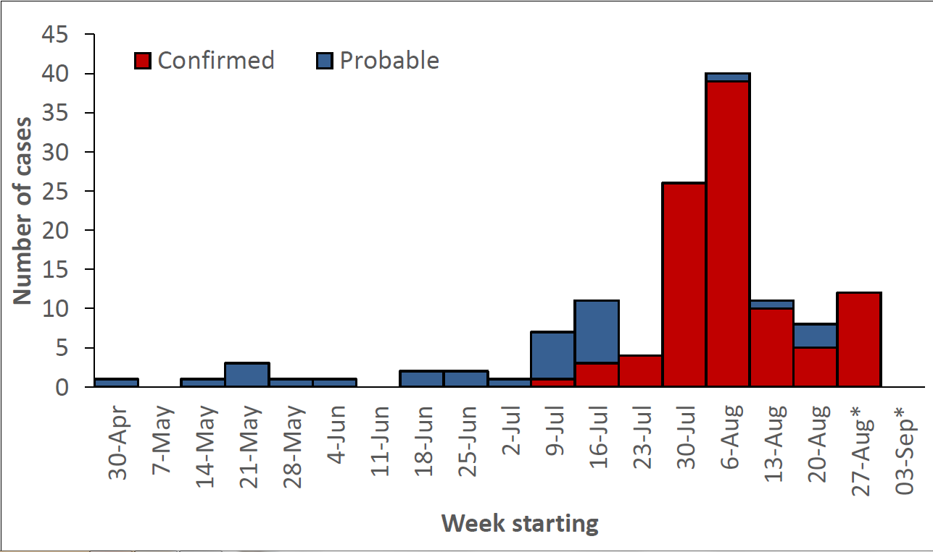

## 3.2: Update on South Sudan EVD preparedness and response

Dr. Pinyi Nyimol, the Director General for Preventive Health Services in the National Ministry of the Health Republic of South Sudan presented the South Sudan EVD outbreak preparedness, current risks, What has been done and response plan. He remarked that WHO has prioritized South Sudan, Burundi, Rwanda, and Uganda as high-risk countries to enhance preparedness and operational readiness based on Proximity to outbreak areas, capacity to manage outbreaks and influx of refugees from DRC to South Sudan.

The DG mentioned the high-risk States in South Sudan which include, Jubek due to the Juba International Airport, Torit, Yei River, Gbudue, Maridi, Tambura and Wau;

**Strategic Priorities for EVD plans for South Sudan**

**Coordination:**

1. National Task Force activated, meetings chaired by Hon Minister of Health on (Tuesday and Thursday)
2. Incident manager appointed, and High-level advocacy visit to all the priority states led by Hon. Minister Health conducted
3. Contingency Plan revised, WFP committed to supporting transportation of Supplies to the priority locations;

**Case Management/IPC/WASH Strengthening**:

1. Isolation sites identified in Juba, Nimule, and Yei (facilities not established)
2. EVD orientation done for health workers in Nimule (26), Yei (30), Juba (40), Maridi (30) and Yambio (30)
3. Mini PPE kits prepositioned in Yambio, Yei, Nimule and Maridi, VHF500 PPE kit prepositioned in Juba, MSF-B has committed to lead case management in event of a confirmed case, currently assessing Yei;

**EPI Surveillance and Laboratory:**

1. Toll-Free line 6666 is operational,
2. Electronic case definitions shared, 5 alert cases investigated, 1 required sample collection;
3. 4 Rapid Response Teams deployed (Yei, Nimule, and Yambio in Gbudue state),
4. Biosafety training for 40 staff conducted at PHL and GenXpert installed at PHL;

**Communication and Social Mobilization**

1. Risk communication strategy developed, Jingles in Arabic, Zande, and Bari are airing on radio stations that allow free broadcasts, UNICEF committed to funding training and IEC materials production,
2. The orientation of 20 Journalists conducted in Juba, Stakeholder engagements in Nimule, Yei, Yambio, Tambura, and Maridi done
3. Trained 30 Home Health Promoters, focal persons in place

**Points of Entry:**

1. 39 points of entry identified in high-risk states, 14 Point of Entry (Nimule 2, Yei-4, JIA, Wau airport, Yambio 4 and Ezo) prioritized for the establishment of screening points,
2. Active screening ongoing at 7 sites (JIA, Wau, Nimule, Gangura, Sakure, Yei airstrip and Yambio airstrip (over 100,000 travelers screened).

**Challenges:**

1. A funding gap of U$ 2,976,615 (planned for 3 Months) and
2. Accessibility issues in some states with insecurity.

**Table 7: A Snapshot of the Ebola Preparedness Dashboard, June 11, 2018**

|  |  |  |  |  |  |  |  |  |  |  |  |  |
| --- | --- | --- | --- | --- | --- | --- | --- | --- | --- | --- | --- | --- |
| **Country** | **Coordination** | **Rapid Response Team** | **Public Awareness** | **Infection Prevention & Control** | **Case Management** | **Safe & dignified Burials** | **Epidemiological surveillance** | **Contact Tracing** | **Laboratory** | **Points of Entry** | **Budget** | **Logistics** |
| **Burundi** | 0% | 17% | 0% | 25% | 0% | 0% | 38% | 0% | 50% | 43% | 17% | 58% |
| **Central Africa Republic** | 22% | 17% | 50% | 0% | 50% | 0% | 25% | 0% | 75% | 14% | 50% | 8% |
| **Congo** | 33% | 0% | 0% | 0% | 33% | 20% | 0% | 0% | 0% | 14% | 67% | 0% |
| **Rwanda** | 22% | 50% | 50% | 25% | 67% | 80% | 63% | 40% | 50% | 43% | 33% | 83% |
| **South Sudan** | 56% | 67% | 75% | 0% | 33% | 20% | 75% | 20% | 50% | 43% | 0% | 8% |
| **Tanzania** | 78% | 17% | 75% | 50% | 50% | 40% | 38% | 20% | 100% | 86% | 50% | 75% |
| **Uganda** | 33% | 67% | 50% | 75% | 83% | 100% | 50% | 40% | 75% | 0% | 33% | 67% |
| **Zambia** | 89% | 33% | 50% | 0% | 100% | 60% | 38% | 0% | 50% | 14% | 50% | 42% |

**County-specific EVD preparedness and Response plans**

**EVD risk to the state**

1. Proximity to the epicenter of the current EVD outbreak in North Kivu and Ituri provinces of Eastern DRC. Up to 4 counties (Morobo, Lujulo, Otogo, and Tore) share a border with DRC.
2. A large number of returnees from a refugee in DRC to Yei, South Sudan.
3. Breakdown of health services due to the armed conflict.
4. The porous border with multiple entry points, e.g. crossing from Ukaba to Morobo town is an unofficial point of entry.

**State EVD Preparedness Plan**

After the declaration of EVD in Eastern DRC on 1st of August 2018, a State EVD task force was formed scale upstate preparedness plan. The task force consists of three subcommittees; surveillance team, case management team, and Social mobilization tea

**Table 8: Activity plan for EVD State Task Force**

|  |  |  |
| --- | --- | --- |
| **S/N** | **Activity Description** | **Time Frame** |
| 1 | Conduct preparatory and advocacy meetings on EVD | September 2018 |
| 2 | Running of Jingles on EVD in relevant languages and conduct radio talk shows | Ongoing |
| 3 | The orientation of community leaders, Chiefs, youths, women groups, religious leaders, organized forces, traditional healers, teachers, pupils and students on EVD | Ongoing |
| 4 | Training of social mobilizers on EVD key messages | Ongoing |
| 5 | Conduct community and social mobilization to create awareness in Yei town | Ongoing |
| 6 | Road drive using mega Phones with key EVD messages | Ongoing |
| 7 | Display/ Distribute IEC materials | Ongoing |
| 8 | Intensify routine Health Education in the Health facilities/Training of Health workers on EVD | Ongoing |
| 9 | Assessment and establishment of screening desks at points of entry | September |

**Achievements**

|  |  |
| --- | --- |
| **Fig 10: Screening desk established at Yei airstrip and Nimule border post** | |
| C:\Users\john\Desktop\Screening point in Yei Airstrip\DSC01576.JPG | C:\Users\john\Desktop\Screening point in Yei Airstrip\DSC01581.JPG |

|  |  |
| --- | --- |
| **Fig 11: Isolation facility at Yei State Hospital established with support MSF in case of suspected EVD.** | **Challenges** |
| C:\Users\john\Desktop\DSC01569.JPG | * Delay establishment of Screening desks at the points of entry * Some border crossing points are not accessible. This has hindered awareness campaigns and monitoring of population movements. * Logistical challenges, the State Hospital doesn’t have an ambulance and Surveillance Vehicles. |

## 3.3: Update on Uganda EVD preparedness and response

Dr. Edson Katushabe presented the Uganda EVD current risks, what has been done and response plans. He reported on the current EVD preparedness plan, which includes:

1. **Coordination:**
2. Functional multi-disciplinary National Task Force with sub-committees formed and now meeting regularly. EVD case definitions, reviewed and are being distributed to high-risk facilities. Coordination of partner inputs ongoing;
3. District Task Force activated in 5 very high-risk districts of Kasese, Kabarole, Bundibugyo, Ntoroko, Bunyangabo, Kampala, Wakiso. 150 health workers in the 5 districts trained on EVD surveillance and contact tracing.
4. Ebola Preparedness Plan developed, focusing on the 5 very high-risk districts. Three isolation and treatment facilities for EVD prepared in Kasese, Bundibugyo, and Fort Portal in collaboration with MoH, WHO, MSF, WFP, JMEDICC. Equipment for the centers provided by WHO, UNICEF, Baylor. PPEs pre-positioned in the 3 facilities;
5. The incident manager assigned. Following confirmation of an Ebola case in Tchomia zone, Ituri Province on 20th September, a national surveillance officer has been deployed to work with the district team to further strengthen health facility and community-based surveillance for Ebola;
6. Prepositioning of triple packages materials for specimen transportation and vehicles available in 5 very high-risk districts for specimen transportation to VHF lab in Entebbe;
7. MoH has disbursed UGX 250 million to the 5 very high-risk districts. 40 Laboratory personnel from 5 very high-risk districts have been trained on safe specimen collection, packaging, and transportation, biosafety and biosecurity procedures in the laboratory.
8. 22 at-risk districts; 07 very high risk, 05 high risk (Kanungu, Kisoro, Rubirizi, Rukungiri, and Kagadi) and 12 medium risk districts (Kabale, Hoima, Buliisa, Arua, Koboko, Maracha, Moyo, Nebbi, Zombo, Yumbe, Adjumani) identified and all are notified to be on high alert.
9. The baseline level of readiness in the very high-risk districts was assessed, gaps identified informed plan development. Alert investigated with samples to Uganda Virus Research Institute. All alerts are so far negative for Ebola.
10. A cross-border meeting involving East African Community countries and DRC being planned on 1st to 4th October 2018 at Entebbe.
11. Joint WCO and MoH in the very high-risk districts to supervise and support Ebola preparedness efforts, to ensure districts keep the preparedness momentum and to troubleshoot on issues where necessary.
12. **CASE MANAGEMENT (CM):**
13. Case Management (CM) experts deployed by WHO to support and mentor district CM teams,
14. CM SOPs and Guidelines provided to the isolation/treatment centers and CM teams,
15. Suspected cases/Alerts being managed in the isolation/treatment facilities,
16. UNHCR/ MoH trained 46 health workers on EVD CM in each of the 12 Refugee hosting districts and High-risk districts;
17. 37 Health workers from KCCA and (UN clinic) trained on EVD case management with support from WHO. Another 44 health workers from China Friendship Hospital Naguru also trained on EVD case management with support from Infectious Diseases Institute, Makerere University.
18. **INFECTION PREVENTION AND CONTROL:**
19. Establishment of IPC committees in the different health facilities; Infection Prevention & Control (IPC) supplies provided to 5 high-risk districts with a focus on isolation/treatment facilities and border screening. IPC assessment in health facilities in the high-risk districts ongoing;
20. Training of health workers in IPC planned; 3 local IPC consultants are being recruited to support IPC training and mentoring in the very high- and high-risk districts;
21. Training of Safe and Dignified Burial teams planned – in high-risk districts and regional teamsplanned;
22. Press release to inform the public by Minister; another press release to inform the public about the newly confirmed case in Tchomia health zone sent by the Ministry of Health on Sunday 23rd September 2018.

**4. Risk Communication:**

1. IEC materials developed, translated into 13 local languages and distributed to the districts, with support from UNICEF being reviewed based on feedback from communities;
2. Radio messages and radio and TV talk show being aired on local FM stations with support from CHC and UNICEF.
3. Community sensitization on EVD being conducted by Red Cross Volunteers
4. Community engagement efforts being intensified; WHO deployed a local risk communication consultant and NPO/HPR to the region to support these efforts.
5. **POINTS OF ENTRY:**

|  |  |
| --- | --- |
| 1. Two thermo-scanners procured – one installed at Entebbe airport. Entry screening at Entebbe International Airport. Training on Point of Entry Screening currently being conducted by CDC/IDI 2. Border screening established in Kasese, Bundibugyo, Ntoroko with support from WHO, Red Cross, WFP, and UNHCR, targeting official/high volume points of entry. Alert cases detected and referred to isolation centers for further investigation | **Fig 12: Thermo-scanner at Entebbe Airport** |

**6. VACCINATION:**

1. MSF has developed a research protocol on ring vaccination with Ebola vaccine. Protocol for vaccination of health workers developed by WHO. Vaccination of very high risk and ring vaccination on confirmation of any case targeted.
2. Finalization of vaccination plan for health workers, Training of vaccination team completed. Cold chain equipment for planned vaccination received and already set up at the National Medical Stores. Training of cold chain technicians planned ahead of receipt of the vaccine.

**7. GAPS:**

1. Preparedness activities mainly target very high-risk districts; need to scale up to high and medium risk districts with an agreed package of interventions.
2. There is a need to strengthen surveillance in at-risk districts; Plans are underway to conduct surveillance training in the remaining 17 districts;
3. IPC practices in lower level health facilities are still below the required standards for EVD readiness;
4. Turnaround time of laboratory results is still high. There is a need to support human resources surge capacity in the VHF lab, and also consider over-time operations. Suggestions for developing laboratory surge capacity under discussion with MoH by WHO.
5. Limited community engagement of at-risk communities/leaders and other duty bearers.
6. VHTs are not yet fully engaged for community-based surveillance. No incentives for health workers and others involved in EVD response.
7. Large inflows through the borders into Uganda from DRC with many unofficial entry points.

### **3.3.1: Updates on EVD preparedness and response at the border District from Koboko district.**

**Dr. Idringi Dieudonne (DHO Koboko),** presented on the EVD preparedness and response at the border district of Koboko Uganda which borders South Sudan -Yei River State and Ituri region in the DRC.

|  |  |
| --- | --- |
| **Achievements** | **Challenges** |
| 1. Social Mobilization and community engagement strengthened, Radio talk shows ongoing and slots running in local language and disseminated IEC materials on Ebola 2. New electronic eIDSR platform developed to enable communities and health workers to notify the MoH. 3. 24/7 toll-free telephone line Em-track 6767 established 4. Three (3) suspected case investigated tested PCR negative for Ebola viral disease ( EVD), 2 died 5. Transit center established at Kuluva equipped with Chlorinated hand washing facilities and hand washing is mandatory for all entrants, IEC materials disseminated, Infra-red thermometers, PPEs, and Isolation facilities. | 1. Limited private sector involvement 2. Low hygiene compliance including by health workers 3. Inadequate sample collection kits and PPEs |

|  |  |
| --- | --- |
| **Fig 13: Hand Hygiene Compliance by Moment-Koboko** | |
| 16%  16%  33%  17%  36% |  |

# 4.0: AGREED ACTION PLANS FOR POLIO ERADICATION, EVD PREPAREDNESS AND RESPONSE:

The action plans for the three countries were arrived at through country Specific Group work. The group works had six thematic areas; (i) Cross-border coordination & collaboration (ii) Polio SIAs (iii) Social Mobilization (iv) Routine Immunization (v) Monitoring &Evaluation and (vi) Cross-cutting issues on Polio eradication and EVD Action Plans. The country-specific action plans were presented by respective rapporteurs and amalgamated to form one action plan for the three countries as presented in

***Annexure 1***.

| 5.0: RESOLUTIONS |
| --- |

**5.1:** polio eradication initiative, EVD outbreak preparedness, and response:

**Following** the declaration of an outbreak of the Vaccine-derived Polioviruses (VDPVs) and Ebola Virus Disease (EVD) in the Democratic Republic of Congo (DRC) on August 5, 2018, and August 1, 2018, respectively as well as sporadic incidences of wild poliomyelitis virus in Pakistan and Afghanistan.

**AWARE** that diseases know no borders and that poliovirus and Ebola Virus Disease can be imported into through the porous borders.

**ACKNOWLEDGING** the proximity of the Ituri Region and the North Kivu Province of the DRC in which cVDPV and EVD outbreak are currently ongoing to Uganda and South Sudan which share international borders.

**KNOWING** the common characteristics of our people along the border lines and the long history of disease outbreaks within the neighboring countries of South Sudan, Uganda and DR Congo, which affect us in common;

**COGNIZANT** of our porous borders which allows free movement of people among the three countries in search of farmland, pastures, refugee and trade among others;

**COMPOUNDED** by the protracted conflicts in the Central African Republic, DRC, and South Sudan which predispose a large pool of our children to vaccine-preventable diseases and denial of the populace to decent and timely health care;

**CONSCIOUS** of the common gaps in our surveillance system, which inhibits early warning and outbreak detection of Poliomyelitis and EVD;

**MINDFUL** of the limited resources notwithstanding the support from our partners in an effort to eradicate poliomyelitis and EVD in our region;

**RECALLING** the standing recommendations of the December 16, 2016, Arua Cross Border Meeting;

**WE:**

1. **ENCOURAGE Cross Border Coordination and Collaborations.**

In an effort to eradicate Polio and Ebola outbreak preparedness and response plan;

1. ***Urge*** the Authorities in Uganda to institute screening desks at the Uganda entry points as are being done at the DRC and South Sudan Borders to enable early warning and outbreak detection of Poliomyelitis and EVD;
2. ***Encourage*** *the border districts, counties and* States to provide all necessary support in the fight against Polio eradication by sharing of data/information, expertise including free movements of health workers within the three countries and lessons learned in accordance with applicable laws.
3. ***Recommend***all the three countries to map high volume ungazetted border crossing points in terms of locations, activities, health facilities and manpower therein to galvanize efforts in early warning and outbreak detection of Poliomyelitis and EVD.
4. ***Commend*** the district/county/State/Provincial leaders of the three countries together with the implementing partners therein to organize biannual cross border collaborative meetings and establish social media platforms to strengthen integrated disease surveillance system, which is government owned and donor supported for a mutually beneficial collaboration in the fight against polio and EVD.
5. **REQUEST for Polio Supplementary Immunization Activities (SIAs):**

Aware that Polio SIAs has contributed to >99% decline in the incidence of poliovirus cases since the beginning of the Global Polio Eradication Initiative; we express concern over missed and or under-immunized children. Thus, we:

1. ***Implore*** the WHO, Ministries of Health and the districts/counties along the borderline to Synchronize Polio SIAs whenever possible to reduce on the incidences of missed opportunities among the migratory children across the borders.
2. ***Appeal*** to the Districts/ counties, Ministries of Health, National Medical Stores and Implementing Partners to appropriately and adequately supply vaccines to reduce on the incidences of stock outs as have been noted in some areas within the region.
3. ***Recommend*** districts/ counties to establish immunization points at the border crossing to cover the mobile children to interrupt cross border transmission of Poliovirus.
4. ***Beseech*** the Humanitarian Agencies in the DRC and South Sudan to lobby with the Government and oppositions for immunization space and days in the rebel-controlled areas and urge the Ministries of Health to deploy the "Hit and Run" immunization strategy to immunize the children therein.
5. ***Invite*** all the District Health Officers (DHOs), County Health Directors (CHDs), State Ministers of Health and Surveillance Focal persons to invigorate active search for cases of polio and other epidemiological diseases in their respective districts, province or region to enable early warning and outbreak detection.
6. **RECOMMEND Social Mobilization Strategies.**

Advocacy can bring about tangible and lasting change. Communities, individuals, governments, the media, and academia alike need to be an integral part of the national, regional and community efforts to Polio eradication initiative, Ebola outbreak preparedness and response team.

Therefore; we:

1. ***Charge*** all the districts/ counties, provinces and states to conduct radio talk shows, community dialogues, radio spot messages, jingles, advocacy meetings; among others to scale up awareness on Polio eradication initiative, Ebola outbreak preparedness and response within and beyond their areas of jurisdiction;
2. ***Call upon*** the Ministries of Health and the district/ county/provincial/State/Regional Health Departments of the three Countries to provide adequate Information, Education and Communication (IEC) Materials properly translated in local dialects as a public health approach to change or reinforce health-related behavior in our communities.
3. ***Implore*** the Nations/States/Districts/ counties/Provinces/Villages/Churches among others to identify and train community mobilizers for health to strengthen community structures for social mobilization for Polio eradication, Ebola outbreak preparedness and response.
4. **INVIGORATE Routine Immunization:**

To protect ourselves and those around us; we recommend all those eligible for Polio and Ebola vaccines to be immunized/vaccinated.

**WE:**

1. ***Invite*** the District/county/Provincial/States/National Medical Stores and all concerned to appropriately quantify and supply adequate quantities of vaccines to reduce incidences of stock-outs at the health facilities;
2. ***Implore*** the States, Districts, counties, Provinces through Cold Chain officers/ NMS/EPI focal persons to conduct preventive cold chain maintenance and lobby for more cold chains from the government and Implementing partners to reduce on wastage of vaccines and maintain their efficacies and proximity to the population;
3. ***Encourage*** the vaccinators across the borders to ensure proper vaccine documentation. The respective Ministries of Health should print adequate child health cards, vaccine control books, tally sheets to enforce accountability and value for money;
4. ***Urge*** the Health workers, District/county/State Surveillance Focal Persons to Strengthen defaulter tracking mechanisms through improved linkages and referral of unimmunized children across the borders;
5. ***Request*** the States and Implementing Partners therein to hire and train more vaccinators/health workers in a bid to curb down the inadequate number of Human Resource for Polio eradication, Ebola outbreak preparedness and response in the region.
6. **ENCOURAGE Monitoring and Evaluation (M&E):**

For greater transparency, accountability, and sharing of lessons learned on Polio eradication, Ebola outbreak preparedness and response activities,

**WE:**

1. **Urge** Districts/counties, Provinces and States within the borders to conduct Joint Quarterly Support Supervision Missions for a mutually beneficial Integrated Disease Surveillance in the Region.
2. **Recommend** Provinces, States and Districts/counties within the borders to conduct Periodic review of action points and progress achieved.
3. **Commend** the Districts/counties, Provinces and States to build the capacity of health workers in Integrated Disease Surveillance, track their performances, improve timely routine reporting and redesign strategies from time to time in line with the emerging gaps.
4. **CONSIDER Cross-cutting issues:**

In view of the intricate relationship of health with the other socio-economic environment,

**WE:**

1. ***Implore*** districts/counties, states, and provinces to conduct screening of diseases of public health concern such as TB, plague alongside Polio eradication, Ebola outbreak preparedness and response to enforce the principle of integrated disease surveillance;
2. ***Recommend*** engagement of all stakeholders i.e. non-health workers including the religious, political, civil, partners, Community Based Organization and traditional herbalists by the Districts/counties, States and Provinces across the three countries.
3. ***Urge*** Resource Mobilization at all levels: National/State/County/sub-county/villages and the partners among others to ensure uninterrupted immunization and Ebola outbreak preparedness and response activities and supplies in the three Countries;

# 6.0: ANNEXES

## Annex 1: ACTION POINTS FROM PLENARY GROUP DISCUSSIONS

|  |  |  |  |  |  |  |  |
| --- | --- | --- | --- | --- | --- | --- | --- |
| **S/N** | **Issues** | **Planned Activities** | **Level of Implementation** | **Time frame** | **Responsible body/person** | **Monitoring Indicators** | **Means of verification** |
|  | **Cross-border coordination & collaboration** | | | | | | |
| 1 | Limited coordination and collaboration among the states | Bi- annual meetings, | States/Zones/Districts/ counties | March & Sept 2019 | DHO/CHD/DSFP/DLG/Implementing Partners | Directors of the states, Resident District/county Commissioners | Number of person appointed |
| 2 | Porous border | Map high volume *ungazetted* border crossing points | Customs, District | 30th/11/2018 | DHO/DSFP/CUSTOMS/DLG | #Porous border sites mapped | Records |
| 3 | Limited sharing of information between the countries. | Conduct biannual cross border collaborative meetings, establish social media platforms: WhatsApp/Google group, email | State/Zone/Region , County/ District /Province | Bi-Annual | MoH/WHO/DLG | # Collaborative meeting conducted | Reports shared |
| 4 | Inadequate cross border surveillance | Strengthening surveillance through sharing of information i.e. social media platforms, situation reports | District/county | Weekly | DSFP/DLG | # timely and complete sit-reps shared | Reports shared |
| 5 | Inactive cross border focal persons | states/districts to appoint active focal persons | State/Zone/Region , County/ District /Province | 18-Oct-2018 | Directors of the states/RDCs/DHOs | Number of persons appointed | Reports shared with focal persons |
| 6 | Non-functionality of coordination structures | Reactivate coordination structures through sharing information, regular meetings | Regional | 12/31/2018 | MOH/WHO/Partners/DLG | # of functional committees formed | reports, minutes |
|  | **Polio SIAs** | | | | | | |
| 7 | Unsynchronized SIA's activities. | Implementation of synchronized polio SIA's across all countries | Regional/National | Next SIA | WHO/MoH/DP | The proportion of countries/districts that implemented synchronized polio SIA's. | Technical reports |
| 8 | Erratic vaccine supplies | Appropriate quantification and supply of adequate quantities | District/National/NMS/Implementing Partners | Monthly | Cold Chain officers/ NMS | # of districts/counties/reporting zero stock-outs of vaccines | Technical reports |
| 9 | Mobile population across the border | To establish immunization points at the border to cover the mobile children | Districts | 18-Dec-2018 | DHOs/State Directors/Governors | # of Immunization Points set up at the border | Records of children immunized at the posts |
| 10 | Inaccessible population in the rebel-controlled areas | Humanitarian Agencies to lobby for "Hit and Run" immunization strategy | State/NMoH/Districts/Province | Quarterly | MoH, EPI, State/ Zone/Province/UN and other partners | # of "Hit and Run" Immunization exercises carried | Records of children immunized |
| 11 | Insufficient active search for Polio cases and other epidemiological diseases | Invigorate active search for cases of polio and other epidemiological diseases. | District/MoH | Immediate | Surveillance Officers/DHO | # of active searches conducted | Technical reports |
|  | **Social Mobilization** | | | | | | |
| 12 | Inadequate information dissemination | Conduct radio talk shows, community dialogues, radio spot messages, jingles, and Advocacy meetings. | DISTRICT | Quarterly | DHO/DHE | # radio talk shows | Recorded messages |
| 13 | Limited and inaccurately translated IEC materials | Provision of adequate IEC materials translated in the proper local dialect. | NATIONAL | Quarterly | MoH/WHO/UNICEF | # of IEC materials distributed | Samples of IEC materials distributed |
| 14 | weak community structures for social mobilization | To identify and train community mobilizers for health | Nation/District/County/Province/Villages/Churches | Dec-18 | MoH/WHO/UNICEF/Politicians/Religious Leaders | # of Community Mobilisers Trained | List of Community Mobilisers |
|  | **Routine Immunization** | | | | | | |
| 15 | Lack of vaccine documentation | Print adequate child health cards, vaccine control books, tally sheets | National/District | Quarterly |  | # children with vaccination cards | Records |
| 16 | Inconsistent supplies of vaccines | Appropriate quantification and supply of adequate quantities | DISTRICT/NATIONAL/NMS | Monthly | Cold Chain officers/ NMS | # of districts reporting zero stock-outs of vaccines | Technical reports |
| 17 | Weak cold chain management system | Conduct preventive cold chain maintenance and lobby for more cold chains from the government and Implementing partners | District/National | Monthly | Cold Chain officers/ NMS/EPI focal persons | # of EPI fridges serviced and supplied | Technical reports |
| 18 | Weak defaulter tracking mechanisms | Improve linkage and referral of unimmunized children | District/county | Monthly | EPI FOCAL PERSON | # Of children linked to care | Technical reports |
| 19 | High dropouts, under or no immunization of children | Rapid response activities, Hit & run activities, acceleration campaigns |  |  |  |  |  |
| 20 | Inadequate number of Human Resource | To hire and train more vaccinators/health workers | National | 1-Jan-2019 | CHD Directors/HSC | # of Health workers Hired | Minutes of Recruitment |
| 21 | Poor defaulter tracing | To Identify and train volunteers for defaulter tracing as well as the use of the bracelet | National/ District/Provincial | 1-Nov-2018 | CHD Directors/DHOs | Number of volunteers train | training reports |
|  | **Monitoring &Evaluation** | | | | | | |
| 22 | Inadequate data collection and reporting tools | Avail adequate data collection tools | NATIONAL | Monthly | MOH/METS | # all primary data tools availed | **available data tools** |
| 23 | Untimely reporting mTRAC, EIDSR | Capacity building of additional health workers | District | Quarterly | BIOSTAT/DSFP | # of staff trained | training reports, case-based reporting |
| 24 | Limited supervision by District Health Officials | Conduct joint quarterly support supervision missions | District | quarterly | DHO | # joint supervisions conducted | supervision reports |
| 25 | Inadequate implementation and evaluation of agreed-upon action points and activities | Periodic review of action points/progress | Regional/National | quarterly | DHO/BIOSTAT | # of performance review meetings conducted | reports |
|  | **Cross-cutting issues** | | | | | | |
| 26 | Non-engagement of all stakeholders i.e. non-health workers | Coordination meeting with stakeholders, i.e. IP's CSO, CBO political/cultural leaders. | District | Quarterly | DHO | # one health coordination meetings conducted | minutes |
| 27 | Non-screening of other diseases of public health concern i.e. TB. ETC | To conduct screening of diseases of public health concern such as TB, plague | District | Immediate | DHO | # persons screened for PHE | records |
| 28 | Inadequate logistics | resource mobilization | National/State/County | Jan-19 | CHD/DG/partners | # of supplies received | Delivery Notes |
| 29 | Inadequate funding | To Lobby and advocate for funds | All levels | Immediate | All stakeholders | # planned activities | work plans and budgets |

## Annex 11: Cross Border Participants list

|  |  |  |  |  |  |  |
| --- | --- | --- | --- | --- | --- | --- |
| **Participants for Cross Border Collaboration Meeting on polio eradication initiative and Ebola outbreak preparedness between South Sudan, DR Congo and Uganda.** | | | | | | |
|  | **Venue: Desert Breeze Hotel Arua Uganda, 25-26 Sept. 2018** | | | | | |
| **N** | **Name** | **Agency** | **Designation** | **County/district** | **Phone No.** | **Email** |
|  | **South Sudan team** | | | | | |
| 1 | Michael Lugalla Nicholas | Government-SS | CHD Director | Yei | 211920010016 | [lugalla52@gmail.com](mailto:lugalla52@gmail.com) |
| 2 | Bidal Martin Dumba | Government-SS | Surveillance Officer | Yei | 211925111509 | [bidalidumba@gmail.com](mailto:bidalidumba@gmail.com) |
| 3 | John Towongo Guya | Government-SS | County EPI Supervisor | Yei | 211922324259 | [jtowongo@actionafricahelp.org](mailto:jtowongo@actionafricahelp.org) |
| 4 | Musa Noah | AAHI-SS | Lot Coordinator | Yei River State | 211921744889 | [nmusa@actionafricahelp.org](mailto:nmusa@actionafricahelp.org) |
| 5 | Dr. James Wani Tom | Government-ss | Director General | Yei River State | 211921776781 | [ntpcecoordinator@gmail.com](mailto:ntpcecoordinator@gmail.com) |
| 6 | Hon. Kogo Manase Levi | Government-ss | Minister of Health | Yei River State | 211926512346 | [manasekogo@gmail.com](mailto:manasekogo@gmail.com) |
| 7 | Dr. John Manaya Sebbit | Government-ss | NGOs' Coordinator/FP Ebola Taskforce | Yei River State | 211927608250 | [drjohn26@yahoo.com](mailto:drjohn26@yahoo.com) |
| 8 | Khamis Yasin | Government-SS | CHD Director | Lainya | 211927759667 | NA |
| 9 | Elias Kaiga | Government-SS | County Surveillance Officer | Lainya | 211926112221 | [kaigaelias@yahoo.com](mailto:kaigaelias@yahoo.com) |
| 10 | Dr. Pinyi Nyimol Mawien | Government-SS | Director General, Preventive serv. | Juba | 211916285676 | [pinyiaupur@gmail.com](mailto:pinyiaupur@gmail.com) |
| 11 | Paul Okech | Government-SS | National SIA Officer | Juba | 211926788990 | [okechpaulo@gmail.com](mailto:okechpaulo@gmail.com) |
| 12 | Stephen Taban | Government-SS | County EPI Supervisor | Lainya | 211925519370 | [tabanstephen2016@gmail.com](mailto:tabanstephen2016@gmail.com) |
| 13 | Buga Simon Peter | Government-SS | CHD Director | Morobo | 256775323508 | [bugasimon2015@gmail.com](mailto:bugasimon2015@gmail.com) |
| 14 | Alfred Lugeyi Akulu | Government-SS | County Surveillance Officer | Morobo | 256790357936 | [simonevansmoro@gmail.com](mailto:simonevansmoro@gmail.com) |
| 15 | Betty Maneno | Government-SS | County EPI Supervisor | Morobo | 256793480876 | NA |
| 16 | Wani Simon Nathaniel | Government-SS | Health Facility in charge of Mere | Kajo-Keji | 211925424056 | NA |
| 17 | Tukube Charles | ARC-SS | MEAL Officer | Kajo-Keji | 256780814438 | [CharlesT@arcrelief.org](mailto:CharlesT@arcrelief.org) |
| 18 | Mogga James Kiriba | ARC-SS | EPI Manager | Kajo-Keji | 256770708841 | NA |
| 19 | Komakech Michael | Government-SS | County Surveillance Officer | Magwei | 211925032907 | [mkomakech@gmail.com](mailto:mkomakech@gmail.com) |
| 20 | Amoko Simon | Government-SS | County Health Officer | Magwei | 211926792930 | [amoko.simon@yahoo.com](mailto:amoko.simon@yahoo.com) |
| 21 | Martin Okot | Government-SS | County Health Officer | Magwei | 211928135933 | [okotmartin007@yahoo.com](mailto:okotmartin007@yahoo.com) |
| 22 | Anthony Kisanga | Core Group SS | Director | Juba | 211924379723 | [cgpp.ssudan@gmail.com](mailto:cgpp.ssudan@gmail.com) |
| 23 | Samuel Rumbe | Core Group SS | Deputy Director | Juba | 211915378517 | [srumbe@gmail.com](mailto:srumbe@gmail.com) |
| 24 | Maliamungu Arnold | Core Group SS | State Surveillance Coordinator | Juba | 211923506263 | [Maliamungu\_Arnold@wvi.org](mailto:Maliamungu_Arnold@wvi.org) |
| 25 | Scopas Ajo | Core Group SS | Logistic Assistant | Juba |  | [scopasajo@gmail.com](mailto:scopasajo@gmail.com) |
| 26 | Omot Josep | Core Group SS | Driver | Juba |  | NA |
| 27 | Dr. Lydie Maoungou Minguiel | UNICEF-SS | EPI Manager | Juba |  | [lmminguiel@unicef.org](mailto:lmminguiel@unicef.org) |
| 28 | Dr. Ademe Tegegne | WHO-SS | Consultants | Juba | 211916949539 | [ayeseshema@who.int](mailto:ayeseshema@who.int) |
| 29 | Dr. Abraham Adut | WHO-SS | Consultants-NPHO | Juba | 211920276660 | [abenegoa@who.int](mailto:abenegoa@who.int) |
| 30 | **WHO Horn of Africa/HQ Geneva** | | | | | |
| 31 | Tracci Garner | WHO/HQ | HOA Country support-TO | GVA | 41795819514 | [garnert@who.int](mailto:garnert@who.int) |
| 32 | Dr. Chris Kamugisha | WHO/HOA | Coordinator | HOA | 254727954451 | [kamugishac@who.int](mailto:kamugishac@who.int) |
|  | **DR CONGO PARTICIPANT** | | | | | |
| 33 | HENRY VENANT KOSSI | GOVEMMET | ADMINISTRATOR | Ituri | 243817823977 | [nkosi762@gmail.com](mailto:nkosi762@gmail.com) |
| 34 | BIMPA ETSEMENANE | GOVEMMET | MIGRATION OFFICER | Ituri | 243816557962 | [heubi201@gmai.com](mailto:heubi201@gmai.com) |
| 35 | Dr. Louis TSULO | GOVEMMET-DPI | ITURI PROVINCE DIVISION H/OFFICER | Ituri | 2.43811E+11 | [louistshulo@gmail.com](mailto:louistshulo@gmail.com) |
| 36 | Dr. SIMON OZIMATI | GOVEMMET | DISTRICT OFFICER | ADI-MOH | 243812005628 | [Almozimati2007@gmail.com](mailto:Almozimati2007@gmail.com) |
| 37 | Dr. Mukuta Juvenal | WHO | MEPS | ADI | 243815304456 | [mukutambayej@who.int](mailto:mukutambayej@who.int) |
| 38 | Dr. Raymond ADHAKU | WHO | CONSULTANT | ARU | 243857695388 | [dradhakuray@gmail.com](mailto:dradhakuray@gmail.com) |
| 39 | Dr Jean Paul UVOYO | MALTESER | MEDICAL COORDINATOR | ADI |  | NA |
| 40 | Dr. Guillaume UDAGA | GOVERNMENT | DISTRICT Health OFFICER(MC2) | ADI | 243813424120 | [woleluhuillaume@gmail.com](mailto:woleluhuillaume@gmail.com) |
| 41 | Dr. Itama Jelt | MALTESER | Coordinator | ADI | 243817544742 | [jeltitama@gmail.com](mailto:jeltitama@gmail.com) |
| 42 | Marcelin ANGAYIKA Metua | LOGISTIC EPI ASSISTANT | LOGISTIC EPI ASSISTANT | ARU | 243810865795 | [angaikamat@gmail.com](mailto:angaikamat@gmail.com) |
| 43 | LEEKU PATI | GOVEMMET | INFIRMIE-Supervisor | ADI | 243815613044 | [leekuemanuel@gmail.com](mailto:leekuemanuel@gmail.com) |
| 44 | AWULE CHANDIGA | GOVEMMET-CS | IT. | ADI | 243082570775 | NA |
| 45 | Frank Bonga | Government- | INTERPRETER | Aru | 243811814032 | [bongaf@gmail.com](mailto:bongaf@gmail.com) |
| 46 | Muhindo | GOVEMMET | DRIVER | Aru |  | NA |
| 47 | MUGENYI | GOVEMMET | DRIVER | Aru |  | NA |
| 48 | JEAN PIERRE KATEMBO | WHO | DRIVER | Aru |  | NA |
| 49 | Azuma Cornelius | PRO-Aruterr | Public Officer | ADI | 256783835692 | NA |
| 50 | Dr. Kamango | PNHF-DRC | Doctor | ADI | NA | [kamangolihitu1334@gmail.com](mailto:kamangolihitu1334@gmail.com) |
| 51 | M. Katembo | WHO DRC | Data base officer | ADI | 2.4381E+11 | [katemboj@who.int](mailto:katemboj@who.int) |
|  | **UGANDAN PARTICIPANTS** | |  |  |  |  |
| 52 | Aseru Rose | Gov't | MCH FP | Maracha DLG | 256778809344 | [roseaseru55@gmail.com](mailto:roseaseru55@gmail.com) |
| 53 | Bako Judith | Gov't | Sec. for Health | Maracha DLG | 256774352744 | [bako87.judith@gmail.com](mailto:bako87.judith@gmail.com) |
| 54 | Ogwok Joshua | Gov't | EPI FP | Moyo | 256777557276 | [joshbgo@gmail.com](mailto:joshbgo@gmail.com) |
| 55 | Lomurechu Dominic | Gov't | DHE | Moyo | 256782208894 | [dlomurechu@gmail.com](mailto:dlomurechu@gmail.com) |
| 56 | Dr. Idi Franklin Amali | Gov't | DHO Moyo | Moyo | 256772832822 | [iddiamuli@gmail.com](mailto:iddiamuli@gmail.com) |
| 57 | Otritia Anguezo Ubbi | Gov't | DSFP | Moyo | 256777953006 | [otrtiaangelo@gmail.com](mailto:otrtiaangelo@gmail.com) |
| 58 | Adiba Richard | Gov't | MDLG-For DHO | Moyo | 256774803965 | [richardadiba@gmail.com](mailto:richardadiba@gmail.com) |
| 59 | Goro Grace | Gov't | Sec. soc Serv. | Koboko | 256772967257 | [gorograce2012@gmail.com](mailto:gorograce2012@gmail.com) |
| 60 | Idringi Dieudonne | Gov't | DHE | Koboko | 256772964437 | [dd.idringi@gmail.com](mailto:dd.idringi@gmail.com) |
| 61 | Witro Rachael | Gov't | ADHO-EPI FP | Koboko | 256782582531 | [rwitro@gmail.com](mailto:rwitro@gmail.com) |
| 62 | Jurua Kizito | Gov't | DSFP | Koboko | 256782795025 | [juruakito@gmail.com](mailto:juruakito@gmail.com) |
| 63 | Obote M Odwar | Gov't | DSFP/DHO | Lamuo | 256772351886 | michobote2yahoo.com |
| 64 | Dr. Shaffi Hamuza | Gov't | DHO | Yumbe-DLG | 256788704045 | [shaffihamuza@yahoo.com](mailto:shaffihamuza@yahoo.com) |
| 65 | Hassan Govule | Gov't | DSFP | Yumbe | 256772969787 | [hassangovule@gmail.com](mailto:hassangovule@gmail.com) |
| 66 | Anyongo Prisca | Gov't | Surv.HE | Yumbe | 256782493712 | [prisyanyonga@yahoo.com](mailto:prisyanyonga@yahoo.com) |
| 67 | Alejo Jane | Gov't | Sec. soc Serv. | Yumbe | 256772867793 | [alejojane72@yahoo.com](mailto:alejojane72@yahoo.com) |
| 68 | Okwonga Galdinus | Gov't | EPI. FP | Amuru | 256779942244 | [galkwonas@gmail.com](mailto:galkwonas@gmail.com) |
| 69 | Aromorach Suzan | Gov't | Surv.FP | Amuru | 256782472088 | [susanfaith.aromorach@gmail.com](mailto:susanfaith.aromorach@gmail.com) |
| 70 | Grace Deberu | Gov't | PHN-HCCP | Gulu | 256772636666 | [gdeberuoche@gmail.com](mailto:gdeberuoche@gmail.com) |
| 71 | Olony Paul | Gov't | DSFP-DLG | Adjumani | 256772878005 | [olonypaul971@gmail.com](mailto:olonypaul971@gmail.com) |
| 72 | Anyanji Stephen | Gov't | Log.Ass/Driver | Adjumani |  | NA |
| 73 | Dr. Bhoka George | Gov't | DHO Adjumani | Adjumani | 256772869894 | [gdbhoka@gmail.com](mailto:gdbhoka@gmail.com) |
| 74 | Drani Sunday | Gov't | DEPIFP-Adj. DLG | Adjumani | 256774136136 | [dranisunday3@gmail.com](mailto:dranisunday3@gmail.com) |
| 75 | Dr. Adrani Patrick | MTI-Adjumani | MEDICAL COORDINATOR | Adjumani | 256782956954 | [Padrani@medicalteams.org](mailto:Padrani@medicalteams.org) |
| 76 | Odongo Francis | Gov't | RDC-Arua | Arua | 256772198864 | [emmabo114@gmai.com](mailto:emmabo114@gmai.com) |
| 77 | Dradiku Christopher | Gov't | Arua RRH -Reg. EPI/IDSR. | Arua | 256772879411 | [cdradiku@gmail.com](mailto:cdradiku@gmail.com) |
| 78 | Emmauel Kerukadho | UNHCR | ASC PHO | Arua | 256789503981 | [kerukadh@unhcr.org](mailto:kerukadh@unhcr.org) |
| 79 | Constance Agwong | IDI | Project Coordinator | Arua | 256773257791 | [cagwang@gmail.com](mailto:cagwang@gmail.com) |
| 80 | Anguaku Anthony | Gov't | DSFP | Arua | 256772198864 | [aguakuaanthony@yahoo.com](mailto:aguakuaanthony@yahoo.com) |
| 81 | Dr. Harogha Allan | Gov't | Arua DLG | Arua | 256772460283 | [harogha@gmail.com](mailto:harogha@gmail.com) |
| 82 | Dr. Katushabe Edson | WHO Ug | NPO/Surv. | Kampala | 256772409131 | [katushabeed@who.int](mailto:katushabeed@who.int) |
| 83 | Onyuthfua Godfrey | MOH-UG | Data clerk-Note taker | Arua | 256775696198 | [0nefrey@gmail.com](mailto:0nefrey@gmail.com) |
| 84 | Opio Jimmy | UG | Dist. Sec-DLG | Arua DLG | 256785687211 | [opio.jimmy@gmail.com](mailto:opio.jimmy@gmail.com) |
| 85 | Allan Amandu | MTI-Arua | MED COORDINATOR | Arua | 256789603965 | [aamandu@medicalteams.org](mailto:aamandu@medicalteams.org) |

## Annex 111: Cross Border Collaboration Meeting Agenda

|  |  |  |  |
| --- | --- | --- | --- |
| **Day 1: September 25, 2018 Polio Eradication Initiative** | | |  |
| **Time** | **Sessions** | **Responsible** | **Moderator** |
| 08:30-09:00 | Arrival and Registration | Chris /Samuel | DHO Arua/  &  DHO Koboko |
| 09:00-09:10 | Introduction of Participants and admin announcements |  |
| 09:10-09:15 | Official Opening by District Resident Commissioner-Arua |  |
| 09:15-09:30 | Objectives and updates on Cross border initiatives in the bordering districts of Uganda, South Sudan and DR Congo | Kisanga Anthony |
| 09:30-09:35 | Remarks from MoH representative (UG) |  |
| 09:35-09:40 | Remarks from the State Minister of Health, Yei River State |  |
| 09:45-09:50 | Remarks from Government representative DR Congo | Henry Venant |
| 09:50-09:55 | Remarks from the Representative of WHO- Uganda |  |
| 09:55-10:00 | Remarks from the Representative of WHO-South Sudan |  |
| 10:00-10:05 | Remarks from the Representative of WHO-DRC |  |
| 10:05-10:10 | Remarks from the Representative of WHO-Horn of Africa |  |
| **10:10- 0:30 Tea break and Group Photo** | | | |
| 10:30-10:50 | WHO-HoA Coordination Office – Updates on Global polio eradication and current suspected outbreak in HoA & DRC | Dr. Kamugisha | Chris/ Kisanga |
| 10:50- 11:10 | Country Level Presentation (Uganda)- Updates on Polio eradication and current risks | Dr. Edison K |
| 11:10-11:20 | Country Level Presentation (South Sudan)- Updates on Polio eradication and current risks | Paul Okech/ Ademe |
| 11:20-11:40 | Country Level Presentation (DR Congo)- Updates on Polio eradication and current risks | Dr. Raymond Adhaku |
| 11:40- 11:50 | **Plenary -Discussion/Question & Answer session** |  |
| 11:50-12.00 | Arua District: Overview presentation on the status on AFP surveillance, Routine immunizations performance | DHO | Dr. Raymond  &  / Dr. Pinyi |
| 12:00-12:10 | Koboko District: Overview presentation on the status on AFP surveillance, Routine immunizations performance | DHO |
| 12:10-12:20 | Yume District: Overview presentation on the status on AFP surveillance, Routine immunizations performance | DHO |
| 12:20-12:30 | Moyo District: Overview presentation on status on AFP surveillance, Routine immunizations performance | DHO |
| 12:30-12:40 | Adjumani District: Overview presentation on status on AFP surveillance, Routine immunizations performance | DHO |
| 12:40-12:50 | Amuru District: Overview presentation on status on AFP surveillance, Routine immunizations performance | DHO |
| 12.50-13:00 | Lamwo District: Overview presentation on status on AFP surveillance, Routine immunizations performance | DHO |
| 13:00-13:10 | **Plenary- Discussion/Question & Answer session** |  |
| **13:10-14:00 Lunch Break** | | |
| 14:00-14:20 | Adi District - Overview presentation on status on AFP surveillance, Routine immunizations performance & the recent cVDPV outbreak response, | Dr. Simon Ozimati | Dr. James Wani/  &  Dr. Musa |
| 14:20-14:30 | Yei County: Overview presentation on status on AFP surveillance, Routine immunizations performance | CHD |
| 14:30-14:40 | Morobo County: Overview presentation on status on AFP surveillance, Routine immunizations performance | CHD |
| 14:40-15:00 | **Plenary- Discussion/Question & Answer session** |  |
| 15:00-15:10 | Lainya County: Overview presentation on the status on AFP surveillance, Routine immunization | CHD | DHO Yumbe/  &  DHO Amuru |
| 15:10-15:10 | Kajo-Keji County: Overview presentation on the status on AFP surveillance, Routine immunizations performance | CHD |
| 15:10-15:20 | Magwi County: Overview presentation on the status on AFP surveillance, Routine immunizations | CHD |
| 15:20-15:40 | **Plenary-Discussion/Question & Answer sessions** |  |
| **15:40-16:10 Tea break and Group Work** | | | Chris/Samuel/ kisanga |
| 16:10-17:00 | Country Specific Group work on Action Plans | All Participants |
| 17:00-17:05 | Presentation on Key Action Points from Uganda | Rapporteur |
| 17:05-17:10 | Presentation on Key Action Points from DR Congo | Rapporteur |
| 17:10:17:15 | Presentation on Key Action Points from South Sudan | Rapporteur |
| 17:15 -17:30 | **Plenary Discussion/Question & Answer session** |  |
| **17: 30: Closure of Day One** | |  | Chris/ Samuel |
| **Day 2: September 26, 2018, DRC EVD Outbreak & Response** | | |
| 08:30-08:50 | Registration for day two and admin announcements |  |
| 08:50-09:00 | **Recap of Day One** | Rep from DRC |
| 09:00-09:30 | Country Level Presentation (DR Congo)- Updates on EVD, current risks, what has been done & Response plans | Dr. Juvenal Mukuta | Dr. Manya/  &  DHO Lamwo |
| 09:30-09:50 | Country Level Presentation (South Sudan)- Updates on EVD, current risks, what has been done & Response plans | Dr. Pinyi |
| 09:50-10:10 | Country Level Presentation (Uganda)- Updates on EVD, current risks, what has been done & Response plans |  |
| 10:10–10:30 | **Plenary-Discussion / Questions & Answer session** |  |
| **10:30–11:00 Coffee break** | | |
| 11:00–11:20 | Yei River State presentation on EVD response | Dr. John Manya | DHO Adjumani |
| 11:20–11:40 | Magwei presentation on EVD response | CHD Magwei |
| 11:40–12:00 | Koboko District presentation on EVD response | DHO |
| 12:00–12:20 | **Plenary-Discussion/Question & Answer session** |  |
| **12:00–13:00 Lunch Break** | | |
| 13:00- 13:40 | Country Specific Group work on EVD Action Plans | Group work | Chris/Kisanga/Samuel |
| 13:40-14:00 | Presentation on Key Action Points from Uganda | Rapporteur |
| 14:00-14:20 | Presentation on Key Action Points from DR Congo | Rapporteur |
| 14:20-14:40 | Presentation on Key Action Points from South Sudan | Rapporteur |
| 14:40-14:50 | Closing remarks- Minister of Health- Yei River State |  | Chris |
| 14:50-15:00 | Closing remarks-DRC Representative | Dr. Louis Tsulo |
| 15:00-15:10 | Closing Remarks- WHO Uganda |  |
| 15:10-15:20 | Closure by DHO-Arua District |  |
| **15:20 Evening Tea and Departure** | | |  |