**FIELD GUIDE**

**Community Based Surveillance**

**(County & Payam Level)**

**July 2017**

**Table of Contents**

|  |  |  |
| --- | --- | --- |
| **Chapter** | **Content** | **Pages** |
| **1.** | Introduction to Community Based Surveillance (CBS) ……………………... | **2** |
| **2.** | Structure and Standard Operational Procedures for CBS …………………… | **2 - 4** |
| **3.** | Working with Key Informants (KI) …………………………………………. | **5** |
| **4.** | Payam Assistants (Roles and Responsibilities) ……………………………… | **6 - 7** |
| **5.** | County Supervisors (Roles and Responsibilities) …………………………… | **7 - 9** |
| **6.** | Processing Suspect AFP Cases ………………………………………………. | **10 - 16** |
|  |  |  |
| **Annex** | **Content** | **Pages** |
| **1** | List of Field-related Formats ………………………………………………… | **17** |
| **1A** | Payam-level forms, report formats and checklist …….……………………… | **18 - 25** |
| **1B** | County-level forms, report formats and checklist ..………………………….. | **26 - 34** |
| **2** | Orientation for Key Informants (KI) ………………………………………… | **35 - 37** |
|  |  |  |

**Chapter 1: Introduction to Community Based Surveillance to Detect Suspect Acute Flaccid Paralysis Cases**

## 1.1 Community Based Disease Surveillance (CBS)

Most disease surveillance systems rely on health facilities to detect and report cases of the disease under surveillance. In some situations, a Community Based system of surveillance can also be established.

Community Based Surveillance is defined as ***“an active process of community participation in the detection, reporting, responding and monitoring health-related events.”*** Community Based Surveillance is as an extension of Facility Based Surveillance.

**1.2 Suspect Acute Flaccid Paralysis (AFP) Case**

The purpose of the community based surveillance described in this document is detection and reporting of suspect Acute Flaccid Paralysis cases (AFP). The definition of a suspect AFP case is:

|  |
| --- |
| ***Any person less than 15 years of age with sudden weakness or loss of movement in one or both arms or legs (not due to injury)*** |

**Chapter 2: Structure and Standard Operating Procedures for Community Based Surveillance**

## 2.1 Structure of Community Based Surveillance

## Community Based Disease Surveillance (CBS) in the three conflict-affected states of South Sudan focuses on establishing a network of “key informants” at community level who report suspect acute flaccid paralysis cases (AFP) to CBS staff at payam level (Payam Assistants).

## 

## The Payam Assistants (PAs) verify the information and pass the report to County Supervisors

## County Supervisor (CSs) will work with WHO surveillance staff to investigate the report

## Juba-based Partner Project Officers and Core Group (CG) State Surveillance Coordinators will support the County Supervisors

|  |
| --- |
| ***See ANNEX 1 for all field-related formats used at county and payam levels*** |

## 2.2 Community Based Surveillance (CBS) Personnel

* **Key informants at village and Boma level**: the Key Informant (KI) is a local person that due to his/her status in the community or the nature of his/her workis likely to be informed about the sudden occurrence of a case of paralysis among children**.** Key informants (KI) include village chiefs, traditional healers, traditional birth attendance, teachers, women association leaders, church leaders, headmen etc.
* **Payam Assistant at payam level:** The Payam Assistants (PA) work closely with KIs and in collaboration with the payam authorities and community leaders to establish an AFP surveillance network and constantly increase the sensitivity of community AFP surveillance in the payams.
* **County Supervisors at county level:** The County Supervisor (CS) is the direct supervisor of the Payam Assistants. He/she helps the PAs to establish the network of Key Informants. The CS ensures that the PAs are implementing their duties. He is the link between the CBS and WHO facility based surveillance system. He also manages the CBS finances at the county level.
* **CG Surveillance Coordinators at state level and Project Officers at partner level:** They work closely and in collaboration with the state authorities, County Health Departments, and County Supervisors to establish and maintain CBS network. They carry out regular support supervision field visits to counties and document finding through a written report. The Partner Project Officers are the direct supervisors of the County Supervisors and will train and support them in the field.

**Summary of CBS Structure & Personnel (Field Level)**

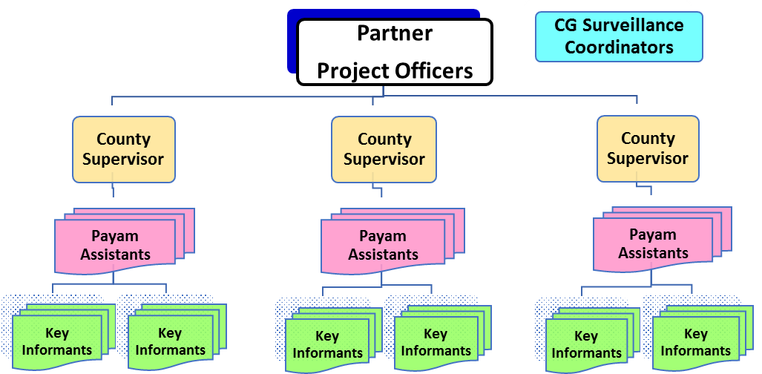

# 2.3 Standard Operating Procedures for Community Based Surveillance

## The objective of this standard operation procedure is to streamline field operations across partners and counties where Core Group is implementing Community Based Surveillance (CBS) activities.

## There will be one Payam Assistant (PA) for each payam who resides and works within the payam from which he/she was recruited; who underwent training on community based surveillance and AFP detection.

## Each Payam Assistant (PA) will identify and train a minimum of ten (10) Key Informants per payam. *NOTE: it is expected that there will generally be more than 10 KI per payam depending on the number of bomas/villages, geography of the payam and size of the population*

## Payam assistants (PAs) must visit 100% of the Key Informants in their payam every month.

## Payam assistants (PA) will use a diary/log-book to document their activities. *NOTE: when the PA visits key informants (KI) in the community, the diary/log-book must be signed by each key informant visited.*

## Each county must have at least one County Supervisor (CS) who has undergone training on community based surveillance and AFP surveillance.

## County supervisors (CS) must visit each payam assistant in the county at least once per month and document the visit (date of visit, name of PA, location of visit, issues discussed, action points).

## County Supervisors (CS) must keep a diary/log-book to document their daily activities.

* County Supervisors will manage and document all funds provided for both salaries and CBS operations in their county (costs associated with transport, training, sensitization meetings)

## All Payam Assistants and County Supervisors must have well-developed monthly work plans (A1-B1) which are revised continuously. *NOTE: see ANNEX 1 for field-related formats*

## All Payam Assistants and County Supervisors must report activities conducted during the month to their next-level supervisors by the 5th of the following month using the standard reporting format (A6-B6).

|  |
| --- |
| **Standard Operating Procedures for State and Headquarters levels:** Partner Project Officers will visit 90% of the CBS counties each quarter to ensure regular supervision of activities.Core Group State Surveillance Coordinators and other secretariat staff will visit at least 40% of the CBS counties each quarter to ensure regular supervision of activities.All field visit conducted by partner staffs and the secretariat must be documented with clear feedback using standard checklists (A7 & B7) and the Field Trip report format (C1)All CG State Surveillance Coordinators, Partner Project Surveillance Officers and partners must have well documented quarterly field supervision plans which are updated each month.  * Partners will produce a monthly CBS Report using the **standard report format (C2)**  There will be at least one partner coordination meeting conducted at Juba level every month with clear minutes and action points disseminated to partners for action |

**Chapter 3: Working with Key Informants**

**3.1 Who are Key Informants (KIs)**

* A Key Informant (KI) is a local person that, due to his/her status in the community or the nature of his/her work, is likely to be informed about the sudden occurrence of a case of paralysis among children.
* He/she should be willing to share this information quickly with the CBS staff on voluntary basis. Types of Key Informants include:

|  |  |
| --- | --- |
| Village chiefsWomen leadersChurch leaders  * Teachers | Traditional birth attendantsTraditional healersPharmacists  * Community health workers |

**3.2 Selection of Key Informants**

## Each Payam Assistant (PA), with the support of the County Supervisor (CS) and community leaders, will identify an appropriate number of Key Informants in the payam (a minimum of 10 but as many as practical) with the following criteria in the selection

## At least one per Boma (good geographical distribution across the payam)

* + Good representation of different types/gender **(**village/boma chiefs, traditional healers, traditional birth attendance, teachers, women association leaders, church leaders, drug sellers, community health workers, etc.)
  + Appropriate as per the prevailing ethnic groups in the location

**3.3 Role of Key informants in Community Based Surveillance**

## Identify suspect AFP cases (in the community in his/her assigned boma or village (see definition below)

## Report identified cases (*any person less than 15 years of age with sudden weakness or loss of movement in one or both arms or legs not due to injury)* to the PA assigned to his/her payam

## Support the Payam Assistant, the County Supervisor and WHO surveillance staff in the investigation of the reported case

## Provide feedback to the community about the reported suspect AFP case

# 3.4 Orientation of the Key Informants

## After identifying the Key Informants, the Payam Assistant with the support of the County Supervisor will provide an orientation to the Key Informants about the nature of the work requested from them. The orientation for Key Informants (see Annex 2) will include:

## What is Polio?

## Why we need surveillance for Polio?

## What is the Role of the Key Informant?

## Which cases to report? Which cases not to report?

* + Feedback about reported cases to the community

## *NOTE: ask your Project Officer for a PowerPoint presentation for Key Informant orientation*

**Chapter 4: Payam Assistants (Roles and Responsibilities)**

Payam Assistants work closely with payam authorities and community leaders to establish an AFP surveillance network and increase sensitivity of community AFP surveillance by working through Key informants that include village/boma chiefs, women leaders, traditional healers, traditional birth attendance, teachers, church leaders, community health workers etc.

**4.1 Scope of Work for the Payam Assistants**

* Establish network of community based surveillance in his/her payam by working closely with community leaders to identify and recruit key informants as per the criteria indicated in the previous chapter.
* Train the selected key informants on their roles and responsibilities as the community front of the AFP surveillance system. The training will be based on the material included in annex I of this guideline.
* Visit each Key Informant at least once a month to check the presence of any suspect AFP cases. These visits and other contacts with the key informants will be documented in a logbook **(A-3)**. The logbook will include the date of contact, name, location, reason for contact and action taken (plus signature of the informant visited)
* Ensure that a minimum of 10 key informants in his/her payam are actively working and reporting any suspect AFP case as soon as they receive a case from the community members
* Prepare and maintain an up-to-date map of the Payam which indicates the location of each boma and key informant in the payam
* Visit and verify all reported suspect AFP cases by Key Informants within 24 hours of receiving the report. Refer cases verified as suspect AFP cases immediately to County Supervisor. The information about the reported cases will be kept in the Initial Reporting Formats **(A-4)** and the Suspect AFP case line-list **(A-5)**
* Support Key Informants to provide feedback to the families of the reported suspect AFP cases.
* Prepare a monthly plan-of-work **(A-1)** indicating on which day he/she will visit each key informant and meetings expected to be held
* Conduct meetings with government officers, community and religion leaders, NGO staffs and others to emphasize the need to report recent paralysis cases. The objectives of these meetings are to sensitize the community about AFP surveillance and ensure that AFP surveillance activities gain support among the community. The information on these meetings held/attended should be recorded in a dairy/logbook **(A-3)**. *NOTE: the Payam Assistant should conduct a minimum of 4 community leader’s meetings in a month and visits to 4 churches/mosques where present.*
* Conduct visits to schools at least once a quarter to meet school teachers and pupils to share key AFP surveillance messages to strengthen the community based AFP surveillance
* Coordinate with WHO staff at the payam (if any) and county level in reporting and investigation suspect AFP cases and in the collection of stool samples of reported cases, their contact or healthy children
* Submit a monthly report **(A-6)** about CBS activities that includes information on visits with informants, meetings held, as well as information on cases reported and verified
* Support other PEI activities in the county as requested by higher level supervisors. This may include supporting SIAs implementation and Routine EPI services when appropriate.
* Carry-out all tasks as listed of the CBS Checklist for Payam Assistants **(A-7)**

# 4.2 The Payam Assistant (PA) will maintain the following documents:

* Monthly Work Plan indicating on which day he/she will visit each key informant and meetings expected to be held and attended **(A-1)**
* List of Key Informants (KI): location, name, type…. **(A-2)**
* Log-book **(A-3)** of activities that includes:
  + Documentation on contacts with key informants (KI) during the month
  + Information on meetings held in the month
* Map of the payam indicating important demographic, health and social features (to include location of all bomas). The map should also indicate the location of the key informants (KI)
* Copies of CBS Initial Reporting Format (IRF) of suspect AFP cases **(A-4)**. *NOTE: keep original IRF for excluded cases. Hand the original IRF to the county supervisor for verified cases*
* Line-list of suspect AFP cases reported **(A-5)**. *NOTE: only suspect AFP cases in the payam will be entered on this list and maintained as a record of disease surveillance in the payam*
* Monthly report **(A-6)** about CBS activities conducted during the month that includes information from the tables above as well as information on suspect AFP cases reported and verified

# Chapter 5: County Supervisor (Roles and Responsibilities)

The County Supervisor is the direct supervisor of the Payam Assistants (PAs). He will help the PAs in establishing the network of Key Informants. He will ensure that the PAs are implementing their duties. He is the link between the CBS and WHO facility based surveillance system. He also manages the CBS finances at the county level.

**5.1 Functions of the County Supervisor**

* Ensure that each payam in the county has at least one Payam Assistant (PA) for disease surveillance
* Each County Supervisor (CS) will have an up to date work plan showing the planned activities for the concerned month **(B-1)**.
* Keep a **diary/log book (B-2)** to document all his/her daily activities for the month.
* Receives and disperse funds related to the CBS in his own county. Maintain records of funds received **(B-3)** and funds spent **(B-4)** by quarter. Include the financial information in the monthly report **(B-6)**
* In collaboration with the WHO field supervisors and county health department support trainings of payam assistants and key informants.
* Supervise the Payam Assistants in his county and ensure that they fulfill all their responsibilities.
* Visit each Payam assistant once every month and document the date of the visit, the name of the payam assistant visited, location, what was discussed and action points. *NOTE: the CS will fill the* ***CBS Checklist for Payam Assistants (A-7****) during each supervisory visit to the payam level.*
* Review and approve the Payam Assistant’s workplan for every month.
* Provide the Payam Assistants with reporting tools and ensure that the supply of the tool is uninterrupted with adequate stock in the office.
* Organize a quarterly meeting for the Payam Assistants in collaboration with WHO field supervisors and the county health departments.
* Prepare a detailed county social map that shows where payam assistants are based, schools, churches, health facilities, cold chain equipment, airstrip, reported AFP cases etc.
* Visit each suspect case with the Payam Assistant within 24 hours of receiving the report from the payam assistant. Include/exclude the suspect case as meeting the criteria of a recent suspect AFP case. The result of the visit will be documented in the Initial Reporting Formats and the suspect AFP cases line-list.
* Refer to WHO recent suspect AFP cases for validation.
* Provide support to WHO in investigating AFP cases and in collecting stool samples from AFP cases, contacts or healthy children.
* Convene monthly meetings with WHO field supervisors, county health departments, government, and NGO staffs to discuss disease surveillance issues.
* Maintain a comprehensive (data from all payams) county line-list of suspect AFP cases **(A-5)**
* Receives monthly reports from the PAs, compiles the data in a county-wide summary as part of the monthly summary report for the county **(B-6)**.
* Submit a monthly summary report and ensures that the report is submitted by the 5th of every month to the project officer based in Juba using the standard reporting form for the county **(B-6)**.
* Support other PEI activities in the county as requested by higher level supervisors. This may include participating in the post-campaign evaluation following SIAs and supporting Routine EPI services when appropriate.
* Represent the Community Based Surveillance project in county level coordination meeting
* Carry-out all tasks as listed of the CBS Checklist for County Supervisors **(B-7)**

## 5.2 The County Supervisor will maintain the following documents:

* A copy of the CBS Field Guide (this document)
* Copy of the list of key informants for each payam **(A-2)**
* Copy of the map of distribution of key informants for each payam
* Social map of the county showing location of payam assistants
* Copy of payam monthly work plans **(A-1)**
* The Initial Reporting Format (IRF) for suspect AFP cases reported from the county **(A-4)**
* Updated line-list of suspect AFP cases reported from the CBS system for the whole county **(A-5)**
* File of supervisory checklists for all visits to the Payam Assistants **(A-7)**
* A “Budget” file that includes:
* Budget document: shows what funds the CS should receive for each quarter by line-item
* Budget document (for each quarter): shows CBS funds **received** **(B-3)**
* Budget document (for each quarter): shows CBS funds **spent** **(B-4)**
* Budget document: **Fund Request Form (B-5)**
* Copy of all Payam Assistant’s monthly reports **(A-6)**
* Monthly County CBS Report **(B-6)**. *NOTE: the CS will send the original to the partner HQ in Juba and keep a copy of each county monthly report in his/her files*

**Chapter 6: Processing suspect AFP cases**

## After receiving a report of a suspected paralysis case from a key informant, social mobilizer, health worker or any other source, the most important work of the Payam Assistant is to immediately visit the case, collect preliminary information and report findings to the County Supervisor.

## Step One: Payam Assistant visit the reported case

## The PA will be informed about a suspect AFP case in a village. He/she will immediately fill Section A of the Initial Reporting Form (IRF)—see example below and a copy of the IFR form (A4) that can be photocopied (see ANNEX 1 (A4).

## The PA will visit the case within 24 hours of receiving the report to verify the existence of an actual paralyzed child

## Update the information in Section A based on the visit outcome (see outcomes below)

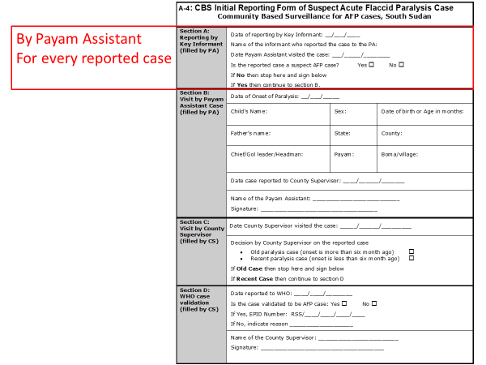

## 1st possible outcome of Step One: Not a suspect AFP case

## If the reported case is NOT a suspect AFP case (not a paralyzed child under 15 years of age), then:

## Update Section A in the IRF (do not fill any other section of the IRF)

## Do not enter any information on the suspect AFP cases line-list

## Record the information in the logbook but do not report this case to the County Supervisor for immediate action

## Keep the IRF for your records

## 2nd possible outcome of Step One: a suspect AFP case

## If the reported case is found to be a suspect AFP case (child less than fifteen years of age with sudden weakness or loss of movement in one or both arms or legs) then the Payam Assistant will:

## Update Section A and fill-out Section B in IRF (see below and A4 in ANNEX 1)

## Also fill section B in the “Line-List of Suspect AFP Cases” format (A5) with initial information:

## Name

## Age

## Location: Village, Boma, Payam, County

## Information regarding the Key Informant (or other person) who reported the case

## Date of onset of paralysis

## Date report received by the Payam Assistant (PA)

## Date of visit by the PA

## The Payam Assistant will inform the County Supervisor about the case within 24 hours of seeing the case (total 48 hours since receiving the information from the Key Informant)

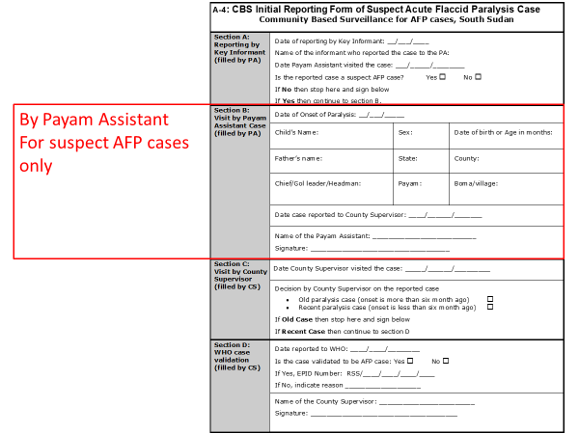

-

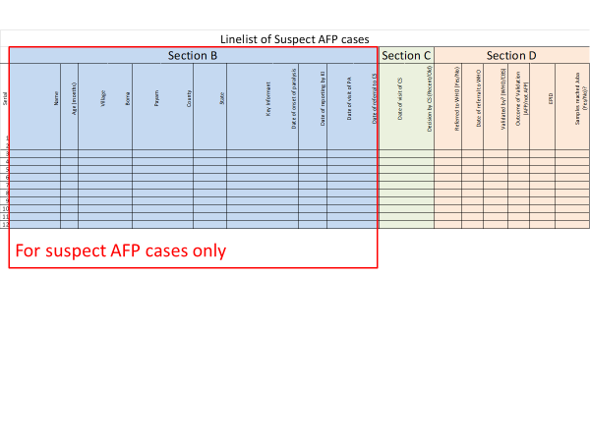

## Step Two: County Supervisor visit to the suspect AFP case

## The County Supervisor will collect the IRF from the Payam Assistant and together they will visit the suspect AFP case

## The CS will check whether this is a recent or old suspect AFP case *NOTE: the visit should take place within 24 hours of receiving the report of the PA*

## The case will be considered NOT a recent suspect AFP case if the following

## A chronic case with long duration of paralysis (started long time ago)

## An old acute case (old polio case) where the date of onset is more than 6 months

## 1st possible outcome of Step Two: Old suspect AFP case

## If the case is found to be an old case as described above then take the following action:

## The County Supervisor fill in section C in the IRF

## The County Supervisor and the Payam assistant fill in section C in the suspect AFP linelist

## Case will be excluded and not reported to WHO

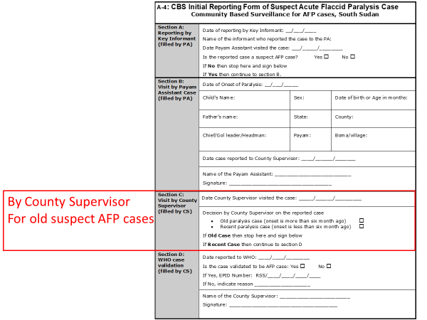

-

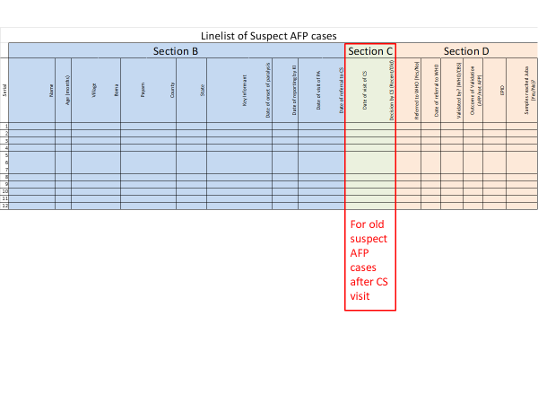

## 2nd possible outcome of Step Two: Recent Suspect AFP case

## If the suspect AFP case is found to be a recent case

## The County Supervisor fill in section C in the IRF

## The County Supervisor and the Payam fill in section C on the suspect AFP case line-list

## Case referred to WHO for validation within 24 Hours *NOTE: fill in the date of referral to WHO in section D in IRF and the line-list*

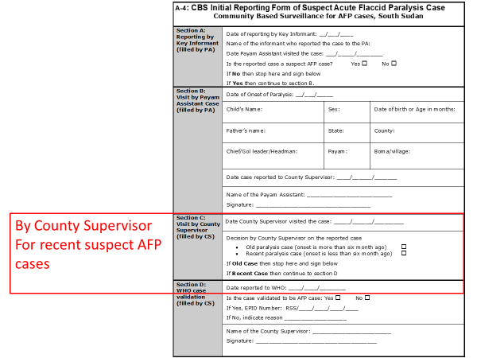

-

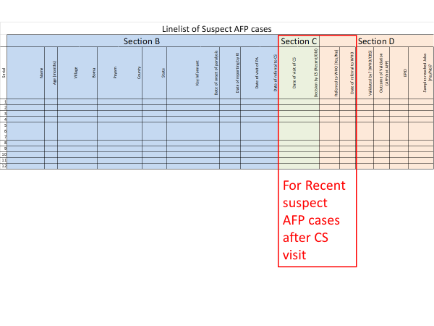

## Step Three: WHO Validation for the reported case

## WHO will check on the presence and the type of paralysis

## Does the child suffer from muscle weakness? As per the standard surveillance procedure, if the investigator is not sure whether there is muscle weakness it is better to err on the safe side and include the case

## Is the paralysis (weakness) flaccid or spastic? If spastic the case should be excluded

## WHO staff will inform the County Supervisor about the decision to include or exclude the case

## Based on the feedback from WHO the County Supervisor will

## Complete section D in the IRF (form A4)

## Complete section D in the suspect AFP case line-list (form A5)

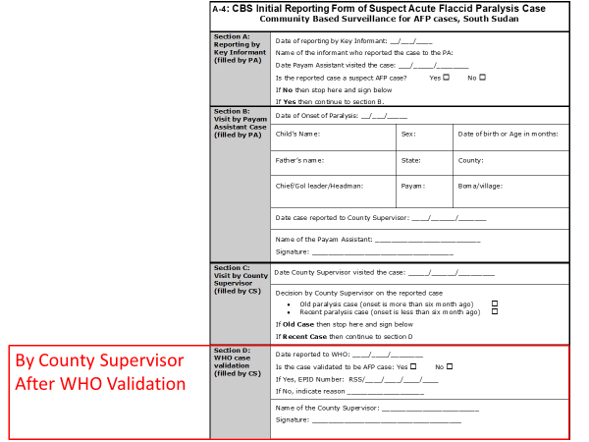

-

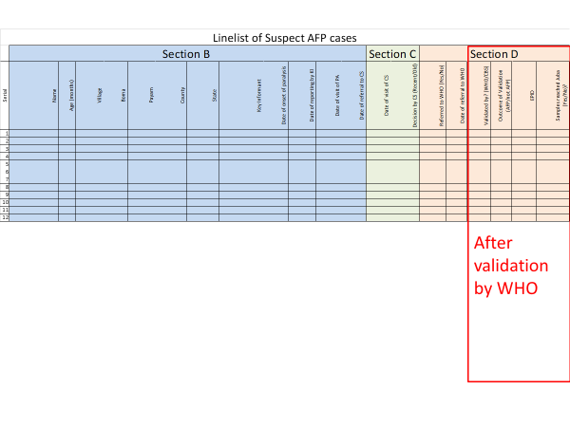

**A summary of the reporting and validation process is provided in the flow chart below:**

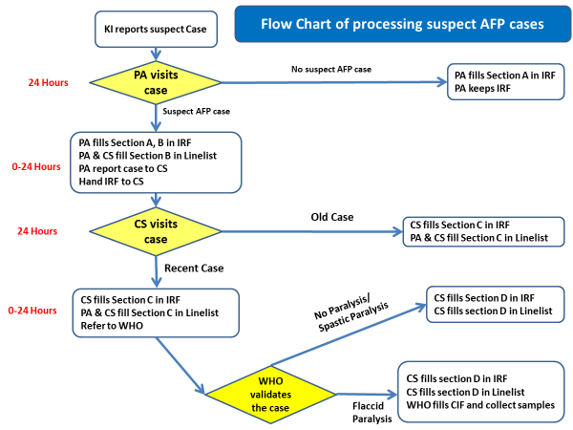

## Time-line for the activities

## Payam Assistant to visit the case reported by the Key Informant and (if needed) report the case to the CS: 24-48 hours

## The County Supervisor visit the case and (if needed) inform WHO for validation: 24-48 hours

## 

## Total time from Key Informant reporting to the Payam Assistant till the County Supervisor referring the case to WHO for validation: 48-96 hours

## Each of the Payam Assistant and County Supervisor are required to carry out two activities; a field visit and (if needed) reporting to another person.

## 

## The field visit should take a maximum of 24 hours

## The reporting can take little time (if mobile coverage is available in the county) or require a visit to the person to be informed about the case which may add another 24 hours.

## What to do if there is no functional WHO surveillance staff in the county?

## In case the county does not have a functioning WHO staff, the County Supervisor or higher-level CBS staff can validate the cases by themselves. This should be the exception rather than the rule.

## If the case turns out to be an AFP case then the county supervisor will

## Fill the Initial case investigation form (WHO form)

## Collect the stool samples and send samples to WHO

## Common mistakes in reporting/verifying/investigating suspect AFP cases

## Referring cases to WHO with date of onset more than 6 month ago

## Collecting stool samples without validating the cases

## Collecting the samples without filling the WHO case investigation form

## Collecting samples of cases with onset more than two months ago

## Collecting samples from cases without collecting samples from contacts

## Not reporting the suspect AFP case to partner headquarters/Core Group to obtain assistance in booking samples on UNHAS flights

**# # #**

**List of Annexes and Formats**

|  |  |  |
| --- | --- | --- |
| **Code** | **Item** | **Page** |
| **ANNEX 1:** | **Field-related formats to be used at (A) payam and (B) county levels** | **17 - 34** |
|  | **A. PAYAM LEVEL** | **18 - 25** |
| **A-1** | **Monthly Work Plan for Payam Assistants** | **18** |
| **A-2** | **List of CBS Key Informants** | **19** |
| **A-3** | **Information to be kept in Payam Assistant’s logbook/dairy** | **20** |
| **A-4** | **CBS “Initial Reporting Form (IRF) of suspect AFP cases** | **21** |
| **A-5** | **Payam CBS Line-List of Suspect AFP Cases** | **22** |
| **A-6** | **CBS Monthly Report by Payam Assistants (PA)** | **23-24** |
| **A-7** | **CBS Checklist for Payam Assistants (PA)** | **25** |
|  |  |  |
|  | **B. COUNTY LEVEL** | **26 - 34** |
| **B-1** | **Monthly Work Plan for County Supervisors (CS)** | **26** |
| **B-2** | **Information to be kept in County Supervisor’s logbook/dairy** | **27** |
| **B-3** | **Budget: Quarterly Funds RECEIVED** | **28** |
| **B-4** | **Budget: Quarterly Funds SPENT** | **29** |
| **B-5** | **Budget: Fund Request Form** | **30** |
| **B-6** | **CBS Monthly Report by County Supervisor (CS)** | **31-33** |
| **B-7** | **CBS Checklist for County Supervisors (CS)** | **34** |
|  |  |  |
| **ANNEX 2:** | **Key Informant Orientation guide and “handout”** | **35 - 37** |
|  |  |  |

**A-1: Monthly Work Plan for Payam Assistant**

|  |  |  |
| --- | --- | --- |
| **Name of Payam Assistant:** | **Planning Month** | **Implementing partner:** |
| **Payam:** | **County:** | **State:** |

**Planed visits to Key Informants**

|  |  |  |  |  |
| --- | --- | --- | --- | --- |
| **SN** | **Name of KI** | **Location of KI** | **Date of planned visit** | **Specific issues to discuss** |
| **1** |  |  |  |  |
| **2** |  |  |  |  |
| **3** |  |  |  |  |
| **4** |  |  |  |  |
| **5** |  |  |  |  |
| **6** |  |  |  |  |
| **7** |  |  |  |  |
| **8** |  |  |  |  |
| **9** |  |  |  |  |
| **10** |  |  |  |  |
| **11** |  |  |  |  |
| **12** |  |  |  |  |
| **13** |  |  |  |  |
| **14** |  |  |  |  |
| **15** |  |  |  |  |

(Note: all Key Informants should be visited every month)

**Planned meeting**

|  |  |  |  |  |
| --- | --- | --- | --- | --- |
| **SN** | **Location of meeting** | **Date of meeting** | **Type of meeting** | **Purpose of meeting** |
| **1** |  |  |  |  |
| **2** |  |  |  |  |
| **3** |  |  |  |  |
| **4** |  |  |  |  |
| **5** |  |  |  |  |
| **6** |  |  |  |  |

**Other planned activities**

|  |
| --- |
|  |

**A-2: List of CBS Key Informants**

**State: County: Payam:**

|  |  |  |  |  |  |
| --- | --- | --- | --- | --- | --- |
| **SN** | **Village** | **Boma** | **Name of KI** | **Type of KI** | **Details of KI** |
|  |  |  |  |  |  |
|  |  |  |  |  |  |
|  |  |  |  |  |  |
|  |  |  |  |  |  |
|  |  |  |  |  |  |
|  |  |  |  |  |  |
|  |  |  |  |  |  |
|  |  |  |  |  |  |
|  |  |  |  |  |  |
|  |  |  |  |  |  |
|  |  |  |  |  |  |
|  |  |  |  |  |  |
|  |  |  |  |  |  |
|  |  |  |  |  |  |
|  |  |  |  |  |  |
|  |  |  |  |  |  |
|  |  |  |  |  |  |
|  |  |  |  |  |  |
|  |  |  |  |  |  |
|  |  |  |  |  |  |
|  |  |  |  |  |  |
|  |  |  |  |  |  |
|  |  |  |  |  |  |
|  |  |  |  |  |  |
|  |  |  |  |  |  |
|  |  |  |  |  |  |
|  |  |  |  |  |  |
|  |  |  |  |  |  |
|  |  |  |  |  |  |
|  |  |  |  |  |  |
|  |  |  |  |  |  |
|  |  |  |  |  |  |
|  |  |  |  |  |  |

**Name of Payam Assistant: _______________________** **Name of County Supervisor**: ______________________

Signature: ________________________________ Signature: __________________________

**A-3: Information to be kept in the Payam Assistant’s Logbook**

**Logbook information for contacts with KIs during the month**

**State: County: Payam:**

|  |  |  |  |  |  |
| --- | --- | --- | --- | --- | --- |
| **Date of contact** | **Name of KI** | **Location of contact** | **Reason of contact\*** | **Follow-up action** | **Signature of KI** |
|  |  |  |  |  |  |
|  |  |  |  |  |  |
|  |  |  |  |  |  |
|  |  |  |  |  |  |
|  |  |  |  |  |  |
|  |  |  |  |  |  |

***\* Reason for contact can be: a) Routine visit by PA, b) Report of suspect case by KI, or c) Other***

**Logbook information for meetings conducted/attended during the month**

**State: County: Payam:**

|  |  |  |  |  |  |  |
| --- | --- | --- | --- | --- | --- | --- |
| **Date of meeting** | **Meeting Location** | **Purpose of Meeting** | **Type of attendees** | **Number attended** | **Main issues discussed** | **Follow-up actions** |
|  |  |  |  |  |  |  |
|  |  |  |  |  |  |  |
|  |  |  |  |  |  |  |
|  |  |  |  |  |  |  |
|  |  |  |  |  |  |  |
|  |  |  |  |  |  |  |

|  |  |  |  |
| --- | --- | --- | --- |
| **A-4: CBS Initial Reporting Form of Suspect Acute Flaccid Paralysis Case**  **Community Based Surveillance for AFP cases, South Sudan** | | | |
| **Section A:**  **Reporting by Key Informant**  **(filled by PA)** | Date of reporting by Key Informant: __/___/____  Name of the informant who reported the case to the PA:  Date Payam Assistant visited the case: ___/_____/________  Is the reported case a suspect AFP case? Yes 🞎 No 🞎  If **No** then stop here and sign below  If **Yes** then continue to section B. | | |
| **Section B:**  **Visit by Payam Assistant**  **(filled by PA)** | Date of Onset of Paralysis: __/___/_____ | | |
| Child’s Name: | Sex: | Date of birth or Age in months: |
| Father’s name: | State: | County: |
| Chief/Gol leader/Headman: | Payam: | Boma/village: |
| Date case reported to County Supervisor: ____/______/_______ | | |
| Name of the Payam Assistant: __________________________  Signature: ___________________________________ | | |
| **Section C:**  **Visit by County Supervisor**  **(filled by CS)** | Date County Supervisor visited the case: _____/______/_________ | | |
| Decision by County Supervisor on the reported case   * Old paralysis case (onset is more than six month ago) 🞎 * Recent paralysis case (onset is less than six month ago) 🞎   If **Old Case** then stop here and sign below  If **Recent Case** then continue to section D | | |
| **Section D:**  **WHO case validation**  **(filled by CS)** | Date reported to WHO: ____/____/________  Is the case validated to be AFP case: Yes 🞎 No 🞎  If Yes, EPID Number: RSS/____/____/____/____  If No, indicate reason ___________________ | | |
| Name of the County Supervisor: ________________________  Signature: _____________________________________ | | |

Version May 2017

**A-5: CBS Line-list of Suspect AFP Cases**

**State: County: Payam:**

|  |  |  |  |  |  |  |  |  |  |  |  |  |  |  |  |  |  |  |  |  |
| --- | --- | --- | --- | --- | --- | --- | --- | --- | --- | --- | --- | --- | --- | --- | --- | --- | --- | --- | --- | --- |
|  | **Section B** | | | | | | | | | | | | **Section C** | | **Section D** | | | | | |
| **Serial** | **Name of Case** | **Age (months)** | **Village** | **Boma** | **Payam** | **County** | **State** | **Key Informant (Source)** | **Date of onset of paralysis** | **Date of reporting by KI** | **Date of visit of PA** | **Date of referral to CS** | **Date of visit of CS** | **Decision by CS (Recent/Old)** | **Referred to WHO (Yes/No)** | **Date of referral to WHO** | **Validated by? (WHO/CBS)** | **Outcome of Validation (AFP/not AFP)** | **EPID** | **Samples reached Juba (Yes/No)?** |
| **1** |  |  |  |  |  |  |  |  |  |  |  |  |  |  |  |  |  |  |  |  |
| **2** |  |  |  |  |  |  |  |  |  |  |  |  |  |  |  |  |  |  |  |  |
| **3** |  |  |  |  |  |  |  |  |  |  |  |  |  |  |  |  |  |  |  |  |
| **4** |  |  |  |  |  |  |  |  |  |  |  |  |  |  |  |  |  |  |  |  |
| **5** |  |  |  |  |  |  |  |  |  |  |  |  |  |  |  |  |  |  |  |  |
| **6** |  |  |  |  |  |  |  |  |  |  |  |  |  |  |  |  |  |  |  |  |

**A-6: Monthly Report by Payam Assistant (PA)**

|  |  |  |
| --- | --- | --- |
| **Name of Payam Assistant:** | **Reporting Month** | **Implementing partner:** |
| **Payam:** | **County:** | **State:** |

**Visits to Key Informants**

|  |  |  |  |  |
| --- | --- | --- | --- | --- |
| **SN** | **Name of KI** | **Date of planned visit** | **Date of actual visit** | **If visit not conducted explain why?** |
| **1** |  |  |  |  |
| **2** |  |  |  |  |
| **3** |  |  |  |  |
| **4** |  |  |  |  |
| **5** |  |  |  |  |
| **6** |  |  |  |  |
| **7** |  |  |  |  |
| **8** |  |  |  |  |
| **9** |  |  |  |  |
| **10** |  |  |  |  |
| **11** |  |  |  |  |
| **12** |  |  |  |  |
| **13** |  |  |  |  |
| **14** |  |  |  |  |
| **15** |  |  |  |  |

**Community meetings**

|  |  |  |  |  |  |
| --- | --- | --- | --- | --- | --- |
| **SN** | **Location of meeting** | **Date of planned meeting** | **Date of actual meeting** | **Number attended** | **If meeting not conducted explain why?** |
| **1** |  |  |  |  |  |
| **2** |  |  |  |  |  |
| **3** |  |  |  |  |  |
| **4** |  |  |  |  |  |
| **5** |  |  |  |  |  |

**Summary of monthly activity in the Payam**

|  |  |
| --- | --- |
| **Total # of KIs** |  |
| **# of KIs more than 10 (Y/N)** |  |
| **# KI visited during the month** |  |
| **% of KI visited during the month** |  |
| **# Planned community meeting** |  |
| **# Conducted community meetings** |  |
| **% of community meeting conducted** |  |
| **# of Participants attended community meetings** |  |

**Suspect AFP cases reported during the current month**

|  |  |  |  |
| --- | --- | --- | --- |
| **SN** | 1 | 2 | 3 |
| **Name** |  |  |  |
| **Age** |  |  |  |
| **Village** |  |  |  |
| **Boma** |  |  |  |
| **Payam** |  |  |  |
| **County** |  |  |  |
| **State** |  |  |  |
| **Reported by? (Key Informant)** |  |  |  |
| **Date reporting by KI to PA** |  |  |  |
| **Date of visit of PA to the case** |  |  |  |
| **Reported Case is Suspect AFP? (Yes/No)** |  |  |  |
| **Date of referral by PA to CS** |  |  |  |
| **Date of onset of paralysis** |  |  |  |
| **Date of visit of CS to the Case** |  |  |  |

**Summary of suspect AFP cases reported during the month**

|  |  |
| --- | --- |
| **# Cases reported by KIs** |  |
| **# Reported cases found to be suspect AFP cases** |  |
| **# Cases referred to CS within 48 Hours of initial report** |  |
| **# Cases excluded by CS (old cases)** |  |
| **# Cases referred to WHO by CS (recent cases)** |  |

**Other activities implemented during the month**

|  |
| --- |
|  |

**Challenges experienced during the month**

|  |
| --- |
|  |

**A-7: CBS Checklist for Payam Assistants (PA)**

|  |  |  |
| --- | --- | --- |
| **Supervisor/visitor’s name:** | **Date of visit:** | **REMARKS** |
| **County:** | **Payam:** |
| **Name of the payam assistant 🡪** |  |
| 1) Does the payam assistant have an up-to-date work plan for the current month? | Yes 🞎 No 🞎 |  |
| 2) Does the payam assistant have a list of the Key Informants (KI) indicating the location and the type of the KI? | Yes 🞎 No 🞎 |  |
| 3) Is the number of the key informants appropriate? | Yes 🞎 No 🞎 |  |
| 4) Is the selection of the Key Informants appropriate? | Yes 🞎 No 🞎 |  |
| 5) Does the payam assistant have map of distribution of the KI? | Yes 🞎 No 🞎 |  |
| 6) Does the distribution of the KI provide full coverage of the population of the payam? | Yes 🞎 No 🞎 |  |
| 7) Does the payam assistant (PA) keep a log book for contacts with key informant? | Yes 🞎 No 🞎 |  |
| 8) Do the key informants sign the log book when visited by the PA? | Yes 🞎 No 🞎 |  |
| 9) Did the PA carry out all planned visits to KI last month? | Yes 🞎 No 🞎 |  |
| 10) Did the PA conduct all planned community meetings last month? | Yes 🞎 No 🞎 |  |
| 11) Does the PA keep a line-list of the suspect AFP cases reported? | Yes 🞎 No 🞎 |  |
| 12) Is the above line-list properly filled? | Yes 🞎 No 🞎 |  |
| 13) Does the Payam Assistant (PA) have a copy of the monthly report for the previous month? | Yes 🞎 No 🞎 |  |
| 14) Does the PA know the name and have contact with the WHO disease surveillance staffs in his/her payam & the county (If any)? | Yes 🞎 No 🞎 |  |
| **TOTAL YES 🡪** |  | **PERCENT YES:** |

**B-1: Monthly Work Plan for County Supervisors (CS)**

|  |  |  |
| --- | --- | --- |
| **Name of County Supervisor:** | **Planning Month** | **Implementing partner:** |
| **County:** | **State:** | |

**Planed visits to Payam Assistants**

|  |  |  |  |  |
| --- | --- | --- | --- | --- |
| **SN** | **Name of PA** | **Payam** | **Date of planned visit** | **Specific issues to discuss** |
| **1** |  |  |  |  |
| **2** |  |  |  |  |
| **3** |  |  |  |  |
| **4** |  |  |  |  |
| **5** |  |  |  |  |
| **6** |  |  |  |  |
| **7** |  |  |  |  |
| **8** |  |  |  |  |
| **9** |  |  |  |  |
| **10** |  |  |  |  |
| **11** |  |  |  |  |
| **12** |  |  |  |  |

(Note: all Payam Assistants should be visited at least once every month)

**Planned meeting**

|  |  |  |  |  |
| --- | --- | --- | --- | --- |
| **SN** | **Location of meeting** | **Date of meeting** | **Type of meeting** | **Purpose of meeting** |
| **1** |  |  |  |  |
| **2** |  |  |  |  |
| **3** |  |  |  |  |
| **4** |  |  |  |  |
| **5** |  |  |  |  |
| **6** |  |  |  |  |
| **7** |  |  |  |  |
| **8** |  |  |  |  |
| **9** |  |  |  |  |
| **10** |  |  |  |  |

**Other planned activities**

|  |
| --- |
|  |

**B-2: Information to be kept in the County Supervisor’s Logbook/Diary**

**Logbook information for contacts with PAs during the month**

**State: County: Payam:**

|  |  |  |  |  |  |
| --- | --- | --- | --- | --- | --- |
| **Date of contact** | **Name of PA and/or other persons** | **Location of contact** | **Reason of contact\*** | **Follow-up action** | **Signature of PA** |
|  |  |  |  |  |  |
|  |  |  |  |  |  |
|  |  |  |  |  |  |
|  |  |  |  |  |  |
|  |  |  |  |  |  |
|  |  |  |  |  |  |

***\* Reason for contact can be: a) Routine visit by PA, b) Report of suspect case by KI, or c) Other***

**Logbook information for meetings conducted/attended during the month**

|  |  |  |  |  |  |  |
| --- | --- | --- | --- | --- | --- | --- |
| **Date of meeting** | **Meeting Location** | **Purpose of Meeting** | **Type of attendees** | **Number attended** | **Main issues discussed** | **Follow-up actions** |
|  |  |  |  |  |  |  |
|  |  |  |  |  |  |  |
|  |  |  |  |  |  |  |
|  |  |  |  |  |  |  |
|  |  |  |  |  |  |  |

|  |
| --- |
| **Other information:** |







**B-6: Monthly Report by County Supervisors**

|  |  |  |
| --- | --- | --- |
| **Name of County Supervisor:** | **Reporting Month** | **Implementing partner:** |
| **County:** | **State:** | |

-

**Visits to Payam Assistants**

|  |  |  |  |  |  |
| --- | --- | --- | --- | --- | --- |
| **SN** | **Name of PA** | **Date of planned visit** | **Date of actual visit** | **Summary score of checklist** | **Issues detected during the visit** |
| **1** |  |  |  |  |  |
| **2** |  |  |  |  |  |
| **3** |  |  |  |  |  |
| **4** |  |  |  |  |  |
| **5** |  |  |  |  |  |
| **6** |  |  |  |  |  |

-

**Summary of checklist for supervising Payam Assistants**

|  |  |  |  |  |  |
| --- | --- | --- | --- | --- | --- |
| **SN** | **Question from Checklist** | **Total PAs visited in the month** | **Number of Checklists filled-out** | **Number of “Yes” answers from checklists** | **%**  **Yes** |
| **1** | **Up-to-date work plan** |  |  |  |  |
| **2** | **List of the Key Informants (KI)** |  |  |  |  |
| **3** | **Number of KI appropriate** |  |  |  |  |
| **4** | **Type of KI appropriate** |  |  |  |  |
| **5** | **Map of distribution of the KI?** |  |  |  |  |
| **6** | **KI fully cover the population of the county** |  |  |  |  |
| **7** | **A log book for contacts with key informant** |  |  |  |  |
| **8** | **key informants sign the log book** |  |  |  |  |
| **9** | **PA carried out the planned visits to KI last month** |  |  |  |  |
| **10** | **PA conducted planned meetings last month** |  |  |  |  |
| **11** | **A line-list of the suspect AFP cases reported** |  |  |  |  |
| **12** | **Line-list properly filled** |  |  |  |  |
| **13** | **Has the monthly report for the previous month** |  |  |  |  |
| **14** | **Knows WHO surveillance staff** |  |  |  |  |
| **Total** | |  |  |  |  |

-

**Compilation of monthly activities by Payam Assistants**

|  |  |  |  |  |  |  |  |
| --- | --- | --- | --- | --- | --- | --- | --- |
| **Name of Payam** |  |  |  |  |  |  | **Total** |
| **Total # of KIs** |  |  |  |  |  |  |  |
| **# KI visited during the month** |  |  |  |  |  |  |  |
| **% of KI visited during the month** |  |  |  |  |  |  |  |
| **# Planned community meeting** |  |  |  |  |  |  |  |
| **# Conducted community meetings** |  |  |  |  |  |  |  |
| **% of community meeting conducted** |  |  |  |  |  |  |  |
| **# of Participants attended meetings** |  |  |  |  |  |  |  |

**County level meetings**

|  |  |  |  |  |  |  |
| --- | --- | --- | --- | --- | --- | --- |
| **SN** | **Location of meeting** | **Planned date of meeting** | **Actual date of meeting** | **If meeting not conducted explain why?** | **Purpose of meeting** | **Main points discussed** |
| **1** |  |  |  |  |  |  |
| **2** |  |  |  |  |  |  |
| **3** |  |  |  |  |  |  |
| **4** |  |  |  |  |  |  |
| **5** |  |  |  |  |  |  |

**Summary of monthly activities by County Supervisor**

|  |  |
| --- | --- |
| **Total # of PAs** |  |
| **# PA visited during the month** |  |
| **% of PAs visited during the month** |  |
| **# Planned county-level meetings** |  |
| **# Conducted county-level meetings** |  |
| **% of county-level meetings conducted** |  |

-

**Other implemented activities**

|  |
| --- |
|  |

**Challenges experienced during the month**

|  |
| --- |
|  |

**Budget Summary**

|  |  |  |  |  |  |  |  |
| --- | --- | --- | --- | --- | --- | --- | --- |
| **Category** | **Quarterly budget** | **Carry over from previous month** | **During the current month** | | **Cumulative during the current quarter** | | **Balance at the end of the month** |
| **Received** | **Spent** | **Received** | **Spent** |
| **Salary** |  |  |  |  |  |  |  |
| **Operations** |  |  |  |  |  |  |  |

**Summary of suspect AFP cases reported in the county during the month**

|  |  |  |  |  |  |  |
| --- | --- | --- | --- | --- | --- | --- |
| **Name of Payam 🡪** |  |  |  |  |  | **Total** |
| **# Cases reported through CBS system (KI, PA, etc.)** |  |  |  |  |  |  |
| **# Cases found to be suspect AFP cases** |  |  |  |  |  |  |
| **# of cases referred to CS within 48 hrs of initial report** |  |  |  |  |  |  |
| **# Referred cases visited within 24 hours of receiving report by PA** |  |  |  |  |  |  |
| **# Cases excluded by CS (old cases)** |  |  |  |  |  |  |
| **# Cases referred to WHO by CS (recent cases)** |  |  |  |  |  |  |
| **# Cases referred to WHO within 96 Hours of initial report to CBS system** |  |  |  |  |  |  |

**B-7: CBS Checklist for County Supervisor (CS)**

|  |  |  |  |
| --- | --- | --- | --- |
| **Date of the visit:** | **Name of the Supervisor:** |  | **REMARKS** |
| **County:** | **State:** |
| **Name of the county supervisor:** | |
| 1) Does the county supervisor (CS) have a work plan for the current month (including a supervision plan)? | | Yes 🞎 No 🞎 |  |
| 2) Does the CS have a list of the key informants (KI) by payam indicating the location and type KI? | | Yes 🞎 No 🞎 |  |
| 3) Does the CS have a social map of the county map showing in which boma the payam assistant (PA) lives? | | Yes 🞎 No 🞎 |  |
| 4) Does the CS have a copy of the PAs payam map showing KIs? | | Yes 🞎 No 🞎 |  |
| 5) Does the CS have a diary/log book which shows all activities conducted during the last month? | | Yes 🞎 No 🞎 |  |
| 6) Does the CS have the monthly reports by **all** PAs for last month? | | Yes 🞎 No 🞎 |  |
| 7) Did the CS carry out planned visits to Payams during the previous month? | | Yes 🞎 No 🞎 |  |
| 8) Does the CS have a copy of the filled-out checklists from previous visits to payams? | | Yes 🞎 No 🞎 |  |
| 9) Does the CS have a copy of his monthly report of the previous month? | | Yes 🞎 No 🞎 |  |
| 10) Does the CS keep a line-list of the suspect AFP cases reported? | | Yes 🞎 No 🞎 |  |
| 11) Is the above line-list properly filled? | | Yes 🞎 No 🞎 |  |
| 12) Did the CS conduct the planned coordination meetings during the previous month? | | Yes 🞎 No 🞎 |  |
| 13) Does the CS know the name and have contact with the WHO disease surveillance staffs (all) in the county ? | | Yes 🞎 No 🞎 |  |
| 14) Does the CS have both Budget Trackers (Funds Received and Funds Spent) format for the current quarter? | | Yes 🞎 No 🞎 |  |
| 15) Is the Funds Received format for the current quarter filled-out correctly and up-to-date? | | Yes 🞎 No 🞎 |  |
| 16) Is the Funds Spent format for the current quarter filled-out correctly and up-to-date? | | Yes 🞎 No 🞎 |  |
| 17) Does the CS have receipts available for expenditures on the “Fund Spent” format? | | Yes 🞎 No 🞎 |  |
| **TOTAL YES 🡪** | |  | **% YES:** |
| 18) Did the CS receive all operational funds for the quarter by the 5th day of the first month of the quarter? | | Yes 🞎 No 🞎 |  |
| 19) Does the information on the CS Budget Tracker (Funds Received) match information from partner’s headquarters? | | Yes 🞎 No 🞎 |  |

Annex 2: Orientation for Key Informants

**What is polio?**

* Polio is a highly infectious disease caused by a virus
* Polio is spread through person-to-person contact and can spread rapidly through a community
* The virus invades the nervous system and can cause permanent paralysis and sometimes death
* Polio mainly affects children under 5 years of age
* There is no cure for polio, it can only be prevented. Polio vaccine, given multiple times, can protect a child for life

**Why Polio surveillance is important?**

* It is very important to find polio cases
* Any child under 15 of age with paralysis should be identified and reported
  + Stool samples will be collected from the child and sent to an international lab
* If the lab indicates that this child has polio, then all under 5 children in the area and even in the whole country have to be immunized to protect them

**Why community based surveillance is important? Why not get cases from hospitals and clinics?**

* Hospitals and clinics may not be available everywhere
* Not every paralyzed child will be taken to a hospital or clinic
* Even if they are taken there, they may not be taken immediately, so it is better if we can catch cases early

**Role of Key informants**

* Identify suspect AFP cases in the community
* Report identified cases to the Payam assistant
* Help in the investigation of the reported case
* Provide feedback to the community about the case

**What is suspect AFP case definition?**

* Any person less than 15 years of age with sudden weakness or loss of movement in one or both arms or legs (not due to injury)

**Have you seen a suspect AFP case?**

* **A suspect AFP case is any child or person less than 15 years of age with sudden weakness or loss of movement in one or both arms or legs which is NOT due to injury.**

**A person

Description generated with high confidence**

* **Report this case as soon as possible to the Payam Assistant**
* **Report by the fastest means possible**
  + **By Phone**
  + **Send somebody**
  + **Come in person**
* **The Payam Assistant will come to the village to verify the case** 
  + **If it is truly an AFP case, then stool samples will be collected to send to the lab**
* **If the lab confirms this case as polio, then all the children in the area (may be even the country) will be immunized to protect them.**

|  |
| --- |
| **If the case you report is a true suspect AFP case you will receive US 50 Dollars** |





