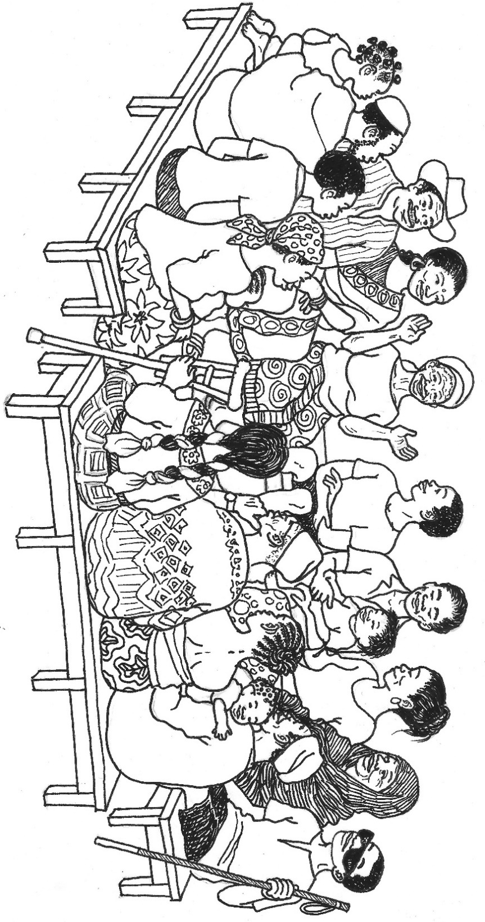
REALIZE:
Social and Behavioral Change for Gender Equity and Diversity
The TOPS Program
July 2017

REALIZE:
Social and Behavioral Change for Gender Equity and Diversity
July 2017

The Technical and Operational Performance Support (TOPS) Program is the USAID/Food for Peace-funded learning mechanism that generates, captures, disseminates, and applies the highest quality information, knowledge, and promising practices in development food assistance programming, to ensure that more communities and households benefit from the U.S. Government’s investment in fighting global hunger. Through technical capacity building, a small grants program to fund research, documentation and innovation, and an in-person and online community of practice (the Food Security and Nutrition [FSN] Network), The TOPS Program empowers food security implementers and the donor community to make lasting impact for millions of the world’s most vulnerable people.
Led by Save the Children, The TOPS Program draws on the expertise of its consortium partners: CORE Group (knowledge management), Food for the Hungry (social and behavioral change), Mercy Corps (agriculture and natural resource management), and TANGO International (monitoring and evaluation). Save the Children brings its experience and expertise in commodity management, gender, and nutrition and food technology, as well as the management of this 7-year (2010–2017) US$30 million award.

Disclaimer:
The Technical and Operational Performance Support (TOPS) Program was made possible by the generous support and contribution of the American people through the U.S. Agency for International Development (USAID). The contents of this guide were created by The TOPS Program and do not necessarily reflect the views of USAID or the U.S. Government.

Citation:
The TOPS Program and CARE International. 2017. REALIZE: Social and Behavioral Change for Gender Equity and Diversity. Washington, DC: The TOPS Program.

Cover Illustration: Regina Doyle

Contact:
The TOPS Program
c/o Save the Children
899 North Capitol Street NE, Suite 900
Washington, DC 20002
info@thetopsprogram.org
www.TheTOPSProgram.org

Contents
Acknowledgements iv
Introduction 1
Activity: Speed Dating 2

Why this Activity? 2

Advanced Preparation 2

Instructions 2
Activity: Norms and Guidelines 4

Why this Activity? 4

Advanced Preparation 4

Instructions 4
Activity: Expectations 6

Why this Activity? 6

Advanced Preparation 6

Instructions 6
Activity: Creating Safe Spaces 7

Why this Activity? 7

Advanced Preparation 7

Instructions 7
Activity: Differentiation Lab 9

Why this Activity? 9

Advanced Preparation 9

Instructions 9
Activity: Exploring Diversity of Power 11

Why this Activity? 11

Advanced Preparation 11

Instructions 12

Handout: Power Dynamics 14

Handout: Power Dynamics (continued) 15
Activity: Our Experience of Behavior Change 16

Why this Activity? 16

Advanced Preparation 16

Instructions 16

Sample Flip Charts for the “Exercise Exercise” 20

The “Exercise Exercise” 20

Alternative Behavior for the “Exercise Exercise” 21

Handout: Stages of Change 22

Handout: Writing a Behavior Statement 23
Activity: Short Stories of Change 24

Why this Activity? 24

Advanced Preparation 24

Instructions 25

Sample of a Completed Story 27
Activity: Negotiated Behavior Change 28

Why this Activity? 28

Advanced Preparation 28

Instructions 29

Handout: Role Play Dialogues: Negotiated Behavior Change 32

Option A 32

Option B 34

Option C 36

Handout: Steps in the Process of Negotiated Behavior Change 39

Handout: Observation Checklist 40
Activity: Listening Triads 41

Why This Activity? 41

Advanced Preparation 41

Instructions 41

Handout: Active Listening Techniques 43
Activity: Voting with Your Feet 44

Why this Activity? 44

Advanced Preparation 44

Instructions 45
Activity: Unpacking the Privilege Knapsack 46

Why this Activity? 46

Advanced Preparation 46

Instructions 46
Activity: Voices 48

Why this Activity? 48

Advanced Preparation 48

Instructions 50

Handout: Socio-Dramas – Health Option 52

Handout: Socio-Dramas – Agriculture Option 53
Activity: Domains and Styles of Learning 54

Why this Activity? 54

Advanced Preparation 54

Instructions 55

Handout: Ama’s Village Story 57
Activity: Birdcage Code 58

Why this Activity? 58

Instructions 58

Handout: Birdcage Code 59

Discussion Questions for Birdcage Code 60
Activity: Gender Box 61

Why this Activity? 61

Advanced Preparation 61

Instructions 61
Activity: A Woman’s Life 63

Why this Activity? 63

Advanced Preparation 63

Instructions 63

Sample of a Completed Circle 65
Activity: Always, Sometimes, Never 66

Why this Activity? 66

Advanced Preparation 66

Instructions 66
Activity: Cultures Change, Changing Culture 69

Why this Activity? 69

Advanced Preparation 69

Instructions 69
Activity: Learning from the Experience of Others 72

Why this Activity? 72

Advanced Preparation 72

Instructions 73
Activity: Linking Social and Behavioral Change (SBC) and Gender Equity and Diversity (GED) 74

Why this Activity? 74

Advanced Preparation 74

Instructions 74
Activity: Head, Heart, Hands, and Feet 77

Why this Activity? 77

Advanced Preparation 77

Instructions 77
Activity: Fly Over 79

Why this Activity? 79

Advanced Preparation 79

Instructions 79
Resource List 81

Acknowledgements
Some of the activities in this workshop were adapted from CARE’s Social Analysis and Action materials, and Gender Equity and Diversity training materials. Other activities were adapted from The TOPS Program’s Make Me a Change Agent materials. The TOPS Program is grateful to Bethann Cottrell and CARE USA for their partnership in the development of this facilitation guide. Bethann Cottrell contributed to the following activities: Creating Safe Spaces; Voices; Domains and Styles of Learning; Birdcage Code and Fly Over. Thanks to Mary DeCoster, Food for the Hungry, for her contribution of the following activities: Always, Sometimes, Never; Cultures Change, Changing Cultures; Learning from the Experience of Others; Linking Social Behavior Change (SBC) to Gender Equity and Diversity (GED); and, Head Heart, Hands & Feet, and to Claire Boswell, Food for the Hungry, for her contribution of Our Experience of Behavior Change. We would like to acknowledge Claire Boswell for pulling this guide together into a clear, facilitator-friendly form. Much appreciation also goes to Joel Mercado Blanco, Food for the Hungry, for adapting the Negotiated Behavior Change activity and for his helpful review and feedback on the manual and for providing the photos used in this manual.
We appreciate the work of our talented illustrator, Regina Doyle, for the cover art and the Birdcage Code drawing.
Many thanks to Adam Keehn, Maja Persson and Mia Durairaj for their excellent work with formatting and editing.

Introduction
The Technical and Operational Performance Support (TOPS) Program and CARE USA are pleased to offer this set of field-friendly activities entitled Realize: Social and Behavior Change for Gender Equity and Diversity (SBC for GED). The aim of these lessons is to build awareness, facilitate critical reflective dialogue, and explore potential action to improve gender equity and diversity among development staff and community members and to identify GED linkages within social and behavior change interventions to increase their effectiveness.
The activities are designed to be experiential, to encourage new thought and communication patterns that motivate people to change gender norms (and other types of societal norms) that impede the success of development programming – in health, agriculture, and other sectors.
While the manual includes several activities offered in a logical order, many of them could be used individually. These activities are primarily intended for staff; however, some of them are appropriate for use with community members, as well. Facilitators should carefully assess the level of trust needed among participants before carrying out activities found later in the manual, as these could cause conflict (or lack of participation) if participants do not feel safe to explore the sensitive issues. The notes under “Advanced Preparation” for each activity will help facilitators judge the appropriateness of the lesson for their group. Many of the activities also require adaptation to the specific context; these notes are also included in the “Advanced Preparation” section. Finally, the delivery cycle for these activities may affect both the order and the choice of lessons. In several of the lessons, the “Advanced Preparation” section suggests choosing one of two possible activities, especially if these are being carried out in a longer workshop-style format. If activities are delivered over time as continuing education, however, these activities could serve as review lessons and facilitators may want to include both.
We chose the name for this facilitation guide based on definitions of the word realize. It is our hope that these materials can help to facilitate change at all three of these levels of realization.
REALIZE:
To understand or become aware of
To cause to become real
To achieve a goal or dream

Activity: Speed Dating

Achievement-Based Objectives
By the end of this activity, participants will have:
- Shared personal or professional experiences of diversity with at least three other participants
- Listened to experiences of diversity from at least three other participants

Duration
30-45 minutes

Materials
None

Why this Activity?
Because gender equity and diversity can be an uncomfortable and even controversial topic, participants will need to build community with one another to safely explore the issues – especially if they have not met before the workshop. While the primary purpose of the activity is to help people relax as they get to know one another, it also helps them to begin thinking about equity and diversity and anchor what they will learn in their own personal experiences.

Advanced Preparation
Determine how well members of the group already know one another. Select questions for discussion based on the existing familiarity within in the group. If the participants already have a high level of rapport, the time for this activity could be shortened.

Instructions
- Have participants stand and form one large circle. Ask them to number off as 1 or 2 so that they are divided into two even groups. (If the number is uneven, facilitators may participate so each person has a partner.) Ask those with the number one to form a small circle facing outward. Ask those with the number two to form a larger circle around them facing inward. The circles should line up so that each person has a partner and participants are positioned at a comfortable conversational distance.
- Pose a question for participants to discuss. Tell them to take turns so that both partners answer the question. Give each person 3-5 minutes to talk, and then call for highlights of the conversation to be shared with the larger group.
- After each question, instruct the outer circle to move two people to their right so that they are partnering with someone different each time. Give them a minute to find their new partner, then prompt them to start discussing their question, following the same guidelines as with the first question.
- Depending on time, ask 3-4 questions total.
- Have participants re-form one large circle. Ask a few people to share how they felt about the activity and the topics they discussed.

Sample Questions
- Discuss with your partner something that you are proud of – professionally or personally.
- Think back to when you were a child. See yourself in your home, your neighborhood, or your school. When was the first time you remember feeling different? What happened? How did you feel?
- Talk about a time as an adult when you were dealing with a person or group who was different, where difference became a part of the interaction, and it did not go well. Why?
- Now talk about an experience where a difference was a clear part of the interaction, and it turned out well. Why?

Activity: Norms and Guidelines

Achievement-Based Objectives
By the end of this activity, participants will have:
- Identified key criteria for their own personal learning
- Developed a list of agreed behavior guidelines as norms for the workshop

Duration
30-35 minutes

Materials
- Post-it notes
- Pens
- Marker
- Flip chart paper and stands

Why this Activity?
Participants need an environment that is conducive to learning – one that limits distractions, is safe from unproductive feedback, and allows them to actively engage in the learning tasks. When participants generate their own list of norms and agree to them as a group, they are more likely to identify the behaviors most critical to their learning styles and cultural contexts and adhere to the guidelines they have set.

Advanced Preparation
No advanced preparation is required.

Instructions
- Have participants form one large circle. Pass out one post-it note (and pen) to each person.
- Tell participants: On your post-it note, write “I learn best when” and complete the sentence for yourself. After you finish, stick your post-it on the flip chart.
- When everyone is finished, ask a volunteer to read all of the post-it notes.
- Tell the group: Based on the post-it notes, let’s develop a set of behavior norms to create the best learning environment for the workshop.
- Ask a volunteer to write on a separate flip chart. Allow the group to call out ideas for norms and discuss the list among themselves.

- If not mentioned, suggest adding the following:
  - Punctuality
  - No cell phones
  - Positive feedback and critique
  - Respecting others’ speaking time and opinions
  - Active participation
- When they are finished, ask if everyone will agree to these guidelines for the workshop. Tape the list of norms and guidelines on the wall where everyone can see them.

Activity: Expectations

Achievement-Based Objectives
By the end of this activity, participants will have:
- Shared personal expectations for the workshop
- Heard expectations from other participants
- Heard expectation from workshop facilitators
- Developed a list of expectations that are agreed on by everyone (participants and facilitators)

Duration
30 minutes

Materials
- Flip charts (3)
- Markers

Why this Activity?
Clarifying expectations helps to limit frustration and keep the group focused on the specified learning topics. Hearing expectations from participants will also allow facilitators to make any necessary adjustments to the workshop.

Advanced Preparation
No advanced preparation is required.

Instructions
- Have participants form one large circle. Ask them to number off as 1 or 2 so that they are divided into two even groups. Ask all of the number 1’s to go to one side of the room and all the number 2’s to another. (Facilitators will form their own group.)
- Ask each group to make a list of workshop expectations on a piece of flip chart paper. Allow 10 minutes for this task.
- Stick the lists to the wall next to each other and ask participants to gather around them. Have one representative from each group read and explain their list.
- Color-code similar expectations among the three groups by underlining them with the same color marker, confirming meaning with the participants as necessary.
- If there are expectations that will not be met, tell the group and explain why (for example, beyond the scope of the workshop, not sufficient time, etc.).
- On a clean piece of flip chart paper, create a combined final list of expectations and stick it to the wall where everyone can see it. (To maximize time, facilitators can also type the final list and print out for participants.)

Activity: Creating Safe Spaces

Achievement-Based Objectives
By the end of this activity, participants will have:
- Reflected on personal experiences of safety in learning environments
- Listened to experiences of safety from at least one other participant
- Identified characteristics of both safe and unsafe learning environments
- Developed a list of what helps provide a safe learning environment.

Duration
One hour

Materials
- 8.5x11 or A4 white paper (enough for one sheet per participant)
- Colored markers, pencils or crayons
- Masking tape
- Large flip chart on a stand

Why this Activity?
Safety is a critical component of a learning situation. Participants need to understand both the importance of safety for learners and how to foster it – as both a participant and facilitator. Since discussions about gender equity and diversity can be uncomfortable, facilitators need to spend more time that usual ensuring that participants feel free from judgment and criticism as they explore and process the concepts that are presented in later activities. Participants do not generally learn well unless they feel safe.

Advanced Preparation
Identify sufficient wall space for participants to tape their drawings. This looks nice if they are all together in a collage or cluster.
Create a sheet of flip chart paper with two columns labeled “Safe” and Unsafe.”

Instructions
- Safety drawings (20 minutes)
1a. Tell participants: Quietly on your own, reflect on what safety means to you. Draw a picture on your paper representing your idea of safety. You may also use words with your drawing if you like. When you finish, please tape your picture on the wall (indicate where). You have 5 minutes to complete this activity.
1b. When everyone has finished (or 5 minutes has passed), ask the group to gather around the pictures. Ask for volunteers to share their picture and what the picture means to them. Allow as many as wish to share until the time is up.
- Safety dialogue (10 minutes)
2a. Tell participants: Find a partner that you did not talk to during the Speed Dating activity. Think of a learning event you have participated in. Now tell your partner about the event: what made you feel safe or unsafe? You each have 2-3 minutes to share.
- Safety norms (30 minutes)
3a. Ask participants to return to the large circle. Solicit examples from their discussions about situations that they remember and what happened that made them feel safe or unsafe. Ask a volunteer to make notes on the prepared flip chart paper and have the group identify whether the example is safe or unsafe. Move the flipcharts to the wall.
3b. Using the “Safe” list, ask the group to create a set of safety standards for the current workshop and for future events they might lead. Allow for discussion as necessary.
3c. Ask participants: Why is safety especially important when addressing sensitive topics such as gender equity and diversity?
3d. Summarize for participants: Safety is essential for people to learn new things. As we work within our own organizations and with communities to address gender equity and diversity, we need to try very hard to ensure that everyone feels safe to explore their feelings, perspectives, and values around these topics.

Activity: Differentiation Lab

Achievement-Based Objectives
By the end of this activity, participants will have:
- Reflected on several categories of self-identity
- Discussed the meaning given to those categories
- Heard from others with differing categories of identity

Duration
1 hour 15 minutes

Materials
- Large flip chart on a stand

Why this Activity?
Most people hold assumptions about their own identity and that of others, many of which they have not explored or examined deeply. As people understand the multifaceted nature of identity and hear from others who identify differently, they begin to appreciate diverse perspectives and empathize more deeply, creating greater opportunities for connection and joint problem solving.

Advanced Preparation
Either as part of a Learning Needs and Resources Assessment or as people arrive to the workshop, ask each participant to list how they identify themselves in several categories. Examples are gender, religion, race, ethnicity, and socio-economic class. (See table below.) Facilitators should choose categories based on context and on the safety for participants to associate with a particular identity group. (For example, sexual orientation may not be a safe category in many parts of the world.)

Instructions
- Identity Groups (45 minutes)
1a. Have participants clear chairs from the center of the room, creating a large space.
1b. Tell participants: Now we are going to look at the many identities we carry and the meaning we give to those identities. I am going to call out different identity groups. Without speaking, please move to the part of the room I designate if you identify with that group. You may use whatever criteria you choose to decide where to stand. Sometimes it can be difficult to choose where to stand if you feel that you partly belong in a couple of groups. Choose a group, anyway.
Sample Categories | Notes
Race | White (Caucasian); Black (African American); Asian or Asian American; Latino or Hispanic; Africa; Native or Indigenous; Middle Eastern; Bi-racial or multi-racial (Terms should be adapted to context.)
Gender | Male; Female; Non-binary
Ability | Disabled or differently abled (or with a family member/close friend who is differently abled; Non-disabled
Religion | Christian (including Catholic, Protestant, Orthodox, etc.); Jewish; Muslim; Hindu; Buddhist; Indigenous; Spiritual; Agnostic; Atheist  (List should be adapted to context.)
Region of Origin | North America (US, Canada or Mexico); Central or South America; Western Europe; Central or Eastern Europe; Middle East; Africa; Asia; Australia/New Zealand; Pacific Islands
Childhood Economic Class | Upper class; Upper middle class, Middle class, Working class; Poor
1c. Start with an easy category such as a dominant hand (the hand people write with, for example). Tell participants: If you are right-handed, move to this side of the room. If you are left-handed, move to the other side of the room. (Indicate where each group should stand.)
1d. When participants have formed their groups, say: Quietly look around the room. Observe the group you chose and the other groups. Pay attention to how you feel. Then discuss with your group why you chose that particular group.
1e. After 2-3 minutes, call out another category (from the samples given or others prepared in advance) and repeat the exercise, giving participants 3-5 minutes to discuss each category. Choose more categories as time allows (usually 5-6).
1f. Bring everyone back to the center of the room. Say: Observe the group together. What do you see and feel? Do you see the group differently? If so, how? Allow 5 minutes of discussion.
- Small group discussion (15 minutes)
2a. Ask participants to form groups of 4-5, trying to find people they were not with frequently during the identity group exercise.
2b. Ask the groups to discuss the following questions among themselves:
- Which group or groups were you most comfortable in? Which were uncomfortable? Why?
- What patterns did you notice?
- How did the exercise make you feel?
- Large group discussion (15 minutes)
3a. Ask for highlights from each of the groups. Then ask additional questions:
- What did you learn from this exercise?
- How does this exercise connect to your personal life?
- How does this exercise connect to your work?

Activity: Exploring Diversity of Power

Achievement-Based Objectives
By the end of this activity, participants will have:
- Defined dominant and subordinate groups
- Listed characteristics/behavioral patterns of each group
- Identified pairings of dominant-subordinate groups
- Defined the three “i’s” of oppression

Duration
45 minutes

Materials
- Flip chart and stand
- Marker
- Handout: Power Dynamics (1 copy per participant, 2-sided)

Why this Activity?
When people belong to a dominant group, they are often unaware of their position of power and equally unaware of corresponding positions of less power. By identifying and defining examples of power dynamics and hearing personal stories of subordinate and dominant group membership, people will be able to recognize power imbalances and find motivation to address these with empathy and compassion.

Advanced Preparation
Before presenting this activity, ensure that the participants have developed trust within their group. Because of the personal (and possibly painful) experiences they will share, participants need to feel safe to tell their stories without fear of ridicule or judgment.
Draw the Dominant-Subordinate Matrix on a piece of flip chart paper. (Cover the matrix until it is time to explain it.)
Prepare personal examples of membership in both dominant and subordinate groups. Sharing your own experiences will help encourage others to do the same during the discussion (1d).
Review and modify the Story of Unconscious Privilege (In Instructions – 1e) to fit the context of the workshop.
List the 3 types of oppression with explanations on a piece of flip chart paper. (Cover until it is time to discuss.)
Review the example dominant-subordinate group pairings and add or modify examples for the specific context.

Instructions
- Tell participants: Power dynamics are very real both in our workplaces and in the communities with whom we partner. Now we are going to explore the effects of these dynamics on our personal lives and on the effectiveness of our work in communities.
- Ask participants: Is anybody left-handed? For those who answer yes, ask: What was it like growing up left-handed? What adjustments had to be made? For whom is the environment usually designed? (Listen to responses. Prompt if necessary: What about desks in school? Scissors? Sports activities?)
- Show the large Dominant-Subordinate Matrix on flip chart paper and pass out the handout labeled Power Dynamics. Ask a volunteer to read the characteristics in the box. Ask someone else to read the 5 Factors of Group Power Dynamics. Note that the terms “dominant” and “subordinate” can also be interchanged with “power up” and “power down”.
- Share a personal example of diverse group membership. (For example: As an American, I am in a dominant group, but as a woman, I am in a subordinate group.)
- Ask a volunteer to read the table on the handout labeled Impact of Different Experiences. Ask participants: What would happen if a blind person walked into the room? Notice that everything in the workshop has been designed for people who see. Do you ever wake up thinking about yourself as a “seeing person”? We are often the same way about our privilege. When we have dominant group membership we are unaware and unconscious of our unearned privilege, while those in a subordinate group are very aware of their lack of it. Tell the following story (or another that you have prepared). Ask if anyone has had a similar experience of discovering a previously unconscious privilege. Allow 2-3 people to briefly share their stories.

Story of Unconscious Privilege
Joy is a white woman who is a professional photographer. Her business partner, Mark, is African American. Before opening their studio, they went into an electronics store to buy camera equipment. Mark paid for the items and the cashier asked if he wanted a receipt. Joy started to say no, but Mark interjected and accepted the offer of the receipt. Later Mark explained to Joy that he did not want to risk being stopped at the store exit and accused of stealing the items they had purchased. Joy was shocked. It had never occurred to her that a receipt was necessary to prove that she bought something rather than stole it. As a white, professional woman, she had never been followed in a store or had to prove a purchase with a receipt and did not realize that Mark’s experience was so different from her own.
- Ask a volunteer to read the table on the handout labeled Mindsets. Say: Because of our different experiences, we have different mindsets. Those with subordinate group membership notice patterns when they see certain behaviors repeated toward them. Their focus is on the outcome and how they felt; their response is to demand immediate change within the broader societal systems. On the other hand, those with dominant group membership will focus on intention and only see each person as a single victim. They normally insist that change will take time. Ask participants if they can think of any examples of these different mindsets in their particular context.
- Tell participants: When you are in a subordinate group you face different types of oppression. Can you name some of these? Allow participants to list a few types of examples of oppression. Then say: Oppression generally falls into one of three categories:
- Interpersonal – between people, in direct interactions and relationships
- Internalized – belief that subordination is deserved, thinking less of oneself, aligning self-beliefs to external messages, feeling angry but powerless
- Institutionalized – involving media, rules and policies
Ask: From the examples we have shared so far, can we identify the type of oppression in each? Give participants 5-10 minutes to discuss.
- Tell participants: Let’s think of some examples of Power up – Power down pairings. Ask for a volunteer to write on the flip chart, making two columns: “Power Up” and “Power Down”. Then ask participants to call out some examples as the volunteer charts the pairings on the flip chart. Suggest examples below if not mentioned.
Power Up | Power Down
Men | Women
White | Non-white
Global North | Global South
Non-poor | Poor
Able-bodied | Differently abled

Handout: Power Dynamics
Dominant +

0 Define reality, 'truth'
0 Sets rules, standards
0 Seen as normal

0 Follows rules
0 Expected to fit in
0 Seen as less than

Subordinated –

5 FACTORS OF GROUP POWER DYNAMICS
- Everyone has multiple and changing group memberships and therefore experience both Power Up and Power Down Membership sometime in their lives
- Power Up Groups do not necessarily constitute the majority groups (South Africa – Apartheid)
- Power Down Group Membership does not suggest submissive attributes of its members
- Power Up and Power Down group dynamics exist everywhere in the world
- Power dynamics are contextual

Handout: Power Dynamics (continued)
Impact of Different Experiences
Dominant/Insider  (In/Right) | Subordinated/Outsider  (Out/Wrong)
Unawareness | Vivid awareness
Unconsciousness | Consciousness
Unearned privilege | Disadvantage

Mindsets
Dominated/Insider  (In/Right) | Subordinated/Outsider  (Out/Wrong)
Intent | Outcome
Individual acts | Patterns
Victim | System
Takes time | Now

Power Up – Power Down Matrix
Power Up Groups | Power Down Groups
See themselves as individuals | Are aware of their “groupness”
See their behavior as normal | Often experience themselves as outsiders or different from the power up group
Have the power to limit access to resources | Have curtailed access to resources
Have advantages they didn’t earn by deeds but by identity attribution | Work extra hard for the same status or advantages enjoyed by the power up group
Are unconscious of their privilege and how it is embedded within norms and structures of society | Often are painfully conscious of their lack of privilege
Focus on intent rather than outcome | Focus on the impact/outcome of behavior

Activity: Our Experience of Behavior Change

Achievement-Based Objectives
By the end of this activity, participants will have:
- Observed that knowledge does not necessarily translate to practice
- Explored the challenges of personal behavior change
- Reviewed and discussed the Stages of Change
- Practiced formulating behavior statements

Duration
60 minutes

Materials
- Large flip chart on a stand
- Markers
- Handout: Stages of Change (1 copy per participant)
- Prepared flip chart pages for Exercise Exercise

Why this Activity?
This activity reminds us that making desired changes is not always quick, easy or straightforward in our own lives, and can help us empathize with the people in the communities where we work. It can remind us why it is helpful to find out where most community members are, in their readiness to adopt a new behavior, so that we can plan program activities that respond to “where people are” at present.

Advanced Preparation
Print handouts for participants.
Prepare and tape up three sets of half page flip charts around the room, covered with blank sheets, along with the behavior statement for the activity.

Instructions
1. Exercise Exercise (15 minutes)
1a. Tell participants to imagine that we are going to be doing some wellness promotion, and they will be our research subjects for our baseline. (Ask them to respond as themselves, not as they imagine others might respond.) Point out and read the behavior statement for the activity.
1b. Remove the cover sheet from each of the three sets of flip charts taped to the wall. Explain that these are three different knowledge statements. Ask volunteers to read each statement.
1c. Ask participants to stand near the statement that is closest to their knowledge level. When participants have settled next to a statement, ask: What do you notice about the groups? Are there any differences based on demographics such as gender, ethnicity or age? Other observations? How many are in each group?
1d. Remove the knowledge statement to reveal the belief statements for each set, and ask volunteers to read the statements, and for people to stand near the one that most closely reflects their beliefs on the subject. Again, ask for observations about each group.
1e. Tell participants, now we will see what happens when we look at your current behaviors or practices. Repeat as before, uncovering and reading the third sheets, containing the practice statements.
1f. Ask participants, what differences do you see? To what extent did your knowledge and belief predict your own behavior?
1g. Reinforce that we frequently find what we know and believe to be quite different from what we do. Why do you suppose that so often our projects focus on providing information since we know that knowledge is not a very good predictor of behavior change?
2. Developing behavior statements (20 minutes)
2a. Tell the group that now we are going to spend a few minutes learning to write clear, well-defined behavior statements. It’s hard to promote change when you can’t clearly articulate what changes you’re talking about. Being able to clearly state what behavior or behaviors we are trying to promote, and how we will know when someone has adopted the behavior can be very helpful on many levels. It can help us think more clearly about our objectives and help us agree on what change we are striving for, and to help us know how to plan for and monitor the change.
2b. In dealing with complex topics, like gender equity and diversity, we may tend to use broad terms that represent an assortment of multiple behaviors, such as “show respect for women” or “male involvement”, “women’s empowerment” or “ensure access for people with disabilities” or “do not discriminate based on race, gender, age, religion or sexual orientation”.
2c. Go over the handout with participants.
2d. Divide them into groups, and ask each group to choose a broad area in gender equity and diversity such as male involvement, women’s empowerment, access for people with disabilities, or non-discrimination. Within that broad area develop two or three more specific behavior statements.
2e. Depending on timing: Option 1) Have groups post their behavior statements on flip chart paper and do a gallery walk. This would work well if the activity occurs right before a break or at the end of the day. The facilitator can help tweak the behavior statements during the break. Option 2) Or, ask for a few people to share their behavior statements. Discuss and strengthen the statements as needed, as a group.
3. Reflecting on change in your own life (15 minutes)
3a. Invite participants to return to their seats, and take a moment to reflect on a change they successfully made in their own lives and make a few notes about it.
3b. Write a few reflection questions on a flip chart for them to consider:
- How did they decide to change?
- Was it difficult or easy?
- What were the steps?
- When/how did they know they had succeeded?
3c. Ask them to discuss these changes in groups of twos or threes.
3d. Invite a few volunteers to share about the changes they made.
3e. Pass out the Stages of Change handout. Go over the different stages. Mention that this is just one theory of how change happens, and, though widely used, it is not universally agreed upon.
3f. Ask participants to consider the changes they made with the following reflection questions:
- How does this model reflect your experience with change?
- How does it differ?
3g. Say: Now think about a change you tried to make unsuccessfully.
- What happened?
- How does this model explain your attempt? Or not?
3h. Say: Now, let’s think about the communities where you work. What are some behavior changes you have been promoting in your work?
- How easy or difficult has it been to see the results you wanted?
- Think about the behavior statement you just wrote. Put yourself in the place of community members where you work. At what stages of change do you think most of them are, in terms of the gender equity behaviors?
- Suppose community members are mostly at the contemplation or preparation for action stages – what do you suppose would help move community members to action?
3i. Ask participants to reflect on this activity. Would it be helpful to know what stage or stages of change the majority of the community is at? How do you suppose you might get this information? Summarize by reinforcing that 1) the process is rarely linear; 2) people start at different stages; 3) it is common to skip around or even repeat stages.
Example Behavior to Promote
Shared Decision Making: Many projects are promoting joint decision making by couples in their programs. We know that gender and power norms influence food security and nutrition outcomes. When women and men share decision making power over resources they can each contribute to the well-being of their families, such as making decisions together about seeking health care services, and growing, buying and preparing nutritious foods for their families.
4. Discussion (10 min)
- We’ve just done the Exercise Exercise, practiced writing clear and specific behavior statements, and explored the Stages of Change Theory. This probably was a review for some of you who are more seasoned SBC practitioners and may have been new concepts to others.
- What stands out for you in these activities we’ve just done? Did anything surprise you?
- What connections did you make with the activities and something in your own life or work?
- Summarize discussion by saying: As you have seen, changing behavior in our own lives is often not so easy. So, it shouldn’t be surprising that it’s challenging in the communities where we work.

Sample Flip Charts for the “Exercise Exercise”
Note to Facilitator: This is an activity that makes the point that people may already have knowledge and beliefs about the value of a behavior, but are still not practicing the behavior. Other topics can be substituted that would work for your group, and if you need to save time the activity can be shortened to only cover Knowledge and Practice rather than Knowledge, Beliefs, and Practice.

The “Exercise Exercise”
Behavior Change Goal (Flip Chart 1): Targeted adults engage in at least 30 minutes of moderate physical exercise four or more times per week.
Trainer Instructions: Three sets of flip charts are needed for this game, and each set should be taped to the wall, along with Flip Chart 1, above, so it is easy to remove each page as the next is revealed. Each set has three flip charts as follows, and each flip chart should be stacked on top of the others in the order they appear below. A blank flip chart page should be taped on top of each set so all pages are hidden.

Set 1
Flip Chart 2. I know that getting exercise is very important. I have read multiple studies that prove it. I have also heard many advertisements promoting good health through exercise.
Flip Chart 3. I believe that getting exercise is very important. I think that everyone should exercise regularly, at least four times a week.
Flip Chart 4. Last week I exercised four or more times for at least 30 minutes at a time.

Set 2
Flip Chart 5. I have only heard that exercising can reduce your chance of heart disease.
Flip Chart 6. I believe exercise is somewhat important. Most people should exercise one to two times per week.
Flip Chart 7. I exercised 2-3 times last week.

Set 3
Flip Chart 8. I know that many people are in shape because they exercise, but I’m not sure how they do it.
Flip Chart 9. I think that we get enough exercise with the routine activities of the day.
Flip Chart 10. I did not do any exercise last week beyond routine activities.

Alternative Behavior for the “Exercise Exercise”
Behavior Change Goal (Flip Chart 1): Targeted adults eat five or more servings of fruits and vegetables daily.
Trainer Instructions: Three sets of flip charts are needed for this game, and each set should be taped to the wall, along with Flip Chart 1, above, so it is easy to remove each page as the next is revealed. Each set has three flip charts as follows, and each flip chart should be stacked on top of the others in the order they appear below. A blank flip chart page should be taped on top of each set so all pages are hidden.

Set 1
Flip Chart 2. I know that eating fruits and vegetables is very important for preventing many diseases and promoting optimal health. Five fruits and veggies a day is the minimum recommended level.
Flip Chart 3. I believe that eating fruits and vegetables is very important. I think that everyone should eat five or more fruits and veggies per day.
Flip Chart 4. Yesterday I ate at least five servings of fruit and vegetables.

Set 2
Flip Chart 5. I have heard that eating vegetables can reduce your chance of becoming overweight and developing diabetes.
Flip Chart 6. I believe eating fruits and vegetables is somewhat important. People should try to eat a balanced diet.
Flip Chart 7. Yesterday I ate 3 or 4 servings of fruit and vegetables.

Set 3
Flip Chart 8. There are many conflicting recommendations on nutrition. I am not really sure these days what I should be eating.
Flip Chart 9. I think that people who don’t enjoy fruit and vegetables will be ok if they just take their vitamins.
Flip Chart 10. I ate between zero to two servings of fruit and vegetables yesterday.

Handout: Stages of Change
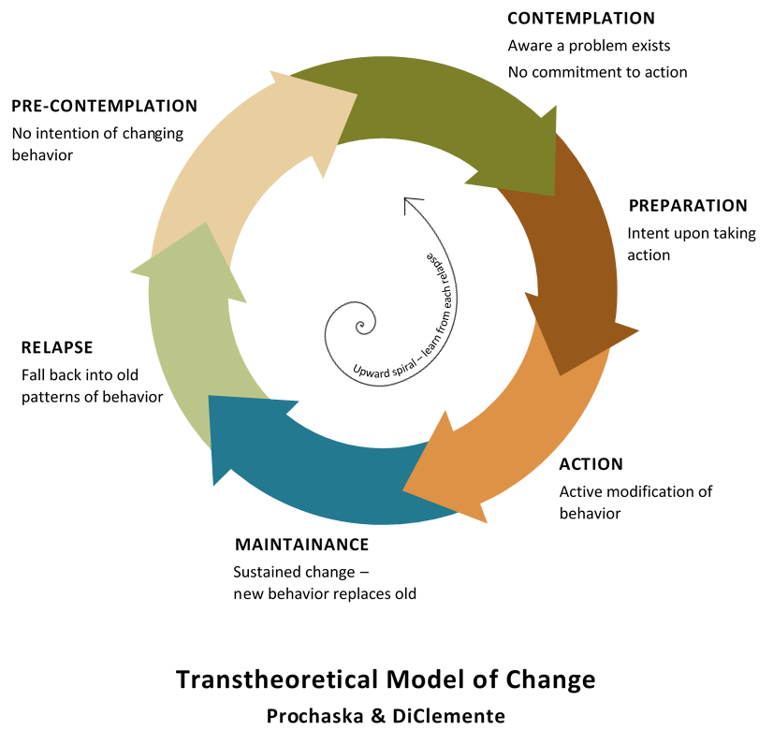
There are many ways to depict the stages of change, usually with ladders, steps or wheels. This version is adapted from: http://www.problemgambling.net.au/howpeoplechange.html

Handout: Writing a Behavior Statement
WHO + WHAT + SPECIFICS
A strong, clear behavior statement tells who will do that behavior, what they will do (action verb) and usually some additional details or specifics.
Examples:
- Mothers of babies under 6 months of age breastfeed them on-demand throughout the day and night, emptying each breast each time
- Women poultry raisers keep chickens enclosed (penned up) at all times
- Men and women farmers with hilly land plant trees on the hillsides
- Fathers of adolescent girls delay arranging their marriages until they reach age 18.
- Fathers assist their children under age five with hand washing before the evening meal
Who: Describe the group who will do the behavior (or assure that it happens).
Action Verb in Present Tense
To test if your verb is an action verb, close your eyes and try to “see” the action.
The Specifics
Add the details that pertain to how the behavior should be practiced, including when the behavior should be practiced, how often, in which place, etc.
Do not include why the behavior should be practiced.

Activity: Short Stories of Change

Achievement-Based Objectives
By the end of this activity, participants will have:
- Explored the goals and actions a community member might take to change a behavior
- Identified potential barriers that people face when trying to change, especially women and girls
- Identified and discussed actions/interventions programs can take to facilitate the change process

Duration
1 hour

Materials
- Flip chart paper
- Markers
- Large index cards in three different colors
- Tape

Why this Activity?
Sometimes when program staff are promoting a particular behavior among a priority group, they may not understand the process required to make the desired change. Many barriers to behavior change may exist, especially for women and girls. Helping practitioners think through these potential obstacles will create empathy, develop patience, and encourage creativity in responding to community needs during the change process.

Advanced Preparation
Review and modify the three short stories of Alisa, Aisha, and Atieno found in the box below. Participants may connect more strongly with the activity if the names, behaviors, and locations match their context. Alternatively, the facilitators could ask participants themselves to create the short stories (using one of the ones below as an example.) If participants write their own stories the time allocated for this activity should increase slightly. The number of stories needed will depend on the size of the training group. Ideally, participants should be working in groups of three to four people.
Once you have modified the stories, write each one on a separate piece of flip chart paper. Then, using the colored index cards, write the words Actions, Barriers, and Interventions each on a different color card. Tape them along the left side of the flip chart paper under the story. (See completed example below.)

Story of Alisa
Alisa is a young woman aged 22. She has one son that is 12 months old and just became pregnant with her second child. She would like to feed her son eggs.

Story of Aisha
Aisha is a 12-year-old girl in grade six. One day she bled through her skirt and stopped attending school. Aisha would like to continue her education.

Story of Atieno
Atieno is a 19-year-old woman. She recently got married. She would like to postpone her first pregnancy.

Instructions
1. Introduction and Story Writing (25 minutes)
1a. Tell participants: As we noted in the session on Personal Behavior Change, change is not simple or linear. It often takes time and requires overcoming obstacles and support from others. Knowledge alone is not enough to achieve change. In this activity we are going to write stories about the change process for three different people and think about what our organizations can do to facilitate the change.
1b. Say: We are going to divide into three groups; each group will have their own story. On your flip chart paper, we have given you the story’s beginning. Your job is to tell what happens next, giving us all the details of the change process along the way. Keep in mind what you have learned about gender and power as you tell the story.
  - First, on the flip chart write the goal for your main character.
  - Next, on the pink cards, write actions she takes to achieve her goal. For example, Alisa asks her husband if she can feed some of their eggs to her son instead of selling them all.
  - Thirdly, on the purple card, identify barriers she encounters when she take the actions towards her goal. For example, Alisa’s husband says that they need the money from the eggs and can’t afford to feed them to their child.
  - Lastly, think of interventions your organization might carry out that could help your character overcome the barriers. Write these on the green cards. For example, a program might use Trials of Improved Practices to discover which animal-source proteins are most acceptable and feasible for families or CHWs might use Negotiated Behavior Change with fathers to encourage them to hold back some eggs for feeding young children.
1c. Have participants choose the story they would like to work with. (If one group is too big, either divide it into two groups or ask a few participants to move to a smaller group.) Tape their flip charts to the walls in different areas of the room. Make sure each group has sufficient cards and tape. As the groups work, move around the room to answer any questions they might have or to help them.

2. Story Report Out (15 minutes)
2a. Bring the participants back together around the first group’s flip chart. Ask someone from that group to tell the story they wrote. When finished, ask the other groups the following questions:
- What other potential actions could Alisa/Aisha/Atieno have taken?
- What other barriers might she have encountered?
- What other things could our organization do to help her?
- Why is telling Alisa/Aisha/Atieno about the benefits of the behavior not enough for her to change?
- Where do you see power and gender norms influencing the story?
2b. Repeat the discussion with the other two groups.
3. Large Group Discussion (5 minutes)
3a. Bring the participants back to the large circle to reflect on the exercise. Facilitate a discussion using these questions:
- What did you learn from this exercise?
- How did it affect your thinking about the change process overall?
- How is your organization already successfully helping people through the change process?
- What would you like to see improved?

Sample of a Completed Story
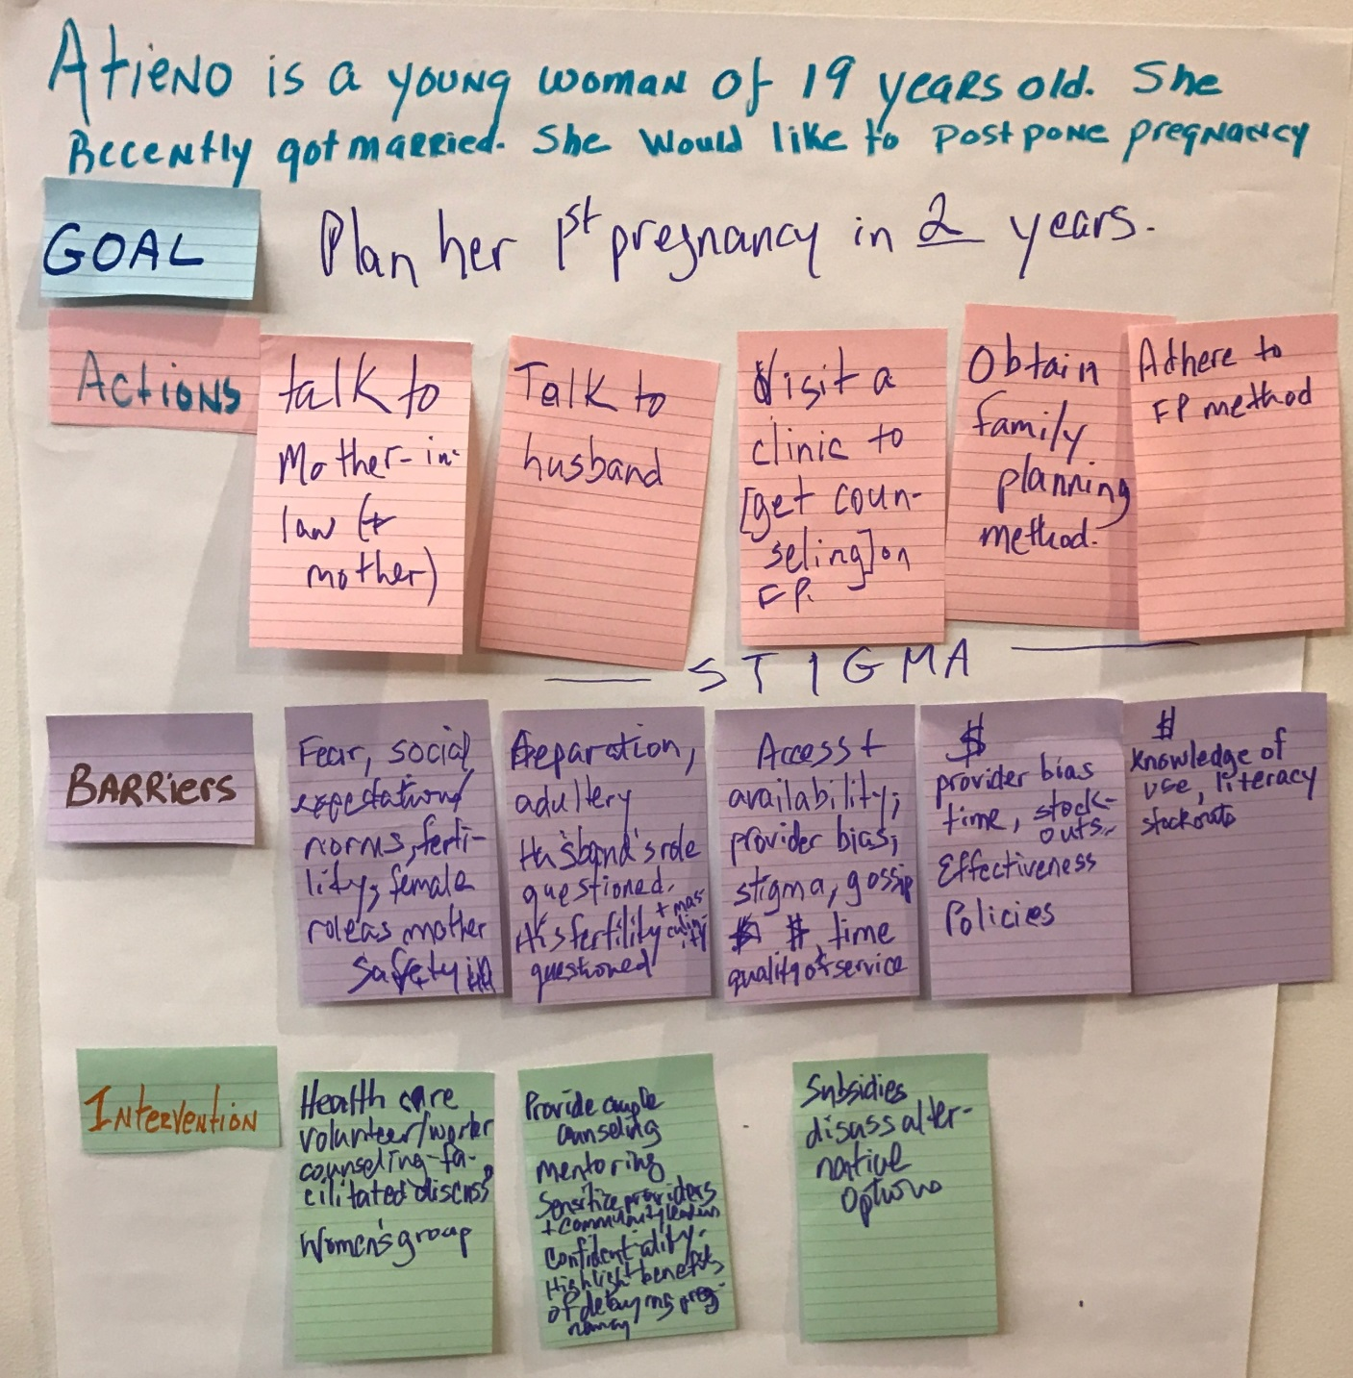

Activity: Negotiated Behavior Change
Achievement-Based Objectives
By the end of this lesson, participants will have:
- Identified the advantages of using Negotiated Behavior Change
- Identified the steps in Negotiated Behavior Change
- Practiced negotiating a behavior change with a familiar scenario about a gender-related behavior
Duration
2 hours
Materials
- Flip chart paper
- Markers
- Masking tape
- Handout: Role Play Dialogues: Negotiated Behavior Change (3 copies)
- Handout: Steps in the Process of Negotiated Behavior Change (one for each participant)

Why this Activity?
In the process of adopting a new behavior, people often encounter personal challenges (difficulties, barriers, or obstacles), more over if those behaviors involve promoting gender equity and diversity. Participants can learn to help their target audience overcome these obstacles by learning Negotiated Behavior Change skills.

Advanced Preparation
Choose two volunteers to do a role play and ask them to practice ahead of time using one of the scripts in the handout: Role Play Dialogue: Negotiated Behavior Change. These role plays can be changed by the facilitator in advance to include information and behaviors that are more relevant to the local situation and the participants’ work in the community. Make sure that each of the eight steps in the process of Negotiated Behavior Change, which are listed in the subheadings of the role play dialogue, are clearly demonstrated in the role play.
On flip chart paper, prepare a list of the keywords from the handout: Steps in the Process of Negotiated Behavior Change (Greet, Ask, Listen, Identify, Discuss, Recommend and Negotiate, Agree, Appointment).
Decide on the term to use for Promoter in the activity. Introduce the term as referring to the front-line worker (usually a volunteer) who meets individually with community members to encourage behavior change. This person could be a Care Group Volunteer, Community Health Worker, Agriculture Extension Agent, or other cadre of community-based worker.
If there are gender experts in the room, they may express concern that this activity does not go far enough to transform harmful gender norms. Reinforce that this methodology respectfully encourages small, doable, actions, and lets the community lead in deciding on and making those changes. This approach is more likely to lead to sustainable norm shifts and less likely to prompt resistance.

Instructions
1. Ideal and Next Best Behavior (15 minutes)
1a. Ask participants: Think about the story of Atieno, Alisa or Aisha. Is it always possible or easy for community members to practice the ideal behavior? (They should answer “no.” If they don’t, ask them to think about the barriers to the behaviors they listed in the Personal Behavior Change activity).
1b. Ask participants: What are some of the reasons that community members might not do the ideal behavior? (Answers could include: no way to get the materials they need, cultural taboos, fear of bad results, difficulty remembering how/when to do the behavior, religious views, fear of bad effects from doing the behavior, thinking the danger isn’t likely to happen to them, thinking the danger isn’t serious)
1c. Ask participants: When community members have trouble changing their behavior, what can our programs do to help them? (Desired response: to help the person find ways to overcome the difficulties.)
Explain that one way to overcome difficulties is called Negotiated Behavior Change.
1d. Explain to participants: Before you can use the Negotiated Behavior Change approach, you need to first identify the ideal behavior. But what if the idea behavior is not yet feasible or acceptable? What would be a next-best behavior that the person could try out, or a behavior that is “on the way” to the ideal behavior? Sometimes this can be a similar behavior, but done less often or using lower amounts, etc.
Example ideal behavior: The husband cooks dinner for the family four times each week.
Example next-best behavior: The husband cooks dinner for the family once a week. (Or: The husband plays with the children three nights a week while the wife cooks dinner.)
- Ask participants individually to write an ideal behavior and a next-best behavior on a piece of paper. Remind them to practice writing behavior statement as they learned in the previous activity (Personal Behavior Change).
- In pairs ask participants to share their ideas and discuss.
- If time permits, ask for volunteers to share with the group and discuss.
2. Definition and Advantages of Negotiated Behavior Change (15 minutes)
2a. Ask the participants: Have you ever heard the term Negotiation for Behavior Change? What do you think this term means?
2b. Read out loud and discuss briefly the definition of the approach. Take questions.
Negotiating for behavior change means that the promoter works together with a community member to consider various options and decide what that person will do. The promoter will not force the person to do something. The promoter listens respectfully to what the other person is saying. In the end, both people will agree with the decision that the other person takes. Remember that this process is a negotiation.
2c. Ask participants individually to make a list of what they think the advantages of Negotiated Behavior Change might be. Give them a few minutes to do this, then ask for volunteers to share a few examples. Write these responses on flip chart paper.
2d. Refer participants to the flip chart with Advantages and ask them to compare the advantages list they made to the list on the flip chart.
Advantages of Negotiation
- Negotiation encourages continued change because it demonstrates how small steps can help people reach bigger goals.
- Negotiation forms a bridge between the needs and values of the community and scientific knowledge.
- Negotiation helps promoters learn what community members think, feel, and do by using skills of listening, asking, and negotiating. This information can help the promoter support people as they identify and work around barriers to change.
- Negotiation promotes positive approaches in promoters and encourages a willingness to learn from the community, empathy for community members’ situations and difficulties, and a better understanding of opportunities for realistic change.
- Negotiation builds trust between the promoter and community members because they have had a chance to express themselves and have their situations taken into account.
- Negotiation with various families identifies the best practices possible within a given situation, even if those are not necessarily the optimal practice.
3. Naming the Steps in Negotiation (30 minutes)
3a. Explain to participants: You are now going to watch a role play that shows the steps in Negotiated Behavior Change.
3b. Ask the previously chosen volunteers to perform one of the role plays found in the handout: Role Play Dialogues: Negotiated Behavior Change (or the adaptation that was prepared in advance). Make sure that each of the eight steps in the process of Negotiated Behavior Change, which are listed in the subheadings of the role play dialogue, are clearly demonstrated in the role play.
3c. After the role play is done, ask participants to tell you what they saw, including: What happened first? Then what happened? Show the flip chart list of steps that you prepared in advance (using the handout: Steps in the Process of Negotiated Behavior Change as a guide). Ask participants if they saw all these steps in the role play.
3d. Explain to and ask participants: In the negotiation process, there needs to be at least one follow up visit. What do you think is the purpose of the follow-up visit? (Answers could include: to see if the person has tried the behavior change and what the results were, to see if the obstacle has been overcome; to find other behaviors that the person might need to adopt.) During the follow-up visit, the promoter follows the same Negotiated Behavior Change process, only this time the promoter asks about the agreed-upon behavior first and goes on from there.
4. Practicing Our Negotiation Skills (1hour)
4a. Explain to participants: We have discussed some of the theory behind the Negotiated Behavior Change process. Now it’s time to put our knowledge into practice ourselves.
4b. Divide the group into small groups of two or three. Ask each group to first select a behavior and write a behavior statement. Have facilitators help each group.
4c. Once participants finalize their behavior statements, ask each small group to develop a role play of 2–3 minutes on how to negotiate the behavior change. One person will play the role of the promoter, and the other will play the role of the community member. The third person can play the role of an influencing person (like a husband or mother-in-law, if need be). Each small group will take a turn performing its role play in front of the large group.
4d. After participants complete all the role plays, facilitate a discussion based on the following questions:
- How did you feel as the community member? How did it go, from your point of view?
- How did you feel as the promoter? How did it go, from your point of view?
- What was difficult?
- What can you improve?
6. Wrap Up (10 minutes)
6a. Explain that the Negotiated Behavior Change approach can be used with any behavior in any sector. Point out that the process requires at least one follow-up visit to see how the recommendation is being followed and to name other behaviors that the person should adopt according to the situation.
6b. Ask participants how they might start incorporating Negotiated Behavior Change into their own programs.

Handout: Role Play Dialogues: Negotiated Behavior Change

Option A
Behavior: Seeking medical care for children
Scenario: Father doesn’t allow mother to seek medical care without his permission and without his presence
Actors: Promoter, Mother, Husband
Actor | Dialogue
1. Greet
Promoter | Good morning, Julia. It’s good to see you. I hope you are doing well.
Mother | Welcome. I’m glad to see you too. Thanks for coming to see me.
2. Ask
3. Listen
Promoter | How old is Peter now? How is he doing?
Mother | Peter is 8 months old now, and he’s not doing well. He caught a cold two weeks ago and is still in bad shape.
Promoter | I am very sorry to hear that. Were you able to take Peter to the doctor?
Mother | Yes, I took him once. Thankfully the day that he was very sick my husband was here and he was able to take us to the doctor. The doctor said that he will need to see Peter one more time to make sure he is recovering well, but my husband wasn’t here to go with me to the doctor.
Promoter | And you couldn’t take Peter by yourself?
Mother | Well, my husband doesn’t allow me to leave the house while he is not here. Since I don’t have his permission to go to the doctor, I couldn’t take Peter back.
Promoter | Oh, I see. So whenever you have to do something outside of the house your husband has to give you permission and be with you?
4. Identify
Mother | Yes. My husband needs to give me permission to do any activity out of the household. For example, he gives me permission to go and collect water every other day. However, when I have to interact with another man, like the doctor, his permission isn’t enough; he wants to be there.
Promoter | So your husband has to be with you to go to the doctor. How do you feel about that?
Mother | My husband loves me a lot and is trying to protect me; that’s why he has that rule in our household. However, it makes things challenging for me since he works out of town. I have to wait for him to come home to take Peter to the doctor, and I am afraid that my baby will get sicker if I wait for such a long time.
Promoter | Yes, that is true. Waiting can be risky. Is your husband here?
Mother | Yes, he just arrived this morning and is resting. We have an appointment with the doctor this afternoon.
Promoter | Great news. Do you think he can join us for a minute or two?
Mother | Yes, let me call him.
5. Discuss
Promoter | Hello. I am happy to meet you. Congratulations on such a beautiful son and for being such a loving and protective father.
Father | It’s nice to meet you. Yes, I love my wife and my son; they are my treasures.
Promoter | I understand that you have to give permission to your wife to do any activities outside of the house. I also understand that she can’t go by herself to the doctor unless she is with you.
Father | Yes, people here in the community gossip, and I don’t want them to gossip about my wife if she goes by herself to the doctor, especially since the doctor is a man.
Promoter | I understand that you are trying to protect your wife. Did you also know that whenever a woman goes by herself to the doctor, the nurse is present at all times during the consultation?
Father | I didn’t know that. That’s interesting.
6. Recommend
Promoter | I understand your concern and your desire to protect your family. However, it is very important to follow doctor’s recommendations to ensure that our children recuperate fast. Since you know that the nurse will be in the room with your wife, Peter, and the doctor, I would like to make a suggestion. Do you think you can give permission to your wife to take Peter to the doctor whenever she thinks it is necessary?
Mother | Anytime!? That is too much I think. I would like my husband to be with me for the routine checkups. Having his permission to take Peter to the doctor whenever he is sick would be a relief.
Father | I agree with my wife. I would like to be present for the routine visits. However, if she thinks that Peter is sick, she can take him to the doctor.
Promoter | Great, let’s try this then: whenever your wife thinks that Peter is sick she will take your son to the doctor assuming that she has your permission. Is that okay?
Mother | What do you think, honey? Can we try this?
Father | Yes, we can try this.
7. Agree
Promoter | Next time I come and visit you we can revisit the decision and see how it worked. What do you think?
Father | Okay, we can try it.
Promoter | So, do we agree that Julia has permission to take Peter to the doctor if she thinks he is sick?
Father | Yes.
8. Appointment
Promoter | That’s great! I will plan to come back in a few weeks to see how things are going. Is that okay with you? And, if anything comes up in the meantime, please just come see me.
Mother | Okay, I will. Thanks for coming by.
Promoter | Peter is a lucky baby to have such a loving mother and father!

Option B
Behavior: Delaying early marriage
Scenario: Mother doesn’t want daughter to get married at 16 but husband wants daughter to get married
Actors: Promoter, Mother, Father
Actor | Dialogue
1. Greet
Promoter | Good morning, Angela. How are you doing?
Mother | Welcome. It’s good to see you again. Thanks for coming to visit.
2. Ask
3. Listen
Promoter | So I heard that Paula’s sixteenth birthday is coming soon, how do you feel about that?
Mother | Yes, I am excited and worried at the same time.
Promoter | I am glad you are excited. Could you tell me more about your concern about your daughter reaching sixteen years of age?
Mother | Sure. Here in our village is very common for girls to get married when they reach sixteen years of age. I am worried because Paula is so intelligent and energetic that I think she has a lot to give to our community and getting married will stop her from going to school and getting prepared to be a great leader.
Promoter | That’s true. Marriage is a lot of responsibility.
Mother | Yes, and I am sure shortly after getting married she will get pregnant and will stop going to school to take care of her children. The same happens to me and I don’t want that for Paula. However, my husband is pushing Paula to get married since he said that is what women supposed to do.
Promoter | I hear you, those traditions are very common in our community and they are difficult to change. Is your husband at home today?
4. Identify
Mother | Yes, he is. He just got back from the field a couple minutes ago.
Promoter | Do you think he will be willing to talk to me?
Mother | Yes, let me call him (calls the husband to join them). This is my husband, Paul.
5. Discuss
Promoter | Hello. I am happy to meet you. Congratulations on raising such a beautiful and gifted daughter.
Father | It’s nice to meet you, too. Yes, I am very proud of who Paula is becoming.
Promoter | I learn that Paula’s sixteenth birthday is approaching soon. You must be really excited. I also learned that you think that girls should get married soon after they reach sixteen years of age.
Father | Yes, my mom, my sisters and almost every other woman I know in the community got married after their sixteenth birthday.
Promoter | Could you tell me why do you think it is important for Paula to get married after her sixteenth birthday?
Father | As I said before that is the costume in our community. I don’t know, I love Paula so much that I don’t want her to not have a family. I am afraid that men will not want to marry her when she is older.
Promoter | Thank you for explaining your concern. You know times are changing for example in the city most girls are now waiting to get married in their twenties. They are going to college before thinking about getting married.
Father | Hmm. I never heard about that. I thought all girls in our country were getting married at sixteenth.
6. Recommend
Promoter | I understand your love for Paula. Do you think you can allow Paula to decide when to get married?
Mother | Well! I don’t want her to not get married either.
Father | Yeah, as I said I love her a lot and I want her to have the joy of having a family.
Promoter | I see. How about letting Paula finish school before asking her to find a husband? Do you think this is doable? What do you think of that suggestion?
Mother | What do you think, Paul? She has only two more years in school. I would love if Paula could graduate from high school.
Father | Well, I guess we can try it out.
7. Agree
Promoter | So, do we agree to let Paula graduate from high school before asking her to find a husband?
Father | Yes, we can wait to ask her to find a husband.
8. Appointment
Promoter | That’s great! I will plan to come back in 2 months to see how things are going. Is that OK with you? And, if anything comes up in the meantime, please just come see me.
Mother | OK, I will. Thanks for coming by.
Promoter | No problem. I am glad that Paula will have the opportunity to finish high school.

Option C
Behavior: Incorporating fish from personal fishponds (aquaculture) into children’s diet
Scenario: Mother wants to include fish in children’s diet but husband sells all the fish at the market
Actors: Behavior Change Agent (BCA), Mother, Father
Actor | Dialogue
1. Greet
BCA | Good morning, Angela. How are you doing? I hope your fish pond is prospering. Congratulations on the first harvest of fish!
Mother | Welcome. It’s good to see you again. Thanks for coming to visit.
2. Ask
3. Listen
BCA | So I understand it’s been about 6 months since you installed your fishpond. How is it going?
Mother | Things are going pretty well. We received some great training and have been trying to apply everything that the fishery outreach workers taught us.
BCA | That’s good to hear. Didn’t you also have a visit from the local health care worker?
Mother | Oh, yes. She mentioned that many children are undernourished in our community and that we need to try including other foods in their diet, like fish.
BCA | That’s is true. Fish are an important source of protein! Tell me, how is it going?
Mother | Well, I have been trying, but there are some things that have made it quite difficult.
BCA | It can be hard to try to change your family’s diet, and I’m very happy that you are trying. Can you tell me about some of the things that have made it hard for you?
4. Identify
Mother | Yes, well, my husband doesn’t want me to use the fish from our fishpond in our family meals. He wants to sell all the fish because he says we can make more money.
BCA | So your husband thinks that making money at the market is more important for the family than incorporating new foods into your children’s diet?
Mother | Yes, he feels that our kids look just like the rest of the kids in the village and they are all pretty healthy. I mean, they get sick sometimes, but he says that is just normal.
BCA | And what do you think?
Mother | Well, in the education sessions we learned that children should eat more foods and different foods to ensure that they grow up big and strong.
BCA | This is true. Have you tried to talk to your husband about this?
Mother | Yes, but it is hard and he doesn’t always listen.
BCA | Maybe it would help if we talked with him together. Is your husband around? Can he join us?
Mother | Yes, he’s just outside. I’ll call him (calls the husband to join them). This is my husband, Cipriano.
Actor | Dialogue
5. Discuss
BCA | Hello. I am happy to meet you. Congratulations on your beautiful fishpond! I understand it was a lot of work, but that you have finally started harvesting the fish. That is great news.
Father | It’s nice to meet you, too. Yes, I am very proud of our fish. It took a while for them to grow, but now it’s all worth it.
BCA | I understand that you have been selling the fish you harvest at the market to get more money.
Father | Yes, almost everyone in our community enjoys eating fish, and my neighbors are happy to buy from me.
BCA | It’s good that people enjoy eating fish. They are a great source of protein, which is important for the body to grow and have energy. Do your kids like to eat fish?
Father | I don’t know. We don’t really feed them fish because they are so valuable I sell them all. I mean, I know my wife wants to feed them fish, but the kids are so small they don’t need to eat that much anyways.
BCA | The kids are small at their young age, but they also have the most growing to do. They actually need even more food at this time in their lives, especially food from animals, so they can continue to grow into strong healthy adults.
Father | Hmm. I never thought of it that way. But, the money is important too.
6. Recommend
BCA | I understand that you need to make money and that selling fish at the market adds another source of income. But, it is also important to make sure your kids have enough quality food. The food you feed them now will determine how healthy they are later.  I would like to make a suggestion. When Angela prepares food, why don’t you help her to include some fish for each of the family members: you, her, and each of your children? You will still have a lot of fish to sell and your kids will be getting the nutrients they need. Do you think you can do this?
Mother | Wow! Adding fish to everyone’s plate every day—that is going to be a lot of fish!
Father | Yeah, I don’t think I can afford to keep all those fish for just our family.
BCA | I see that including fish in your household diet every day is a lot to ask. How about trying to add fish to your meals every other day? Angela, can you remind Cipriano to save a few fish for you to make with dinner every other day? What do you think of that suggestion?
Mother | What do you think, Cipriano? Every other day would be okay. The kids do love to eat fish…
Father | Well, I guess we can try it out.
7. Agree
BCA | Great! Why don’t you keep track of how many fish you sell per week and how many fish your family eats? Also, we can measure the kids now and then check them again when I come back in a couple months to see how much they grow!
Father | Ok, I guess we can try it for a couple months.
BCA | So, do we agree that Angela will feed everyone in the family fish at least every other day?
Mother and Father | Yes.
8. Appointment
BCA | That’s great! I will plan to come back in 2 months to see how things are going. Is that OK with you? And, if anything comes up in the meantime, please just come see me.
Mother | OK, I will. Thanks for coming by.
BCA | No problem. I am glad the fish pond is working out and that your kids are going to benefit on top of the added income for the family.

Handout: Steps in the Process of Negotiated Behavior Change
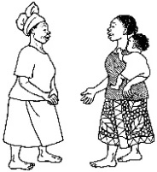 | 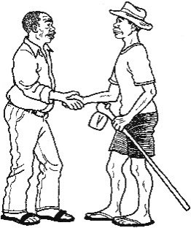 | - Greet the person and establish confidence.
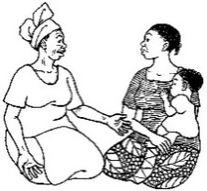 | 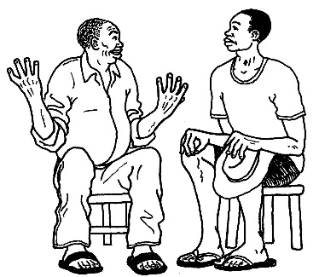 | - Ask the person about current behaviors/practices.
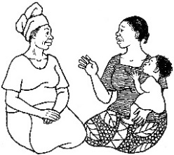 | 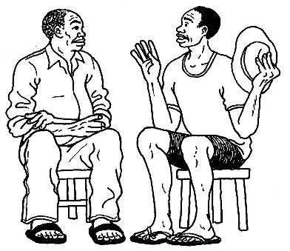 | - Listen to/reflect on what the person says.
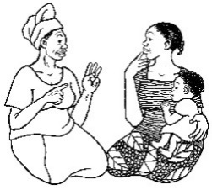 | 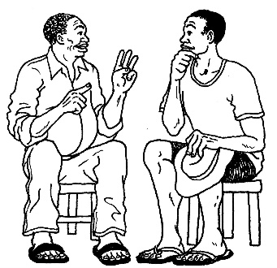 | - Identify any difficulties/obstacles and possible causes; select one difficulty/obstacle to work on.
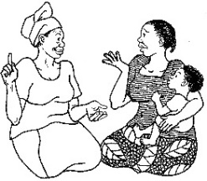 | 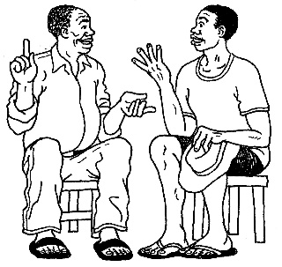 | - Discuss with the person different possible ways to overcome the obstacle.
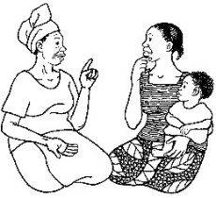 | 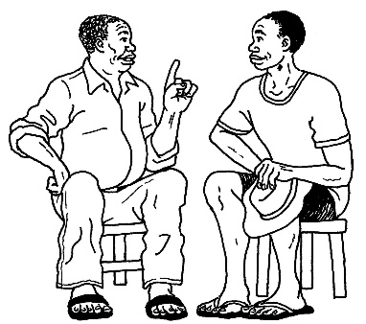 | - Recommend and negotiate doable actions: Ask for solutions from the community member; offer additional options/suggestions and NEGOTIATE with the person to help him/her select one option/action that he/she can try.
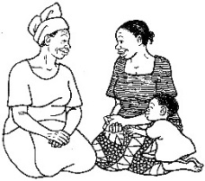 | 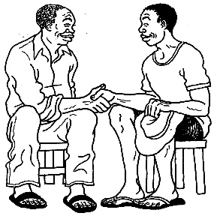 | - Person agrees to try one or more of the options, and the person repeats the agreed upon action.
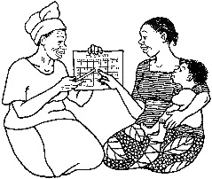 | 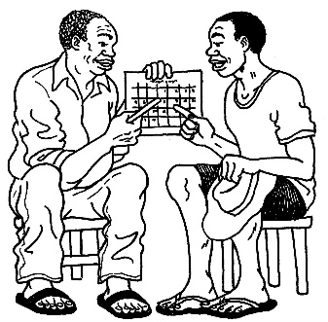 | - Make an appointment for the follow-up visit.

Handout: Observation Checklist
Did the Promoter do the following?
- 1. Greet the person and establish confidence.
- 2. Ask the person about current practices.
- 3. Listen to the person.
- 4. Identify obstacles and a next best practice that the person can try.
- 5. Discuss with the person different possible ways to overcome the obstacle.
- 6. Recommend ways to overcome the obstacles and practice an intermediate behavior.
- 7. Gain Agreement of the person to try the recommendation.
- 8. Make an Appointment for the follow-up visit.

Ask the promoter to name one or more thing(s) he/she did well. Note your observations here:

Name one important thing you recommend the promoter work on to improve the next time.

Activity: Listening Triads

Achievement-Based Objectives
By the end of this activity, participants will have:
- Shared a personal story of subordinate group membership
- Practiced active listening

Duration
1 hour

Materials
- Flip chart and stand
- Marker
- Handout: Active Listening Techniques (1 copy per participant)

Why This Activity?
Participants learn to develop empathy for others when they listen to experiences different from their own and when they reflect on their own experiences of subordinate group membership.

Advanced Preparation
This activity includes a brief introduction to the practice of listening. For a more in-depth exercise, see the lesson on Behavior Change through Effective Communication in the Make Me a Change Agent manual.
When deciding how and if to use this activity with a particular group consider the potentially sensitive nature of topics that may arise. For example, if participants are from the same work team that already experiences tension, direct them to choose non-work examples to share. If the group needs to work more on listening skills before treating the issue of power, choose a different subject for discussion.

Instructions
- Review Active Listening Techniques (15 minutes)
1a. Tell participants: Now we are going to share our own stories of power down/subordinate relationships and practice active listening. First, let’s discuss the three techniques from the handout labeled Active Listening Techniques. Ask one volunteer to read each of the techniques on the handout. Ask for questions and make necessary clarifications.
- Practice Active Listening Techniques: Listening Triads (30 minutes)
2a. Divide participants into groups of three. Say: In your groups, you will take turns in the roles of Speaker, Listener, and Observer. The Speaker tells a story of when he/she was a subordinate group member (power down relationship). The Listener will focus on the speaker, using the three techniques: listening without responding, asking clarifying questions, and listening and reformulating. The Observer does not speak, but simply observes the interaction between the Speaker and the Listener, paying close attention to the Listener’s use of active listening. After the Speaker has finished, the Observer will give feedback to the Listener. The observers should use phrases such as, “What if...?” or “How about ...?” (Those giving feedback should be kind and encouraging, and not too detailed – we are just learning! Those receiving feedback should just say “Thank you” and not argue or explain why they did things a certain way.)
You have 30 minutes total (10 minutes for each round). Tip to facilitator: This is an estimate. If people have not finished, give them a few more minutes so that everyone has a chance to tell their story.
- Debrief from Listening Triads (15 minutes)
3a. Bring the group back into the large circle. Tell participants: We will start with the Speaker role. How did it feel to share your story? What did you learn from telling it?
Allow 2-3 people to share.
3b. Say: Now let’s hear from the Listeners. What was it like to hear these stories? How hard/easy was it to use the active listening techniques? What did you learn?
Allow 2-3 people to share.
3c. Say: Lastly, how was the experience of being an Observer? How hard/easy was it to observe without engaging? What did you learn from watching the Speaker – Listener interaction?
Allow 2-3 people to share.
3d. Summarize the activity by saying: Power dynamics affect both our personal lives and our work in communities. When people belong to a dominant group, they are often unaware of their position of power and equally unaware of corresponding positions of less power. As we learn to recognize power imbalances and help others to do so as well, we will find the motivation to address these with empathy and compassion.

Handout: Active Listening Techniques

1. Listen without Responding
The listener uses only non-verbal communication (eye contact, nodding the head, open posture) and brief responses (“uh huh,” “yes,” “umm”) to show interest and to encourage the speaker to continue speaking.
The listener avoids gestures that communicate boredom, like checking his/her watch, drumming his/her fingers, or signs of impatience to get to the point.
This technique encourages the speaker to speak freely and express his/her ideas.

2. Ask Clarifying Questions
The listener asks specific questions of the speaker to clarify what the speaker is saying.
This technique helps the listener get more information about the situation in order to understand the speaker well. It helps the speaker to consider all aspects of the situation or topic by answering questions related to his/her ideas. This technique also can help the speaker and listener evaluate alternatives and possible solutions.

3. Listen and Reformulate
The listener restates in his/her own words what he/she understood the speaker to have said. The listener can use reframing statements to reformulate, such as “it’s like you’re saying,” “what I hear you saying is,” or “so if I understand you correctly.” This technique helps the listener ensure that he/she understood what the speaker said. It also allows the speaker to clarify anything that the listener did not understand because he/she can hear ideas repeated back in summary form and the listener will allow the speaker to correct his/her understanding.

Activity: Voting with Your Feet

Achievement-Based Objectives
By the end of this activity, participants will have:
- Reflected on their own attitudes, beliefs, and values around gender and diversity
- Heard from others about their attitudes, beliefs, and values around gender and diversity
- Discussed differences in attitudes, beliefs, and values around gender and diversity

Duration
1 hour

Materials
- Two signs – one that says “Agree” and one that says “Disagree”

Why this Activity?
Our values are deeply held, but often not articulated or examined closely. As participants are required to choose a side, they will explore their reasoning for doing so – which is tied to their own personal values. As they examine these values, they will also hear from others who might hold different values and learn to respect differing opinions.

Advanced Preparation
Prepare 5-10 statements of attitudes and beliefs about gender roles that may influence norms in the community. Some examples are provided here, but be sure to tailor the questions to fit your community’s culture and language. Write or draw 2 signs: “Agree” and “Disagree”, or a smiling face and a frowning face. Place these signs on opposite sides of the room.

Sample Statements of Gender Attitudes and Beliefs
- It is a woman’s responsibility to avoid getting pregnant
- A 15-year-old girl has the right to make her own choices about sex
- We need a female Commander-in-Chief to move forward on issues of equality in the USA
- Globally, women make the best decisions on how to spend money for their children.
- Women perpetuate stereotypes that prevent them from reaching equality in the home and in the workplace.
- Globally, men have become more active in childcare.
Review sample discussion questions below (2a.); adapt, remove, or add questions, as necessary for the context.

Instructions
- Voting (45 minutes)
1a. Gather all participants in the center of the room between the two signs. Explain: I am going to read a statement. If you agree with the statement, stand next to the “Agree” sign. If you do not agree, stand next to the “Disagree” sign. The purpose of this activity is to respectfully explore personal attitudes and values around commonly held beliefs. The goal is not necessarily to convince anyone of anything but to encourage dialogue. If you are not comfortable responding to a statement, feel free to skip it and step off to the side.
1b. Read the first statement. Give participants about 30-60 seconds to decide and move to a sign. Then ask them to discuss within their groups why they chose that particular side. Give them 3-5 minutes. Then ask each group to choose one person to represent their position (summarize their discussion) for the other side. Allow 2-3 minutes of dialogue. (If necessary, remind participants, that the purpose is to listen to others’ perspectives, not to convince anyone to change his/her mind.)
1c. Continue the process with the remaining statements as time allows.
- Discussion (15 minutes)
2a. Bring the group back to the large circle and facilitate dialogue about the exercise using the following questions (or similar ones):
- How did it feel to discuss these different types of values?
- What did you learn from this activity?
- Did you change your opinion on any of these issues?
- How did you make decisions when you partially agreed (or disagreed) with a value?
- How can you start discussions with other community members on commonly held values and beliefs?
- Are these values and beliefs easy or difficult to change?
- What challenges would you face with this activity or discussion around beliefs in the communities where you work?

Activity: Unpacking the Privilege Knapsack

Achievement-Based Objectives
By the end of this activity, participants will have:
- Discovered some of the unconscious privileges they enjoy as part of a dominant group
- Discussed observations and feelings about their discoveries

Duration
1 hour

Materials
- Flip chart paper and stands
- Markers
- Tape

Why this Activity?
When we are members of a dominant group, we enjoy certain benefits and privileges that we did not earn and are often unaware of. By attempting to identify these privileges, we also begin to empathize more with those in subordinate groups, which creates more dialogue and understanding between groups.

Advanced Preparation
Only introduce this activity after the group has established trust, not early in the workshop. Choose 4-5 dominant groups to which participants have membership. Write each one at the top of a piece of flip chart paper and post around the room. Choose the groups based on the observed level of comfort in the participants during previous activities and discussions; do not choose highly sensitive topics (such as homosexuality in Africa). Some examples are included in the box below.

Sample Dominant Groups
- White
- Male
- American (or European)
- Able-bodied

Instructions
- Listing Privileges (40 minutes)
1a. Tell participants: We have four (or five) dominant groups written on the flip charts around the room. Choose one of the groups to which you belong and stand by the flip chart representing that group.
1b. Once participants have moved to their groups, ask them to discuss and list on the flip chart the privileges, advantages, and benefits they have because they are a member of this group.
1c. After all the groups have finished, ask participants to do a “gallery walk” to look at all of the lists, and to add anything significant they feel is missing.
- Group Discussion (20 minutes)
2a. Gather the group back in the large circle and lead a discussion using the following reflection questions:
- What did you notice as you made the lists?
- What have you learned about privilege and power?
- What privileges are you aware of that you weren’t previously aware of?
- What do you lose by having these dominant group characteristics?
- How is this relevant to your work?

Activity: Voices

Achievement-Based Objectives
By the end of this activity, participants will have:
- Seen examples of the three types of voices we use with our co-workers and community members
- Examined and discussed how the use of these voices affects others and influences our efforts at behavior change
- Generated ideas to help increase use of the “adult voice”

Duration
1 hour

Materials
- Handout: Socio-Dramas – Health Option or Handout: Socio-Dramas – Agriculture Option (2 copies)
- Flip chart paper and stand
- Marker

Why this Activity?
Though we think we show respect to our clients, this isn’t always the case. It is important to understand how we use our voice and the effect that our voice has on those with whom we interact. We need to always examine our motives, voice, and actions to ensure that we are helping to be a vehicle of change in a positive way.
When attempting to influence someone to adopt or maintain a new behavior, we are likely to use one of three primary “voices” or attitudes towards the person – critical parent, spoiling parent, and adult. These three voices are not characterized by a person’s age or parenthood status. The circumstances of our interactions and ways in which we act or react determine the voice we choose and actions with which we communicate and respond to the situation. We each use all of three voices depending on situation and circumstance.
As we try to change behavior, many of us lean heavily on the parental voices (either controlling or condescending), treating others as children rather than as adults. Behavior change is much more likely to be successful and sustainable when people are treated respectfully – as having equal status.

Advanced Preparation
Read the sample socio-dramas below and adapt as necessary to fit the context and relevant behaviors. These samples were written for the agriculture and health sectors, but the concepts are applicable to a wide range of sectors and behaviors. Two options (one health and one agriculture) are given for each “voice”, but the activity only requires one socio-drama per “voice”. Make sure to maintain the “voices” when adapting.
Before the session, ask for six volunteers to act out the socio-dramas (2 volunteers for each of the three dramas). Print 2 copies of the selected handout (Health or Agriculture) and cut out each socio-drama. Give volunteers copies of their socio-dramas to review and prepare beforehand. Do not tell them which “voice” their drama represents. Choose either the 3 health examples or the 3 agriculture examples depending on your context.
Sample Socio-Dramas: Health Option
Critical Parent
A health worker visits a mother whose child has diarrhea. The health worker scolds the mother for the child’s illness and for not following the hygiene practices she was taught. The health worker tells the mother to sit down as she goes to the child. She gives ORS to the child after which she returns the child to the mother with obvious annoyance.
Spoiling Parent
A health worker visits a mother whose child has diarrhea. The health worker tells the mother how sorry she feels for her and pats her on the back. The health worker tells the mother to sit down and she goes to the child. She gives the child ORS. She puts the child in the mother’s arms and tells her that she will be back tomorrow to check on the child.
Adult
A health worker visits a mother whose child has diarrhea. The nurse says I am glad you came in today. I can see you are concerned. What have you done so far to help stop the diarrhea? S/he shows compassion to the mother. She invites the mother to come with her as she checks the child. She gives the ORS packet to the mother and shows her how to administer it to her child. Together the health worker and the mother discuss how to continue treating the child with homemade ORS and continued feeding. She invites the mother to come to the clinic if she needs further help. She walks to the door with the mother and affirms that she can treat her child, conveying confidence in the mother’s abilities.

Sample Socio-Dramas: Agriculture Option
Critical Parent
An ag extensionist visits a farmer. The extensionist scolds (in a tone of voice as if scolding a naughty child) the farmer for not following the farming practices she was taught. The extensionist is obviously annoyed to see that the farmer’s field is scattered with seedlings growing in clumps with areas where there are no seedlings rather than in the rows and spacing as she was told to do by the extensionist. The extensionist tells the farmer her harvest will not be very good as a result of the farmer not following the extensionist’s advice. The extensionist adds that the farmer needs to listen more carefully to what she is being taught as the extensionist has many years of training and education, while she is just a poor, ignorant farmer.
Spoiling Parent
An ag extensionist visits a farmer. The extensionist sees that the farmer’s field is scattered with seedlings growing in clumps with areas where there are no seedlings rather than in the rows and spacing recommended by the extensionist. The extensionist tells the farmer that she feels sorry for her, because she wasn’t able to understand the correct way of planting. The extensionist (speaking in a tone of voice as if patiently explaining something to a child) says “Don’t worry; I will explain it and we can practice together until you learn how to do it. I can see that this is really hard for you to do”. The extensionist starts explaining again and proceeds to thin out the seedlings growing together in clumps. The extensionist tells the farmer that he/she will bring more seeds in a few days, so that they can practice planting properly together, in the open spaces.
Adult
An ag extensionist visits a farmer to discuss the progress of the experiment started jointly by the extensionist and the farmer. One month ago, the extensionist and the farmer discussed two planting methods: broadcasting seed [spreading seeds in a field] and planting seeds in rows following specific spacing recommendations. The farmer and extensionist agreed to try the two methods to see which plot produces healthier plants and greater yields. The two methods were used to plant seeds three weeks ago. The extensionist is visiting the farmer to discuss the farmer’s observations thus far. He and the farmer check the fields together. The extensionist asks the farmer what she thinks of the different fields. Which one has the greatest yield? What does she think she will use in the future?

Instructions
- Socio-dramas (45 minutes)
1a. Tell participants: Now we are going to examine the ways in which we interact with others, especially those whose behavior we are trying to change. We will see three skits, each of which depicts one “voice” that we use.
1b. After the first socio-drama, ask: What were the behaviors of the health worker/extensionist? And what was the effect of this behavior on the mother/farmer? How do you think she felt? Was she empowered or disempowered?
After listening to participant responses, summarize the discussion: We call this “voice” or attitude the “critical parent” because the health worker/extensionist behaves as if the mother/farmer is a naughty child should be reprimanded for not adopting the behavior. The health worker/extensionist does not respect the mother/farmer and doesn’t believe that s/he has legitimate reasons for adopting or not adopting the behavior.
When we use this “voice” with people, we not only decrease their motivation to adopt the behavior, we ignore the real barriers to it, missing the chance to help find solutions.
1c. After the second socio-drama, ask: What were the behaviors and responses of each person this time? How was it different than the first?
After listening to participant responses, summarize: We call this “voice” or attitude the “spoiling parent” because the health worker/extensionist treats the mother/farmer as a child without the capacity to adopt the behavior. The health worker/extensionist does not respect the mother/farmer’s abilities to either decide to adopt the behavior or actually carry it out.
When we use this “voice” with people, we lose the opportunity to encourage self-efficacy and to improve skills needed to adopt a behavior.
1d. After the third socio-drama, ask: What were the behaviors and responses of each person this time? How were they different than the previous interactions?
After listening to participant responses, summarize: We call this “voice” or attitude the “adult” because the health worker/extensionist treats the mother/farmer as an equal who has the right and ability to decide whether the behavior is right for him/her and to carry it out.
When we use this “voice”, we acknowledge that people are experts in their own experiences, give them the opportunity to try out behaviors (testing for positive consequences and increasing skills), and encourage self-efficacy (the belief that one has the ability to do a behavior and overcome obstacles).
- Discussion (15 minutes)
2a. Ask: How can we ensure our interactions communicate respect and bring out the adult voice and behavior in those with whom we work? Write ideas on a piece of flip chart paper.

Handout: Socio-Dramas – Health Option
(Cut out on dotted lines and give to volunteers acting out the dramas.)

A health worker visits a mother whose child has diarrhea. The health worker scolds the mother for the child’s illness and for not following the hygiene practices she was taught. The health worker tells the mother to sit down as she goes to the child. She gives ORS to the child after which she returns the child to the mother with obvious annoyance.

A health worker visits a mother whose child has diarrhea. The health worker tells the mother how sorry she feels for her and pats her on the back. The health worker tells the mother to sit down and she goes to the child. She gives the child ORS. She puts the child in the mother’s arms and tells her that she will be back tomorrow to check on the child.

A health worker visits a mother whose child has diarrhea. The nurse says I am glad you came in today. I can see you are concerned. What have you done so far to help stop the diarrhea? S/he shows compassion to the mother. She invites the mother to come with her as she checks the child. She gives the ORS packet to the mother and shows her how to administer it to her child. Together the health worker and the mother discuss how to continue treating the child with homemade ORS and continued feeding. She invites the mother to come to the clinic if she needs further help. She walks to the door with the mother and affirms that she can treat her child, conveying confidence in the mother’s abilities.

Handout: Socio-Dramas – Agriculture Option
(Cut out on dotted lines and give to volunteers acting out the dramas.)

An ag extensionist visits a farmer. The extensionist scolds (in a tone of voice as if scolding a naughty child) the farmer for not following the farming practices she was taught. The extensionist is obviously annoyed to see that the farmer’s field is scattered with seedlings growing in clumps with areas where there are no seedlings rather than in the rows and spacing as she was told to do by the extensionist. The extensionist tells the farmer her harvest will not be very good as a result of the farmer not following the extensionist’s advice. The extensionist adds that the farmer needs to listen more carefully to what she is being taught as the extensionist has many years of training and education, while she is just a poor, ignorant farmer.

An ag extensionist visits a farmer. The extensionist sees that the farmer’s field is scattered with seedlings growing in clumps with areas where there are no seedlings rather than in the rows and spacing recommended by the extensionist. The extensionist tells the farmer that she feels sorry for her, because she wasn’t able to understand the correct way of planting. The extensionist (speaking in a tone of voice as if patiently explaining something to a child) says “Don’t worry; I will explain it and we can practice together until you learn how to do it. I can see that this is really hard for you to do”. The extensionist starts explaining again, and proceeds to thin out the seedlings growing together in clumps. The extensionist tells the farmer that he/she will bring more seeds in a few days, so that they can practice planting properly together, in the open spaces.

An ag extensionist visits a farmer to discuss the progress of the experiment started jointly by the extensionist and the farmer. One month ago, the extensionist and the farmer discussed two planting methods: broadcasting seed [spreading seeds in a field] and planting seeds in rows following specific spacing recommendations. The farmer and extensionist agreed to try the two methods to see which plot produces healthier plants and greater yields. The two methods were used to plant seeds three weeks ago. The extensionist is visiting the farmer to discuss the farmer’s observations thus far. He and the farmer check the fields together. The extensionist asks the farmer what she thinks of the different fields. Which one has the greatest yield? What does she think she will use in the future?

Activity: Domains and Styles of Learning

Achievement-Based Objectives
By the end of this activity, participants will have:
- Learned the three domains of learning and the three styles of learning
- Applied the domains and styles to a case study

Duration
One hour

Materials
- Copies of Ama’s Village Meeting (one per participant)

Why this Activity?
Formal education frequently focuses only on ideas and is as Paulo Freire stated, a “banking education,” meaning that information is deposited in the participants’ heads and they are expected to withdraw it when asked or when needed. Real learning is much more than information retrieval and involves how we feel (affective) about ideas and concepts we are learning and what we can do(psychomotor) with those ideas. The deepest learning takes place in the affective domain.
Additionally, many education efforts focus on only one style of learning – usually auditory. People learn in three different styles – kinesthetic (doing), visual (seeing) and auditory (hearing). Most of us can learn something through all three styles, but generally, we have one dominant style with which we learn best.
To effectively implement behavior change programs, we need to address the diversity of learning domains and learning styles, recognizing that people are not all the same!

Advanced Preparation
Review the story “Ama’s Village Meeting” and make revisions as necessary to adapt to the context of the workshop participants.

Ama's Village Meeting
Ama Agyeman is an agricultural extension agent. She is speaking to a group of smallholder women farmers at a Village Savings and Loan Association (VSLA) meeting. A mid-term evaluation recently showed that although the women were growing more vegetables and raising chickens, they were not consuming them and therefore no reduction of anemia has occurred.
Ama was asked to help the group understand how important it is for them to consume the products that they produce through their household production and to help other women in the community also understand this as well. They need to understand the importance of these foods for giving them iron which will make their blood strong and give them more energy.
She begins by giving the group a list of the nutrients found in the foods they are producing. Then she explains the way the body uses iron in the body. Ama really understands how to grow these vegetables and how to raise chickens. She has recently learned the nutritional importance of these foods. She is excited about learning this new information, understands it clearly and has worked hard to summarize the information for the women. In an effort to get her points across she tells the women about the consequences of not getting enough iron and the iron recommendations for women from the World Health Organization.
As the VSLA members listen, she goes into detail explaining the role of iron in the body and the importance of consuming iron rich foods for women and children. Ama then asks the group, “What will you do to help other women in your community eat iron rich foods?"
The VSLA members look at Ama, look at each other, shrug their shoulders and stay silent. No one responds. Ama thinks that group doesn't understand her and wonders why.

This activity is an introduction on how to facilitate learning. If your group needs more guidance on this topic, see the Behavior Change through Effective Facilitation lesson in the Make Me a Change Agent manual. Additionally, this activity only addresses designing learning sessions and does not include how to plan an overall behavior change strategy. (For developing behavior change strategies, see Designing for Behavior Change.)

Instructions
- Introduce Domains and Styles of Learning (15 minutes)
1a. Tell participants: Learning takes place across three domains: Can someone name one of these? Solicit a few responses then summarize. The three domains of learning are cognitive, affective and psychomotor.
- Cognitive learning of ideas that takes place in the mind
- Affective learning based on feelings and emotions that take place in the heart
- Psychomotor learning based on action that takes place in the mind and body

1b. Ask: Can anyone give us an example of cognitive learning? Affective? Psychomotor? Allow for 1-2 responses per domain.
1c. Tell participants: Formal education frequently focuses only on ideas. Paulo Freire described it as a “banking education,” meaning that information is deposited in the participants’ heads and they are expected to withdraw it when asked or when needed. Real learning requires more than just the study of ideas and the learning of information. It also involves how we feel (affective) about ideas and concepts we are learning and what we can do with those ideas. The deepest learning takes place in the affective domain.
1d. Say: In addition to learning domains, each person has a combination of three learning styles. Does anyone know what those are?
Allow for responses, then summarize: The three learning styles are visual, auditory, and kinesthetic (movement). Most of us use a combination of all three learning styles, but we usually have a dominant one. Because people have diverse learning styles, we have to remember to address each one when we are conducting a learning event.
- Ama’s Story (25 minutes)
2a. Divide participants into small groups of 4-5. Give everyone a copy of the story: Ama’s Village Meeting. Ask them to read the story, then answer the questions below in their groups. Give them 10 minutes to read and discuss.
- What is happening in the story?
- What is the problem?
- How does this happen in real life?
- Why does this happen?
- What can be done?
- Who will do it?
2b. Then ask the groups to reformulate Ama’s story to improve her results, considering the 3 domains and 3 styles of learning. Have them write their suggestions on a piece of flip chart paper. Give them 15 minutes.
- Group Discussion (20 minutes)
3a. When the groups are finished (or when the time is up), ask them to post their suggestions on the wall. Then give everyone 5 minutes to walk around the room and read the ideas from the other groups.
3b. Bring everyone back to the large circle and facilitate a discussion using the following questions:
- Was it easy to add the affective and psychomotor dimensions?
- What process did you do through to identify where you might include all 3 learning domains?
- How do you think the group would respond if the session were conducted with your suggestions?
- How can you apply the domains and styles of learning to your work in behavior change and GED?

Handout: Ama’s Village Story
Ama Agyeman is an agricultural extension agent. She is speaking to a group of smallholder women farmers at a Village Savings and Loan Association (VSLA) meeting. A mid-term evaluation recently showed that although the women were growing more vegetables and raising chickens, they were not consuming them and therefore no reduction of anemia has occurred.
Ama was asked to help the group understand how important it is for them to consume the products that they produce through their household production and to help other women in the community also understand this as well. They need to understand the importance of these foods for giving them iron which will make their blood strong and give them more energy.
She begins by giving the group a list of the nutrients found in the foods they are producing. Then she explains the way the body uses iron in the body. Ama really understands how to grow these vegetables and how to raise chickens. She has recently learned the nutritional importance of these foods. She is excited about learning this new information, understands it clearly and has worked hard to summarize the information for the women. In an effort to get her points across she tells the women about the consequences of not getting enough iron and the iron recommendations for women from the World Health Organization.
As the VSLA members listen, she goes into detail explaining the role of iron in the body and the importance of consuming iron rich foods for women and children. Ama then asks the group, “What will you do to help other women in your community eat iron rich foods?"
The VSLA members look at Ama, look at each other, shrug their shoulders and stay silent. No one responds. Ama thinks that group doesn't understand her and wonders why.

Activity: Birdcage Code

Achievement-Based Objectives
By the end of this activity, participants will have:
- Explored what holds us back in terms of gender equity and diversity behaviors

Duration
1 hour

Materials
- Handout: Birdcage code with questions on the back

Why this Activity?
To provide an opportunity for small group reflection on where we may be stuck or limited in terms of gender equity and diversity behaviors

Instructions
- Divide the participants into small groups no bigger than 5 people
- Pass out the Birdcage handout with the discussion questions printed on the back
- Ask participants to choose one person to facilitate the discussion (reading the discussion questions on the back of the picture, one at a time, and allowing time for discussion before moving on to the next questions.
- Study the picture carefully and discuss using the following questions on the back of the picture:
- Describe the picture in your own words. What do you see in the picture?
- What is the problem? How does this happen in real life?
- What “cages” related to GED exist in our own lives?
- Why do we stay in these cages?
- What will it take to fly out of the open door?
- Reassemble the group and ask them to share insights on each question from their small group discussions.
- Wrap up? Conclusions?
Using Codes
Paolo Freire, known as the father of popular education, promoted the use of “codes” to stimulate discussion and inquiry into the root causes of community problems. When using this approach with groups, it’s helpful to pre-test the “code” or stimulus for discussion, to make sure it will work well in your context.

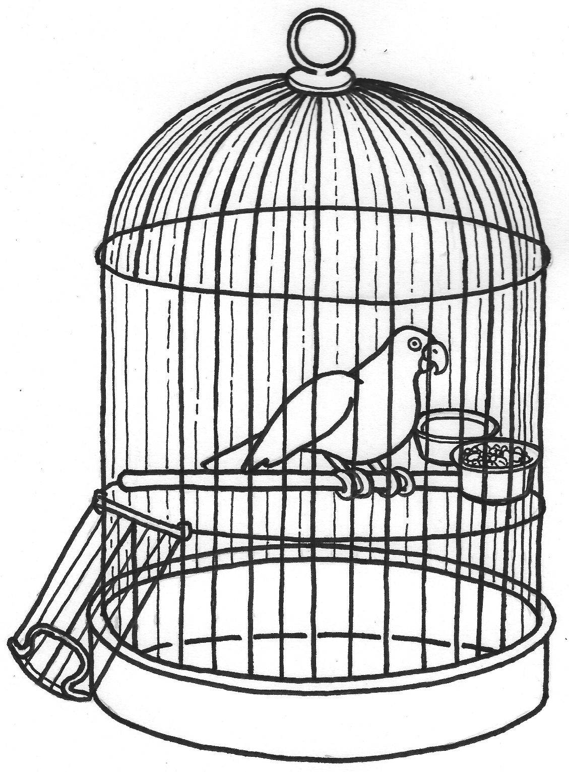
Handout: Birdcage Code
Illustration by: Regina Doyle

Discussion Questions for Birdcage Code
- Describe the picture in your own words. What do you see?
- What is the problem?
- What “cages” related to GED exist in our own lives?
- Why do we stay in these cages?
- What will it take to fly out of the open door?

Activity: Gender Box

Achievement-Based Objectives
By the end of this activity, participants will have:
- Explored roles, qualities, and behaviors expected of men and women, who imposes them, and the pressures they bring
- Identified and discussed which roles, behaviors, and expectations can (and need to) be changed and how that could be done.

Duration
1 hour

Materials
- Flip chart paper
- Markers

Why this Activity?
The gender box tool allows participants to explore what is expected of them as men and women in their societies – and the consequences of breaking those cultural norms. This activity provides a non-threatening way to identify these roles and behaviors, particularly as they relate to vulnerability, power, and inequality. Participants can also begin to explore which expectations and behaviors need to change and how they might go about effecting that change.

Advanced Preparation
If conducting a workshop that includes all or most of these lessons, you may want to choose between this activity and Birdcage Code, as many of the themes are similar. If the activities are being offered over time, Gender Box may serve as a review or refresher for Birdcage Code (or vice versa).

Instructions
- Small Group Work (30 min)
1a. Divide participants into women-only and men-only groups. If the group is single sex (all men or all women), ask half of them to work as if they were the other sex.
1b. Give each group a piece of flip chart paper and ask them to draw a medium-sized square, which will be their gender box. Inside the box, they will draw a “typical” woman (for the women’s group) or man (for the men’s group).
1c. Ask the groups to discuss the qualities, roles, and behaviors that their society expects of the “typical” man or woman and draw and write the key points inside the box. Ask participants to discuss where the expectations come from.
1d. Once they have discussed societal expectations, ask the groups to think about what happens if a man or woman behaves differently than these norms dictate. They should write these consequences outside of the box.
- Review (5 min)
2a. When both groups have finished, ask them to move to the other group’s flip chart, review, and add any missing aspects.
- Large Group Discussion (10 min)
3a. After reviewing each other’s boxes, bring the groups back together and post both boxes on the wall for everyone to see. Ask one person from each group to briefly present and explain their box to the others. Lead a discussion using the following questions:
  - What was this activity like for you? How did it make you feel? Was it difficult or easy?
  - What pressure are people under to stay in their gender box? Where do these pressures come from?
  - How do gender boxes affect health (or HIV or food and nutrition security or livelihoods)?
  - What are the advantages of people coming out of their gender boxes? What are the disadvantages?
  - How can our programs help people come out of these boxes in a positive way?

Activity: A Woman’s Life

Achievement-Based Objectives
By the end of this activity, participants will have:
- Identified social norms that have gender implications.
- Examined the effects of specific social norms on various domains of women’s lives.

Duration
1 hour

Materials
- Flip chart paper
- Markers
- Handout: example circle (one for each participant)

Why this Activity?
Frequently, social norms are so embedded that members of that culture have not examined the impacts of these norms on the lives of women and girls. By specifically identifying norms and their negative effects on women within specific domains of her life, participants begin to challenge some of their cultural assumptions and recognize ways to improve gender equity in their communities.

Advanced Preparation
Prepare a flip chart with a large circle and a stick figure of a woman inside. Around the edge of the circle list several domains of a woman’s life: education, social position, health, livelihoods, household roles, and sexuality. Add domains as relevant to the context.
Prepare a list of sample social norms to prompt participants’ thinking, such as son preference, men making household financial decisions, girls get married by a certain age, women must be accompanied by men when leaving the household, etc.

Instructions
1. Introduction and Small Group Work (25 min)
1a. Say to participants: Now we are going to examine the impact of common social norms on the lives of community women (or girls) within specific domains. We are going to select to your specific context and then examine how social norm affects various domains of women’s lives.
1b. Show the prepared flip chart with the circle and domains of a woman’s life. Explain: We are going to divide into groups, and each group will select a different social norm relevant to your specific context. (Each group should choose a different norm.) Write the norm at the top of your flip chart paper, then draw your circle with the various domains of a woman’s life. You may use the sample domains listed here (on prepared flip chart), add more, or choose different ones. For each domain, think about how the social norm affects a woman. For example, if the norm you choose is marriage by age 15, you might write that a woman does not finish her education. For the health domain, you might list that she gets pregnant and is at higher risk for anemia and obstructed labor because of her young age.
1c. Ask for questions and clarify as needed. Ask participants to count off 1-2-3-4. (Modify based on the number of participants; ideally, groups should be no larger than five participants.) Give each group flip chart paper and markers. Circulate as the groups work and answer any questions. If groups have trouble identifying a social norm, give them ideas from the prepared list.
2. Report out (15 min)
2a. Ask for a volunteer from the first group to share the circle they developed. Afterwards ask the other groups the following questions:
- What other impacts might this norm have?
- What other domains of a woman’s/girl’s life might this norm affect?
2b. Repeat the discussion with the remaining groups.
3. Discussion (5 min)
3a. Bring the participants back to the large circle to reflect on the exercise. Facilitate a discussion using these questions:
- What did you learn from this exercise?
- How did it affect your thinking about these social norms?
- How and with whom might you use this activity?

Sample of a Completed Circle
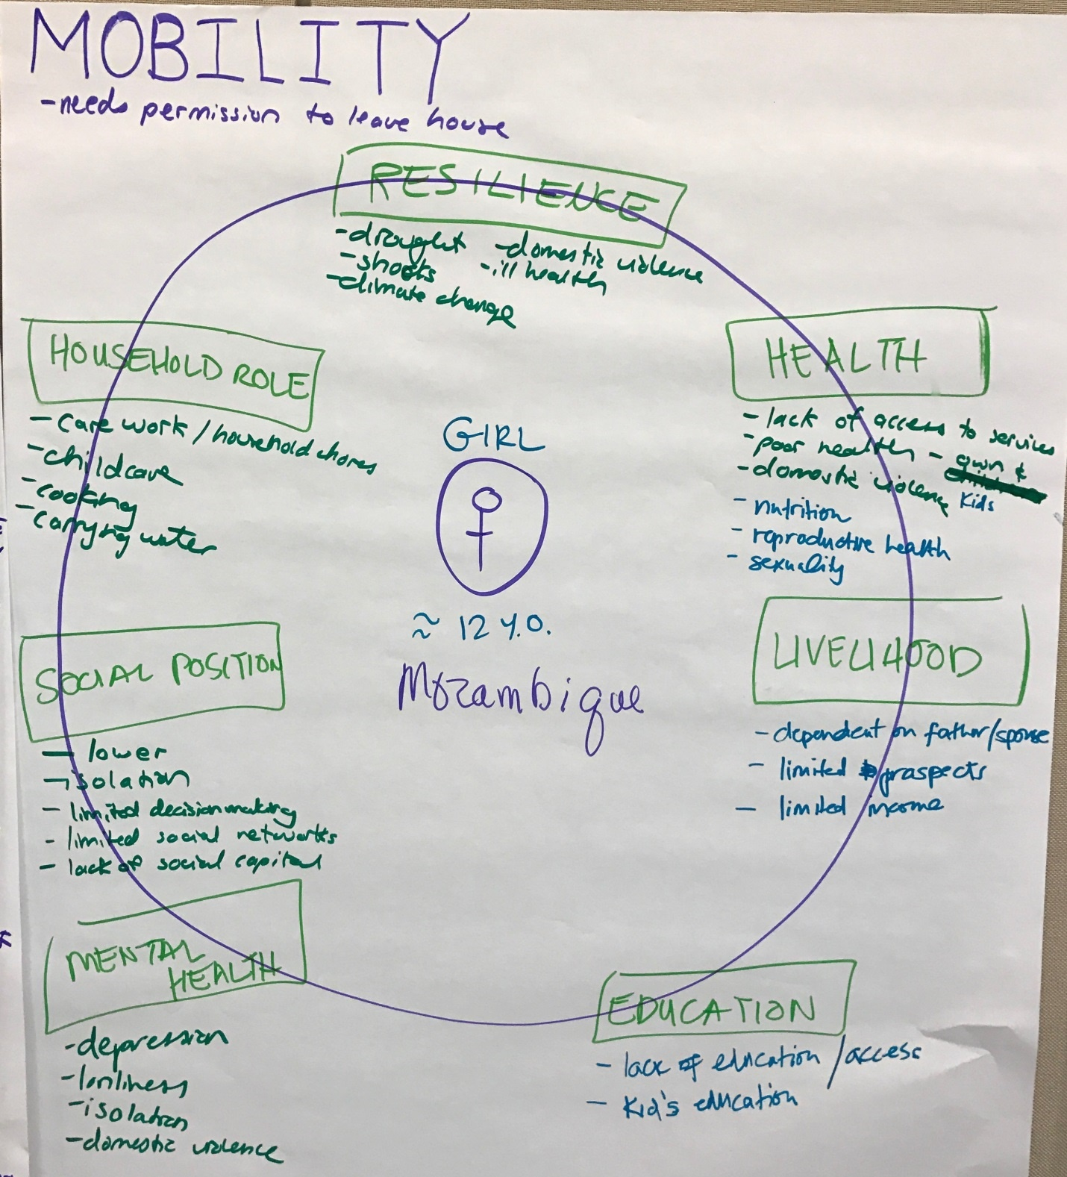

Activity: Always, Sometimes, Never

Achievement-Based Objectives
By the end of this activity, participants will have:
- Explored ways to identify behaviors that could be easier or harder to change
- Practiced matching behavior change strategies to behaviors

Duration
1 hour 15 minutes

Materials
- Flip charts or sheet of flip chart paper for each small group
- Markers
- Masking tape
- Behavior cards

Why this Activity?
Gender equity and diversity is such an enormous topic, it can be hard to decide where to start. It can be challenging to name exactly what behaviors to promote, and how to promote them. This activity is designed to have participants think more directly about behaviors, feasibility, and approaches to change.

Advanced Preparation
Review the list of behaviors for the activity cards and adapt to your context as necessary.
If conducting these activities in a multi-day workshop, you may want to choose between this activity and the next one – Cultures Change, Changing Culture – as many of the themes are similar. If you are facilitating these lessons over time, one may serve as a fresh way of reviewing concepts from the previous one.

Instructions
- Introduce the activity. Tell participants we are going to move from thinking about our own lives to thinking about the people in the communities where we work. (20 minutes)
1a. Have participants form small groups of 4-5 people
1b. Give each group a packet of behavior cards. Explain that there are behaviors listed on the cards. Groups may also wish to write additional behaviors. If you do, be sure they are SPECIFIC behavior that adults would do, not very general ones.
Example: Is “Showing respect to elders” a specific behavior? (No, it’s quite general.) Ask participants to name more specific ways of showing respect to elders.
1c. Ask participants to take two sheets of paper and make four columns. Write Always, Sometimes, Never on the top. Or if you prefer, you can write Usually, Sometimes, and Seldom, because the words “always” and “never” are a bit too strong in most cases. List the behaviors down the side. The flip chart will look something like this:
 | ALWAYS | SOMETIMES | NEVER
Repair the roof | Men |  | Women
Grow maize |  | Men and Women
Go to market
Cook meals
1d. Look at each behavior, and see if you can agree as a group where to put the behavior (In the communities where you work do women always, sometimes, or never ride bicycles? How about men?)
1e. Add additional behaviors specific to your community or project, if you wish.
- Large group discussion (15 minutes)
2a. Ask for groups to share a few of the behaviors, how they categorized them and whether it was easy or difficult for the group to agree.
2b. Using a social and behavior change lens, which types of behaviors would be the hardest to change (e.g., the ones that are always, sometimes or never)? (Participants will likely say, the always and never behaviors would be the hardest to change).
Explain that few people like to try something if they have never seen it done before, and won’t find it easy to stop doing something that is a strong social and cultural norm in their community. Explain that it is usually more challenging to promote change in the “always” and “never” behaviors. In many cases these behaviors may be associated with strong social and cultural norms in their community. So, to effectively promote change, it typically works best to start with the middle column – promoting an increase or decrease in a behavior that is already familiar and practiced by some women or men in the community. This indicates that it is probably feasible and acceptable in the community. However, sometimes it may be important to work on these more difficult behaviors right away – to do so, use interventions designed to address changing norms. See the activity: Cultures Change, Changing Cultures for more information on working to promote change in social norms.
- Developing SBC strategies to address behaviors (20 minutes)
3a. In your groups, select a “sometimes” behavior from their list and develop a few behavior change strategies to increase or decrease that behavior. Use the handout (tables and figures containing evidence-based behavior change methods) or other behavior change approaches that you are familiar with.
3b. Have groups share some of the strategies they came up with. Explain that in our projects, it would often be necessary to also do some formative research, to learn more about the determinants and motivations, to help with developing context specific and effective behavior change strategies. (Mention resource list.)
List of possible behaviors for the activity cards – you don’t have to use them all!
- Fishing
- Weaving
- Washing clothes
- Farming
- Hunting
- Cooking
- Caring for children
- Carrying water
- Going to market
- Riding bicycles
- Riding motorcycles
- Repairing the roof
- Driving trucks
- Drinking alcohol
- Going to school
- Attending community meetings
- Caring for elderly/sick family members
- Helping children with schoolwork
- Shouting, getting visibly angry
- Hitting spouse or intimate partner
- Deciding how money is spent
- Working outside the home
- Being sexually faithful to spouse
- Going to religious services

Activity: Cultures Change, Changing Culture

Achievement-Based Objectives
By the end of this activity, participants will have:
- Examined cultural changes in their lifetimes
- Explored the difference between respecting culture and changing culture
- Discussed when and how it’s appropriate to nudge changes in social and cultural norms

Duration
1 hour 30 minutes

Materials
- Flip charts or sheet of flip chart paper for each small group, markers, masking tape

Why this Activity?
It’s a common belief that culture change is difficult or impossible to effect in social and behavioral change work. Many development workers feel that cultural change is “off limits”. However, we can observe that behavioral norms do change over time, for communities and societies. This activity may help us explore, how we could contribute, through our work, to discussions and activities that explore cultural norms, which respect and preserve traditions that work well for everyone, and to explore ways to adapt or discontinue practices that are harmful and limiting to men and women, girls and boys.

Advanced Preparation
If conducting these activities in a multi-day workshop, you may want to choose between this activity and the previous one – Always, Sometimes, Never – as many of the themes are similar. If you are facilitating these lessons over time, one may serve as a fresh way of reviewing concepts from the previous one.

Instructions
Introduce the activity. Explain to participants that we are going to take some time to reflect on how things have changed since they were children. Some things have remained the same, but other things have changed? For example, who remembers a time when cell phones were not commonplace?
- Changes in what children do – what changes, if any, have occurred since you were a child? (20 minutes)
1a. Have participants form small groups of 4-5 people (if not already in small groups).
1b. Tell participants: In your groups take about 5 minutes to talk about what life was like when you were children, and how things have changed for children today, in your communities.
1c. Label on piece of flip chart paper like this with two columns:
THEN -- BOYS NOW -- BOYS
1d. Now think specifically about things that boys were not allowed to do, or were discouraged from doing when you were children. Write them in the column on the left. Perhaps boys were not allowed to learn to cook, even if they wanted to.
1e. On the right column, show whether that limitation has changed, or remained the same. Write “same” or “changed” in the right column.
1f. Now look to see if there were things that boys were allowed to do, or were encouraged to do, put them on your list as well, in the left column, and in the right column, as before, show whether that has remained the same or it has changed. Perhaps boys were encouraged to engage in rough, physical play.
1g. Take a second sheet of flip chart paper and label the top:
THEN -- GIRLS NOW -- GIRLS
1h. Now think specifically about things that girls were not allowed to do, or were discouraged from doing when you were children. Write them in the column on the left. Perhaps girls were not allowed to wear trousers to school.
1i. In the right hand column, show whether that limitation has changed, or remained the same. Write “same” or “changed” in the right column.
1j. Now look to see if there were things that girls were allowed to do, or were encouraged to do, put them on your list as well, in the left column, and on the right column, as before, show whether that has remained the same or it has changed.
- Changes in what adult men and women do – what changes, if any, have occurred since you were a child? (15 minutes)
2a. Ask participants to discuss in their small groups and list on a third sheet of paper a few changes that they have observed in the lives of adults, since they were children. Are there things that men now do that only women did when you were a child? Or things that women do now that only men did before?
- Large group discussion (15 minutes)
3a. Ask for highlights from each of the groups. Then ask additional questions:
- Did you see many changes from when you were children?
- Were some of these changes things you would consider positive change, that open up more possibilities and opportunities for men and women, boys and girls?
- Were some of these changes things you would not consider healthy or positive changes? Were valuable traditions lost, in your opinion? Did men and women, boys and girls lose opportunities in some areas?
3b. Summarize some of the discussion (adding if appropriate: We tend to treat culture as something that is static and unchanging, and traditions as something that must always be respected. This activity is meant to demonstrate that cultures do change. Sometimes change comes quickly, sometimes slowly, sometimes the changes make things better, sometimes valuable cultural traditions are lost. Culture is like a river, it is always moving, always changing. It never stands still.
3c. Ask: What does it mean to respect culture? In our work, how can we know when to respect culture and when to work to help make changes?
3d. How can we, in our work with communities, encourage communities to preserve beneficial traditions?
3e. Ask: What are some traditions that are difficult to respect? (If none are mentioned, perhaps mention female genital cutting as an example). How do we handle challenging issues like that, and support changes in harmful traditional practices?
For more information: SBC Approaches For Changing Social Norms
Here are a few methods for changing social norms from Kok, G., Gottlieb, N. H., Peters, G.-J. Y., Mullen, P. D., Parcel, G. S., Ruiter, R. A. C., Fernández, M. E., Markham, C., & Bartholomew, L. K. (2015). A Taxonomy of Behavior Change Methods; an Intervention Mapping Approach. Health Psychology Review, supplemental materials, Table 10. [http://www.tandfonline.com/doi/suppl/10.1080/17437199.2015.1077155/suppl_file/rhpr_a_1077155_sm9693.pdf]
- Mass media role-modeling
- Entertainment education
- Behavioral journalism
- Mobilizing social networks.
Other approaches may include the Care Groups model [http://www.fsnnetwork.org/care-groups-training-manual-program-design-and-implementation], which has been shown to be effective in sustainably changing community norms, and the use of storytelling or guided testimonials (see the Make Me a Change Agent manual for lessons on using storytelling and guided testimonials) that help community members imagine what it could be like to adopt the new behaviors and change social norms. [http://www.fsnnetwork.org/make-me-change-agent-multisectoral-sbc-resource-community-workers-and-field-staff]

Activity: Learning from the Experience of Others

Achievement-Based Objectives
By the end of this activity, participants will have:
- Reviewed a paper on experiences with SBC approaches for GED
- Discussed successful approaches or lessons learned from these examples
- Considered how these approaches could be applied to our work

Duration
45 – 60 minutes

Materials
- Flip chart paper
- Markers
- Journal articles or unpublished papers

Why this Activity?
In this activity, participants will have an opportunity to learn from the experiences of other practitioners, and in some cases to draw inspiration from how others were able to facilitate changes and address difficult or challenging issues. This activity appeals to our cognitive side and gives participants a chance to do some critical thinking about how others have promoted change.

Advanced Preparation
Find and print copies of a few journal articles or studies where implementers worked to facilitate change in behaviors related to gender equity and diversity. Make enough copies of the articles so that each participant will have one of the articles to read.
The facilitators should plan to read all of the articles and prepare some questions to help spark discussion of each if needed.
Plan to give participants time to read one article, either as homework the night before, or during the activity time. Here are some examples of articles we have used:

Ending Female Genital Cutting: A Positive Deviance Approach in Egypt
Evaluation of the Responsible, Engaged, and Loving (REAL) Fathers Initiative on Physical Child Punishment and Intimate Partner Violence in Northern Uganda
Father Engagement Article by CRS in Nicaragua

Instructions
1. Divide participants into groups (or allow them to choose which group to join, based on the article they are most interested in reading). So, if you have 4 papers, and 20 participants, you would have 4 groups of 5 participants, each group reading a different paper. But if you only have 2 or 3 papers, you could assign 2 different groups the same paper.
1a. If possible, ask the participants read their papers the night before, as homework. Otherwise, give them adequate time to read them during the activity time. Ask them to underline the words or phrases that stand out for them while they are reading.
1b. (After reading) Ask group members to take some time in their small groups to discuss their article. (15-30 minutes)
  - What stood out for you, when you read this article? What surprised you or sparked your interest the most?
  - What worked well in the program? Or what didn’t work well? Were there any unintended results, either positive or negative?
  - What ideas does this give you that you might be able to apply in your own work or life?
1c. Ask participants to choose one or two people from their small group to share back with the large group. The group representatives should be prepared to summarize the article they read as well as some of the discussion.
2. Large Group Discussion (20 minutes)
2a. Bring the participants back together in the big circle. As small group members to sit together in the circle. Ask for a volunteer to report out from the first group, and for other group members to add their reflections if there is something important that wasn’t mentioned yet.
Allow time for questions from group members, and discussion. Facilitators can add reflection questions that they prepared in advance if needed.
2b. Repeat the report out and discussion for each group.
3. Summary Discussion (5-10 minutes)
3a. Ask participants: Thinking about all the articles we read and discussed, do you see any common threads? Were you surprised at the sort of changes that people made? Did any of these examples change your mind about something or help you see a new possibility for your own life or work?
How else can we learn from the experience of others (people may mention field visits, or interviewing other practitioners, or maybe watching documentaries)?
Sometimes we think of some culturally entrenched practices as being too difficult to change – but there are inspiring examples, that may encourage us to try a new approach, and there is a lot we can learn from the experience of others.

Activity: Linking Social and Behavioral Change (SBC) and Gender Equity and Diversity (GED)

Achievement-Based Objectives
By the end of this activity, participants will have:
- Identified explicit ways that SBC can contribute to GED
- Discussed specific methodologies and resources for improving GED in their work

Duration
45 min - 1 hour

Materials
- Flip chart paper
- Markers

Why this Activity?
Many of the activities in this guide are experiential and encourage participants to explore their own thoughts and feelings about gender equity and diversity. It also introduces some basic SBC concepts for those new to the field. This closing session will help participants to think strategically about how to join these two topics in their work. The purpose of the session is to begin to answer the question, “How can we use SBC to improve GED in the communities where we work?

Advanced Preparation
This session should build on discussions that have taken place during previous activities, so facilitators should take great license to adapt the topics and discussion questions presented here to reflect the interests/needs of the group.

Instructions
1. Bring participants into the large circle for the closing discussion. Say: now we are going to try and identify some concrete ways that we can use SBC to improve GED in the communities where we work.
2. Choosing Behaviors to Address (15 min)
2a. Ask participants: What are some of the broad Gender Equity and Diversity topics that people are trying to address in their work? List these topics on the flip chart as they are mentioned.
2b. Ask participants to work in small groups (2-3 people) to review writing behavior statements handout and practice writing a few behavior statements that relate to the broad topics we just came up with.
2c. After 5-10 minutes, bring people back to the large group and ask them to share a few behaviors. As a group, make necessary adjustments to the behaviors.
3. Prioritizing Behaviors to Address (20 min)
3a. Say, now let’s talk about what behaviors we would choose to address first. There are several different ways we might prioritize behaviors:
- Evidence link to improved outcomes – health, economic or otherwise. What are some behaviors where we have evidence that they improve outcomes (sending daughters to more years of school, delaying marriage, others?)
- Disaggregating data by gender can sometimes point the way to obvious gender equity issues – but we’d miss some important ones, too. Remember the example from Nicaragua on involving men in maternal and newborn health care? You wouldn’t have found the problem of attendance at ANC by disaggregating data.
- What might be some behaviors where we could get an easy win, that are on the way to larger goals, or low hanging fruit? Any examples?
- There may be some behaviors that seem difficult but very important – but hard to know where to start.
- We learned about PD from the Egypt FGC example as well as the MCH example in Nicaragua. Who has experience using PD? To solve what problems? Sometimes PD can help us in some cases, some approaches that are already being used locally, by a few, and would be feasible in the community. What are some tough behaviors we might use the PD approach with?
- How about TIPS? Who has heard of TIPS or has experience with TIPS? Remember the negotiated behavior change lesson? Negotiated behavior change is a BC approach that has its origins in Trials of Improved Practices – a formative research approach developed by the Manoff Group.
3b. Say to participants: Suppose that in our communities we are offering a course for women to improve their literacy and numeracy skills. But attending classes and doing homework takes time away from their other obligations. So we are looking at promoting task sharing to make this more manageable for the women – encouraging male involvement in tasks traditionally done by their wives. To test this approach we would offer a small menu of options of tasks that might be shared by the partner, and negotiate with the couple which option they might be able to share.
3c. Ask participants to take out a sheet of paper and jot down an idea or two for a task sharing behavior that they might offer as part of the menu of options for a the TIPS formative research.
3d. Ask people to share some of their ideas and, as a group, choose a few options for the imaginary study.
4. Determining How to Promote Behaviors (15 min)
4a. Ask participants: Once you’ve already settled on behaviors to promote what’s next? You may still need more study on HOW to best promote the behaviors.
4b. Say: One way to study the behavior is through Barrier Analysis? Who is familiar with BA? This is another kind of formative research, where you interview people to learn about common barriers and motivators – comparing the responses of people who already practice the behavior you want to promote with people who do not already practice the behavior, across a number of factors. This kind of study works best where there are a fair number of people who already practice the behavior and can serve as informants for your study. This approach would not be used to settle on the behavior to promote but would inform your choice of activities and messages on HOW to promote the behavior.
What if you don’t have many people doing the behavior already? How can you find out more about what community members think, feel, and know about the behavior?
- Most simply, as Paolo Freire encouraged, you could use something to spark discussion, as we did with the Birdcage Code, to learn more about how the community sees the problem and possible solutions.
- Many participatory learning and action activities could be done, such as card sort activities.
4c. Another resource is the Make Me a Change Agent manual. Who is familiar with that manual? It provides some skill building lessons on behavior change approaches that may be helpful, such as storytelling, using guided testimonials, and more. Sometimes when people aren’t familiar with a new practice it’s beneficial to help them imagine it.
4d. Videos or radio dramas can also be a great way to introduce new practices and is most effective when people look and sound like the intended audience and when accompanied by group discussion and commitment to try the behavior or individual counseling and commitment such as Negotiated Behavior Change.
5. Closing Questions (5-10 min)
5a. Ask a final general question to spark discussion, such as: How else can we promote gender equity and diversity in the communities where we work?

Activity: Head, Heart, Hands, and Feet

Achievement-Based Objectives
By the end of this activity, participants will have:
- Reflected on personal learning, insights, and feelings from this workshop
- Reflected and planned personal action going forward from this workshop

Duration
15 minutes

Materials
- Paper, pens, colorful markers

Why this Activity?
This activity provides opportunities for participants to reflect on personal learnings, insights, and feelings, and to plan personal action going forward after a workshop or event.

Advanced Preparation
Review activity Domains and Styles of Learning to incorporate those concepts into the discussion (2b).
Depending on the make-up of the group, you may want to choose between this activity and the following one – Fly Over. This activity may work best if participants come from a variety of different organizations, while Fly Over may be more appropriate for groups from the same organization or project.

Instructions
- Personal Reflection (10 min)
1a. Explain that this exercise creates an opportunity to reflect on thoughts, feelings, or actions participants plan for the future as a result of this workshop.
1b. On flip chart paper, draw a large picture of a person. Exaggerate the head, chest, hands, and feet. Draw a heart on the chest.
1c. Explain that as we move toward the end of our time together, you will have some time to reflect on what you learned (the head), what you felt (the heart) and what you’ll do after leaving this workshop (the hands and feet).
1d. Ask participants to draw a person, something like the one on the flip chart. Give participants time to reflect individually draw a person and add the words on their paper, to express their head, heart, hands, and feet reflections.
- Group Discussion (5 min)
2a. Bring the group back together, and ask for a few volunteers to share some of their Head, Heart, Hands, and Feet reflections.
2b. Ask the group: why it might be important for head, heart and hands and feet to all be involved? If not mentioned by participants, remind participants of the activity on the three domains of learning (Ideas, Feelings, and Actions also known as Cognitive, Affective, and Psychomotor Learning) if this activity was included in your workshop.

Activity: Fly Over

Achievement-Based Objectives
By the end of this activity, participants will have:
- Reflected on personal learning, insights, and feelings from this workshop
- Reflected and planned personal action going forward from this workshop

Duration
45 minutes

Materials
- Flip chart page with 3 questions
- Paper, pens, colorful markers

Why this Activity?
In order to be able to improve gender equity and diversity in our own lives and in our workplaces, we first need to assess the current situation. Everyone needs to spend time looking at what is currently going on and determine what structures, focus, attitudes, beliefs, values, and actions foster GED and which ones actually work against a gender equitable and diverse environment. Once this determination is made, each person will be prepared to interact with their environment in new ways and work to make changes deemed important for ensuring that we are promoting gender equity and diversity in our own spaces and workplaces.

Advanced Preparation
Depending on the make-up of the group, you may want to choose between this activity and the previous one – Head, Heart, Hands, and Feet. Head, Heart, Hands, and Feet may work best if participants come from a variety of different organizations, while Fly Over may be more appropriate for groups from the same organization or project.
Write the three Fly Over questions (see below) on a piece of flip chart paper and post where everyone can see.

Instructions
- Personal Reflection (20 minutes)
1a. Gather participants in one large circle. Pass out one blank sheet of paper to each participant, along with markers or pens.
1b. Say: In order to improve gender equity and diversity in our workplaces, we need to assess the current situation. Once we have done that we will be prepared to interact with our environment and make the necessary changes. Right now, pretend that you are flying a helicopter over your organization. On your piece of paper, answer these three questions (read from the flip chart paper):
Fly Over Questions
- What aspects of GED do you see that are working well?
- What aspects of GED do you see that need improvement?
- When you return to your organization, what is one thing you can do to improve GED?
- Small Group Discussion (15 minutes)
2a. Ask participants to divide themselves into groups of three and share some of their responses. Group participants by organization, unit, department (or other logical grouping) if possible.
- Large Group Discussion (10 minutes)
3a. Return to the large circle and ask for volunteers to share responses or particular challenges for which they would like input.

Resource List
Cain, Susan. 2012. Quiet: the power of introverts in a world that can't stop talking. New York: Crown Publishers.
Food Security and Nutrition Network Social and Behavioral Change Task Force. 2013. Designing for Behavior Change: For Agriculture, Natural Resource Management, Health and Nutrition. Washington, DC: The Technical and Operational Performance Support (TOPS) Program. http://www.fsnnetwork.org/designing-behavior-change-agriculture-natural-resource-management-health-and-nutrition
The FSN Network and CORE Group. 2015. Make Me a Change Agent: A Multisectoral SBC Resource for Community Workers and Field Staff. Washington, DC: The TOPS Program. http://www.fsnnetwork.org/make-me-change-agent-multisectoral-sbc-resource-community-workers-and-field-staff
Hope, Anne and Sally Timmel. 1984. Training for transformation: A handbook for community workers. Gweru: Mambo Press. http://www.grailprogrammes.org.za/
Heath, Chip, and Dan Heath. 2007. Made to stick: why some ideas survive and others die. New York: Random House.
Heath, Chip, and Dan Heath. 2011. Switch: how to change things when change is hard. Waterville, Me: Thorndike Press.
Hillenbrand, Emily and Diane Lindsey, Ramona Ridolfi and Astrid Von Kotze. 2015. Nurturing Connections – Adapted for Homestead Food Production and Nutrition. New York, NY: Helen Keller International. http://www.fsnnetwork.org/nurturing-connections-adapted-homestead-food-production-and-nutrition
Ivankovich, Megan and Taroub Harb Faramand. 2015. Enhancing Nutrition and Food Security during the First 1,000 Days through Gender-sensitive Social and Behavior Change: A Technical Resource Guide. Washington, DC: CORE Group. http://www.wi-her.org/enhancing-nutrition-and-food-security-during-the-first-1000-days-through-gender-sensitive-social-and-behavior-change/
Kittle, Bonnie. 2013. A Practical Guide to Conducting a Barrier Analysis. New York, NY: Helen Keller International. http://www.fsnnetwork.org/practical-guide-conducting-barrier-analysis
Liberating Structures: Including and Unleashing Everyone.
http://www.liberatingstructures.com
The Technical and Operational Performance Support (TOPS) Program. 2015. Designing Participatory Meetings and Brownbags: A TOPS Quick Guide to Linking Development Practitioners (Version 2). Washington, DC: The TOPS Program. http://www.fsnnetwork.org/designing-participatory-meetings-and-brownbags-tops-quick-guide-linking-development-practitioners

CARE is a humanitarian organization leading the fight against global poverty. CARE places special focus on working towards gender equality and women’s voice alongside with women and girls, boys and men.
Adapted from CARE’s Gender Equity and Diversity Training Materials. Copyright 2014 Cooperative for Assistance and Relief Everywhere, Inc. (CARE). Used by Permission. CARE Gender, Equity and Diversity Solutions.
Adapted from: CARE’s Gender Equity and Diversity Training Materials. Copyright 2014 Cooperative for Assistance and Relief Everywhere, Inc. (CARE). Used by Permission. CARE Gender, Equity and Diversity Solutions.
Adapted from: CARE’s Gender Equity and Diversity Training Materials. Copyright 2014 Cooperative for Assistance and Relief Everywhere, Inc. (CARE). Used by Permission. CARE Gender, Equity and Diversity Solutions.
This handout was adapted from: CARE’s Gender Equity and Diversity Training Materials. Copyright 2014 Cooperative for Assistance and Relief Everywhere, Inc. (CARE). Used by Permission. CARE Gender, Equity and Diversity Solutions
The “Exercise Exercise” is adapted from Designing for Behavior Change: For Agriculture, Natural Resource Management, Health and Nutrition http://www.fsnnetwork.org/designing-behavior-change-agriculture-natural-resource-management-health-and-nutrition
In the training manual, Designing for Behavior Change: For Agriculture, Natural Resource Management, and Gender [http://www.fsnnetwork.org/designing-behavior-change-agriculture-natural-resource-management-and-gender] there is more information about writing a strong behavior statement. This activity here is only intended as an introduction to writing behavior statements
Adapted from Ideas and Action: Addressing the Social Factors that Influence Sexual and Reproductive Health. Copyright 2007 Cooperative for Assistance and Relief Everywhere, Inc. and from Social Analysis and Action Toolkit for Food and Nutrition Security, Cooperative for Assistance and Relief Everywhere, Inc. (CARE). 2017. Used by Permission.
For help in the detailed design of a behavior change strategy, see the manual Designing for Behavior Change Manual: http://www.fsnnetwork.org/designing-behavior-change-agriculture-natural-resource-management-health-and-nutrition
Adapted from The FSN Network and CORE Group. 2015. Make Me a Change Agent: A Multisectoral SBC Resource for Community Workers and Field Staff. Washington, DC: The TOPS Program. http://www.fsnnetwork.org/make-me-change-agent-multisectoral-sbc-resource-community-workers-and-field-staff
Adapted from: CARE’s Gender Equity and Diversity Training Materials. Copyright 2014 Cooperative for Assistance and Relief Everywhere, Inc. (CARE). Used by Permission. CARE Gender, Equity and Diversity Solutions.
The FSN Network and CORE Group. 2015. Make Me a Change Agent: A Multisectoral SBC Resource for Community Workers and Field Staff. Washington, DC: The TOPS Program. http://www.fsnnetwork.org/make-me-change-agent-multisectoral-sbc-resource-community-workers-and-field-staff
From: The FSN Network and CORE Group. 2015. Make Me a Change Agent: A Multisectoral SBC Resource for Community Workers and Field Staff. Washington, DC: The TOPS Program
Adapted from Ideas and Action: Addressing the Social Factors that Influence Sexual and Reproductive Health. Copyright 2007 Cooperative for Assistance and Relief Everywhere, Inc. and from Social Analysis and Action Toolkit for Food and Nutrition Security, Cooperative for Assistance and Relief Everywhere, Inc. (CARE). 2017. Used by Permission.
Adapted from: CARE’s Gender Equity and Diversity Training Materials. Copyright 2014 Cooperative for Assistance and Relief Everywhere, Inc. (CARE). Used by Permission. CARE Gender, Equity and Diversity Solutions
The Make Me a Change Agent manual can be found here: http://www.fsnnetwork.org/make-me-change-agent-multisectoral-sbc-resource-community-workers-and-field-staff
The Designing for Behavior Change manual can be found here: http://www.fsnnetwork.org/designing-behavior-change-agriculture-natural-resource-management-health-and-nutrition
Adapted from Ideas and Action: Addressing the Social Factors that Influence Sexual and Reproductive Health. Copyright 2007 Cooperative for Assistance and Relief Everywhere, Inc. Used by Permission.
Adapted from Ideas and Action: Addressing the Social Factors that Influence Sexual and Reproductive Health. Copyright 2007 Cooperative for Assistance and Relief Everywhere, Inc. and from Social Analysis and Action Toolkit for Food and Nutrition Security, Cooperative for Assistance and Relief Everywhere, Inc. (CARE). 2017. Used by Permission.
https://osf.io/bpxwq/
http://www.positivedeviance.org/pdf/publications/Ending%20FGC.pdf
http://irh.org/wp-content/uploads/2016/10/REAL_Fathers_Prevention_Science_2016.pdf
http://www.mcsprogram.org/wp-content/uploads/2015/08/CRS-Nicaragua-OR-Brief.pdf

