Lost & Found
The Magic of CORE’s Congratulatory Card*

Veerpal, a rickshaw puller in Meerut, India lost his son in January 2013 but an Immunisation card was instrumental in uniting them.
This is the story in Veerpal’s words…………………………..
Dheeraj is my only child and I love him dearly. I want to give him good health and the best education that I can afford with my meagre earnings. I had practically no knowledge about immunization till CORE’s mobiliser, Mamta Ma’am came to our door when Dheeraj was just two months old. Initially I was hesitant to talk to her but when she said “Please listen to me once and then you decide what is best for your child”, I relented.

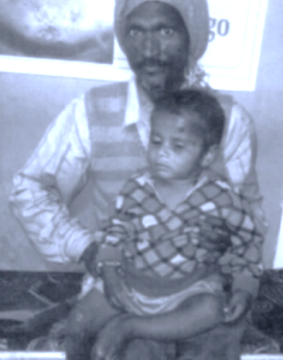
I had seen Mamtaji a couple of times interacting with the women living in my area but I was not aware that she worked for children’s health, especially for their injections.

My life was difficult as my wife has a mental illness and I take care of all the household work. Whenever I went out for work I had to lock her and Dheeraj inside for security reasons. That is the reason Mamtaji always found my house locked during the day. However one late evening she stopped by and I was pleased to meet her.

Once she found out that I was available at home only early morning or at lunchtime, she started visiting us regularly. She would talk to us about the need for getting Dheeraj immunised, the importance of hand washing and personal hygiene, etc.
Veerpal with his son, Dheeraj

Her messages on child care and cleanliness were very simple and easy to follow, especially when she showed us pictures and charts. She also gave us a ‘Badhai Card’ – a Congratulatory card developed by CORE given to every new parent. In places where there is no government immunisation card, it records all childhood immunisations and also carries messages on breastfeeding, weaning, sanitation, etc.
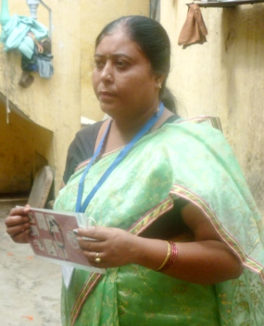
Thanks to Mamta Ma’am, Dheeraj was getting his due immunizations and his Badhai card was also updated regularly. So far, I was happy living in Meerut and my son was doing well.

But on a bitterly cold night in January 2013, when I returned home, I found my wife waiting for me at the door. I noticed that Dheeraj, who was a year and a half old, was not around and thought he might be sleeping inside. But he was nowhere to be seen. My wife was unable to answer any of my questions. Whatever little I gathered from her was that I had forgotten to lock the door today so she had taken Dheeraj out to a nearby park. She did not remember anything after that.
CORE mobiliser, Mamta

My world fell apart! I looked for Dheeraj frantically everywhere, checked with my neighbours and friends but he was nowhere to be found. I then called Mamtaji and she told me to contact the nearest police station. I was reluctant to do so because of the complex procedures that would require money and time.
Filled with grief, I would ply my rickshaw every day, all the while looking for Dheeraj in every street and corner of our colony and nearby areas. During this period Mamtaji got announcements done through the local mosque and temple and visited my house regularly.

It was now more than two and a half months and I was losing all hope of ever finding my son. One morning a neighbour told me about an advertisement in the newspaper regarding a lost child. Straightaway I rushed to the Childline office and was overjoyed to see my son sitting in one corner of the room. He was quiet but seeing me, started smiling.

While completing the legal formalities, the officer asked me to show a valid identity proof by which I could prove that this was my lost child. I was in tears because I did not have any such document and I had no idea what to do next.

Then Mamtaji came to my rescue and suggested I show the Badhai card. I remembered that I had kept it inside the given polybag in a safe place. It had the date and place of birth and parents’ names written on it. Luckily, the card fulfilled the officer’s requirement. In addition, Mamtaji had to show details of my family in her register as well. This helped me complete all legal formalities and finally Dheeraj was handed over to me.

The Badhai card gave my child a new life as well as an identity!
…………………………….

After this experience Veerpal and his family shifted to another district and away from Mamtaji but with a promise that Dheeraj would complete all his immunizations. The Badhai card became a prized possession, always to be kept in safe custody.
……………………………………………

CORE's Badhai Card

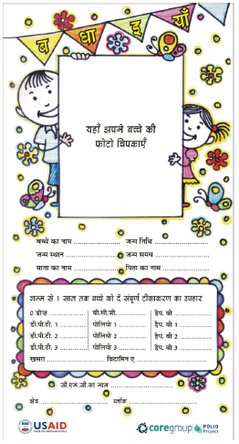
Child's Photo
Immunisations & Date

* CORE Group Polio Project works in India, Ethiopia, S.Sudan, Angola, Nigeria and Kenya on social mobilisation for Oral Polio Vaccine and Routine Immunisation through community mobilisers working with NGOs.

